Snowy bear
How do the animals stay warm in the winter?
Draw a picture or write a sentence to tell how each stays warm in the winter.
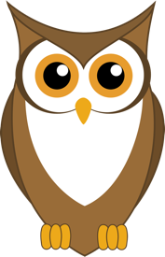
Owl
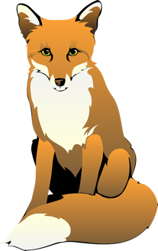
Fox
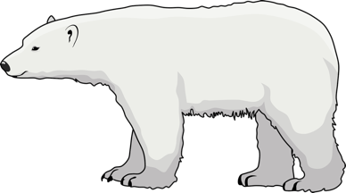
Polar Bear
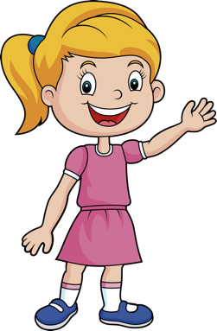
Girl

Maiconfz. (2016). Owl [Clip art]. Pixabay. https://pixabay.com/vectors/owl-animal-wildlife-bird-wild-1266206/
Clker-Free-Vector-Images. (2012). Fox [Clip art]. Pixabay. https://pixabay.com/vectors/fox-animal-mammal-forest-wild-48420/
mostafaekturkey97. (2021). Animal [Clip art]. Pixabay. https://pixabay.com/vectors/animal-polar-bear-arctic-mammal-6628303/
Felixmh. (2020). Child [Clip art]. Pixabay. https://pixabay.com/illustrations/child-little-girl-person-girl-wave-5765633/

