Picture set–Painting a picture

Picture 1A
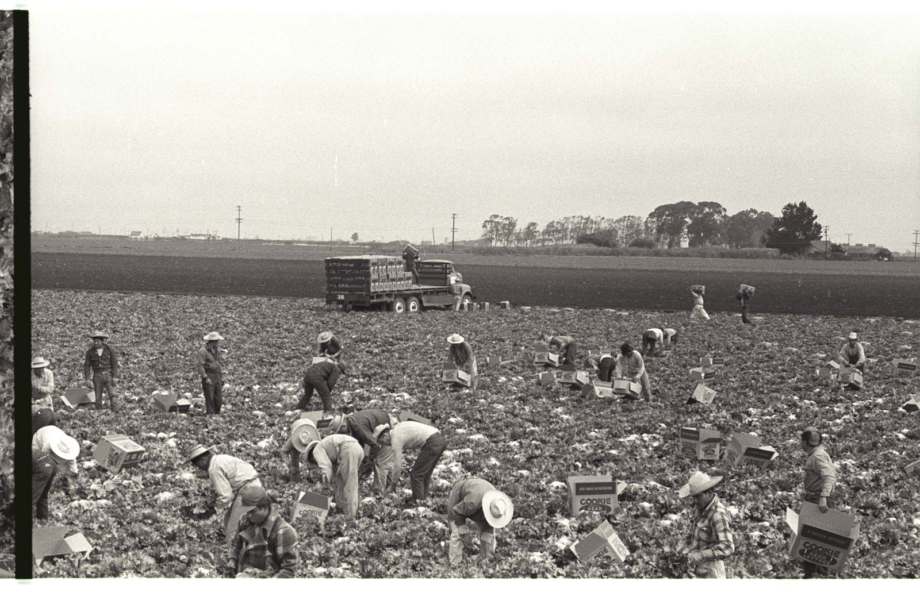
Nadel, L. (1956). Braceros pick lettuce and fill it into Cookie head lettuce boxes in a field in California [Photograph]. The Leonard Nadel Collection, National Museum of American History. https://braceroarchive.org/files/original/NAD-200401385618.jpg
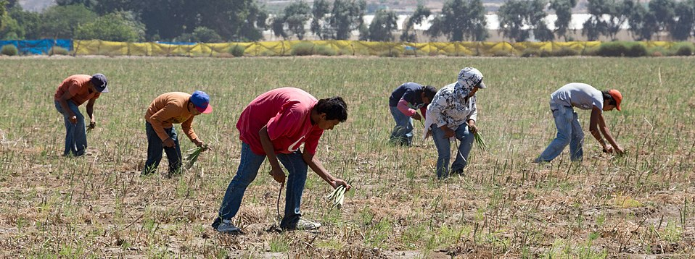
Picture 1B

Tomascastelazo. (2014). Sparragus pickers. Photo taken in the valley of Maneadero, south of Ensenada, Baja California [Photograph]. Wikimedia Commons. https://commons.wikimedia.org/wiki/File:Sparragus_pickers.jpg

Picture 2A Picture 2A
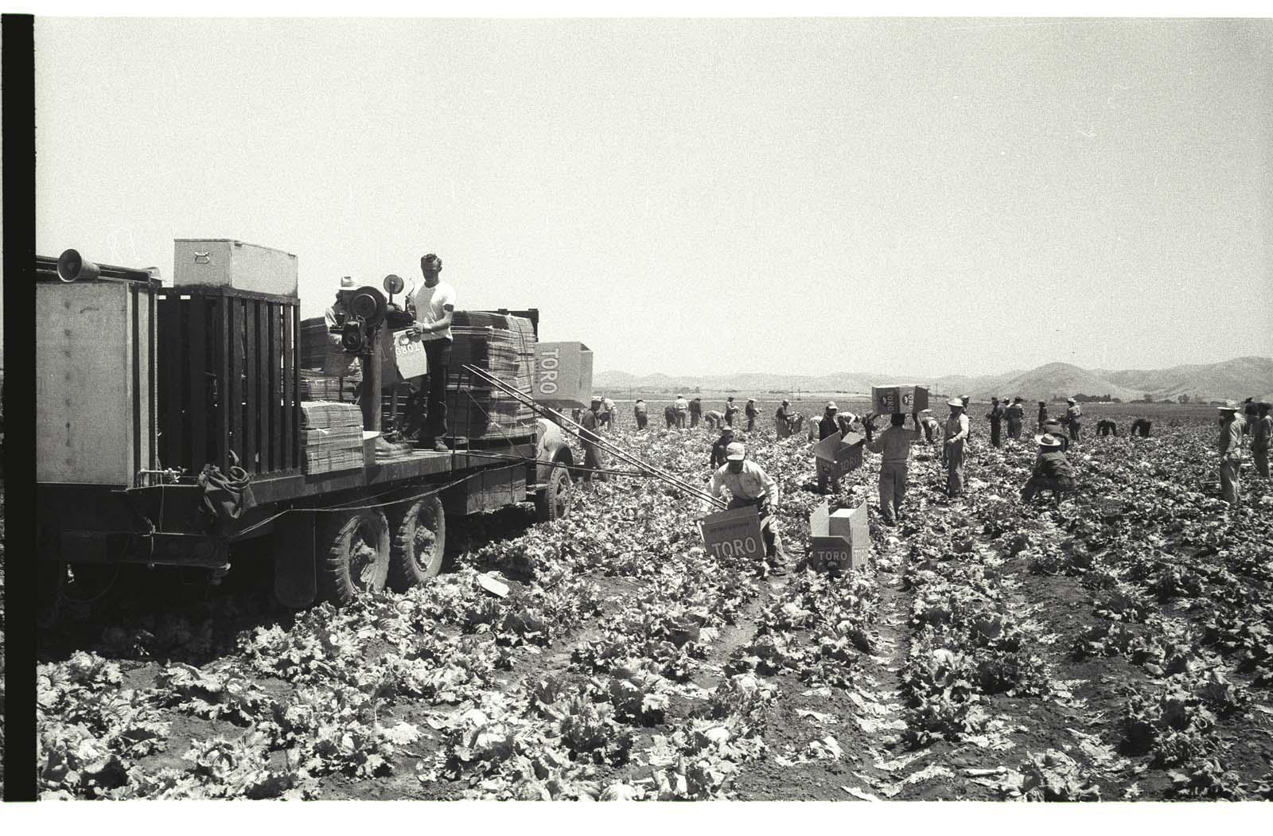
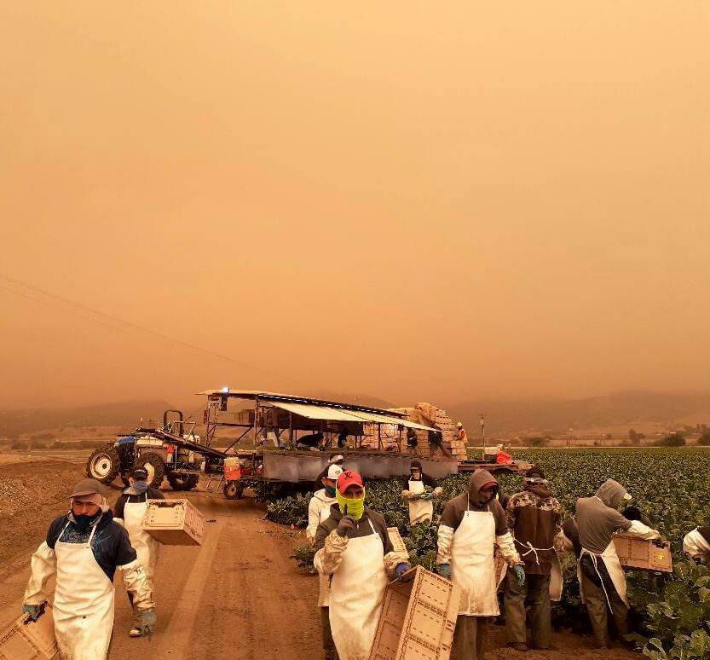

Picture 2A: Nadel, L. (1956). Braceros load Toro lettuce boxes on a truck on a lettuce field in the Salinas Valley, California [Photograph]. The Leonard Nadel Collection, National Museum of American History. https://braceroarchive.org/files/original/NAD200401383703.jpg

Picture 2B: United Farm Workers [@UFWupdates]. (2020). Erick shared this photo arriving to work in King City CA. He shares “There is nothing heroic about what we do…” [Image attached] [Tweet]. Twitter. https://twitter.com/UFWupdates/status/1304196728208461825/photo/1

Picture 3A Picture 3B
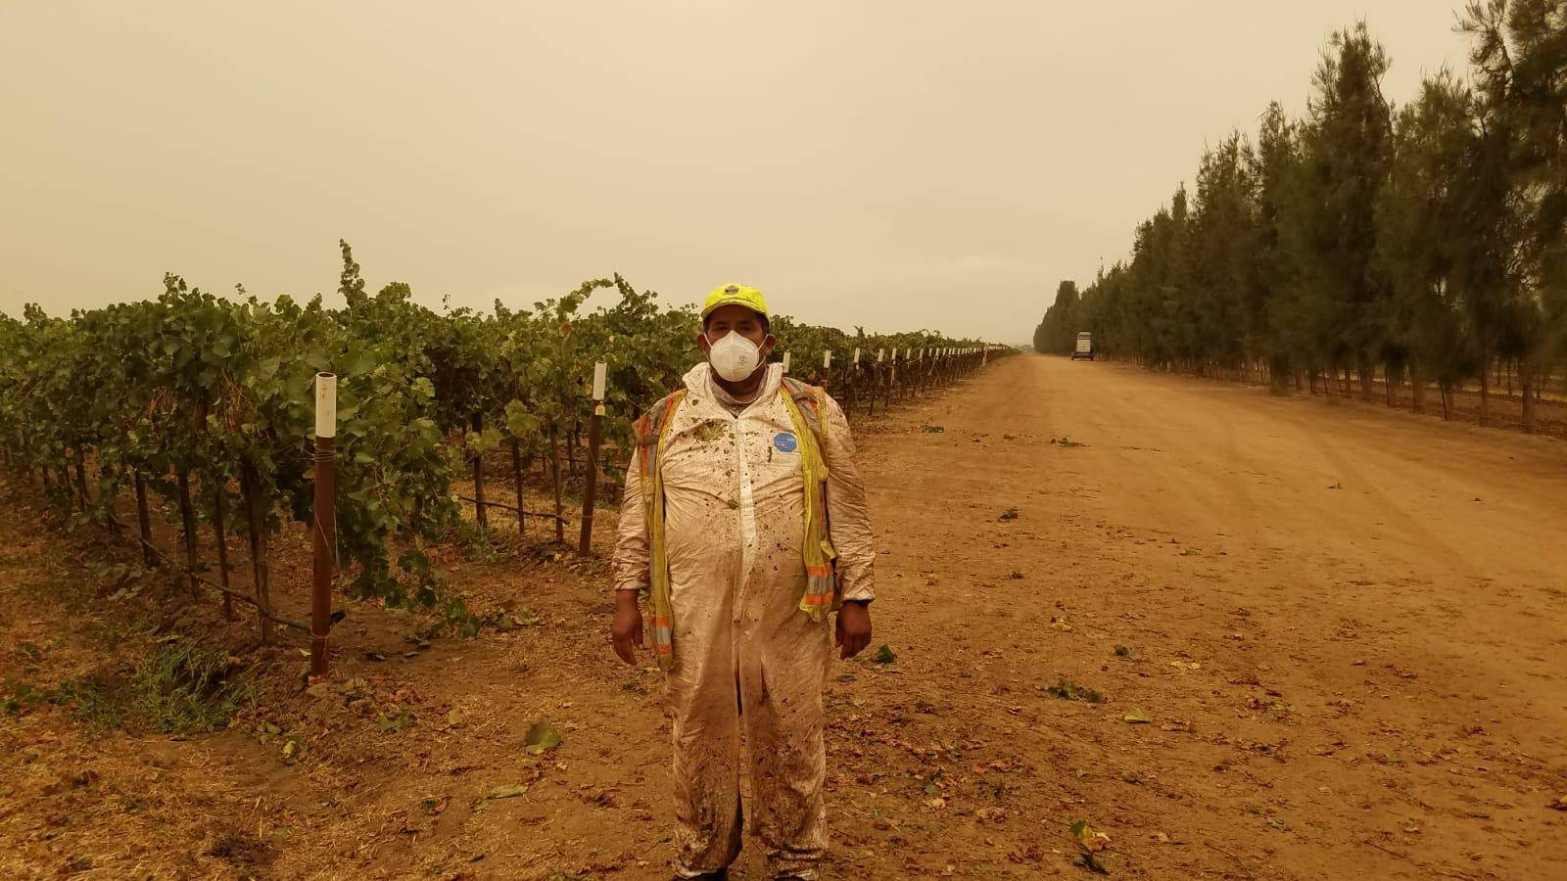
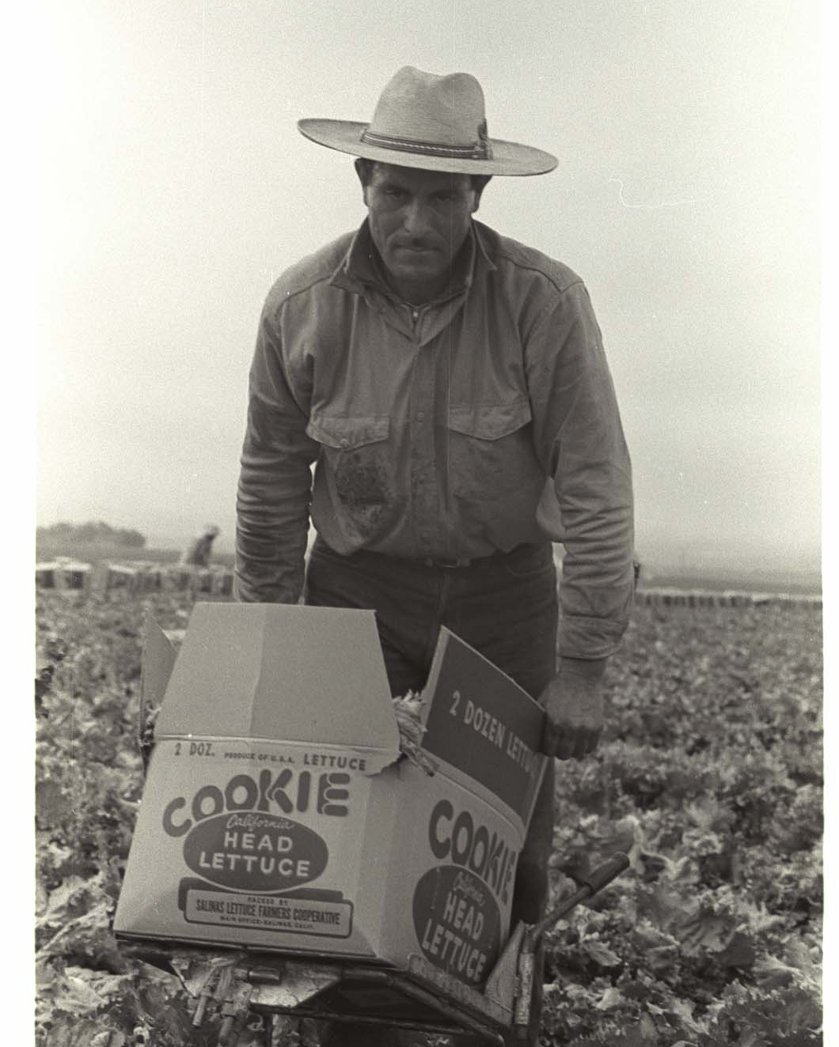
Picture 3A: Nadel, L. (1956). A bracero carries a full Cookie Head lettuce box on a trolley in a field in the Salinas Valley, California [Photograph]. The Leonard Nadel Collection, National Museum of American History. https://braceroarchive.org/files/original/NAD-200401385634.jpg
Picture 3B: United Farm Workers [@UFWupdates]. (2020). The UFW distributed P95 masks to farmworkers in Monterey County CA who are laboring despite poor air quality from nearby fires… [Image attached] [Tweet]. Twitter. https://twitter.com/UFWupdates/status/1305189651230187521/photo/1
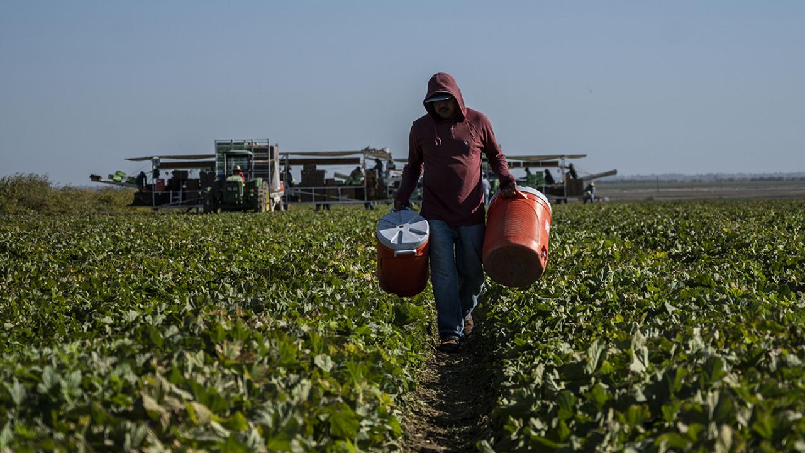
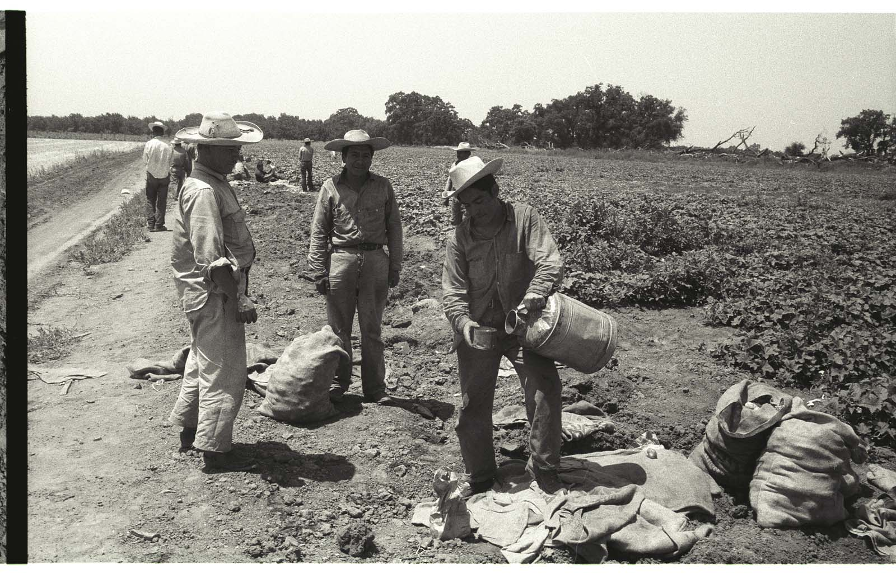
Picture 4A Picture 4B
Picture 4A: Nadel, L. (1956). A bracero fills water from a vat into a cup on the edge of a field in California [Photograph]. The Leonard Nadel Collection, National Museum of American History. https://braceroarchive.org/files/original/NAD-200401384515.jpg
Picture 4B: Amezcua, H. (2019). Farmworker wearing a bandana mask in a field in California [Photograph]. College of Agriculture and Environmental Sciences at UC Davis. https://aghealth.ucdavis.edu/news/research-highlight-stressors-and-psychological-distress-latino-immigrant-agricultural-workers

