PICTURE SET
Picture Set 1

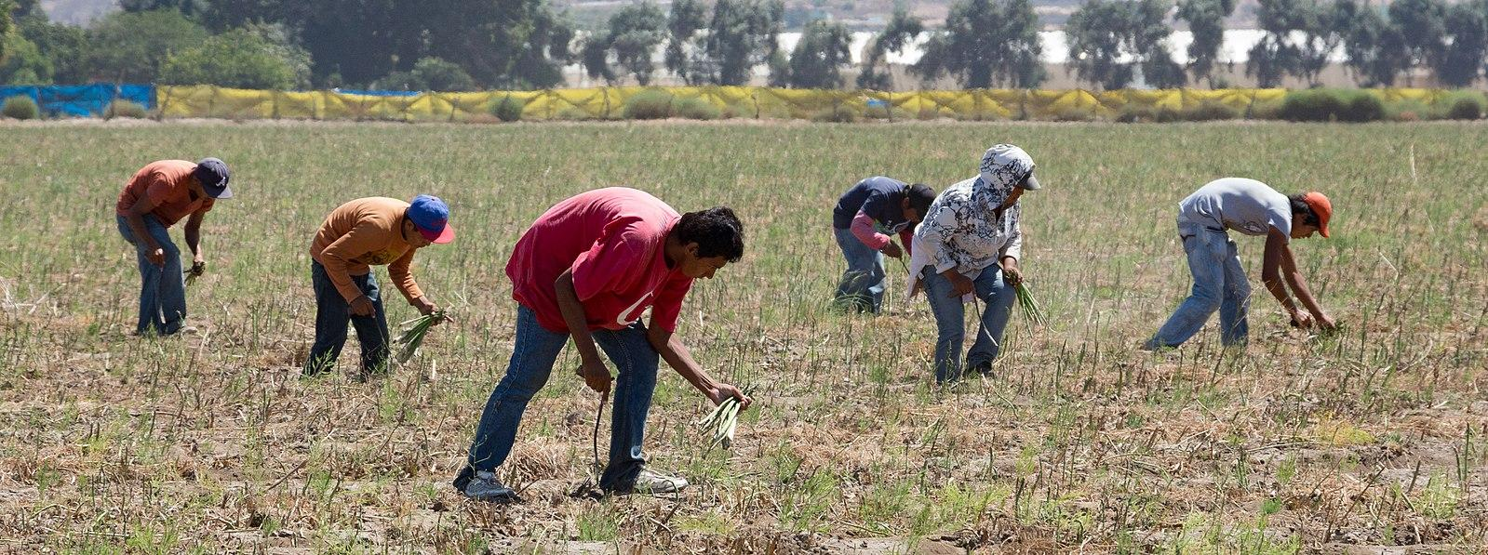
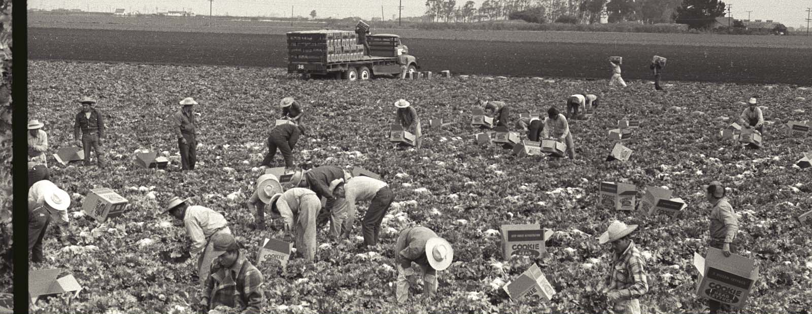  Nadel, L. (1956). Braceros pick lettuce and fill it into cookie head lettuce boxes in a field in California. The Leonard Nadel Collection, NMAH. https://braceroarchive.org/files/original/NAD-200401385618.jpg | Tomascastelazo. (2014, August 31). Sparragus pickers. Photo taken in the valley of Maneadero, south of Ensenada, Baja California. Wikimedia Commons. https://commons.wikimedia.org/wiki/File:Sparragus_pickers.jpg

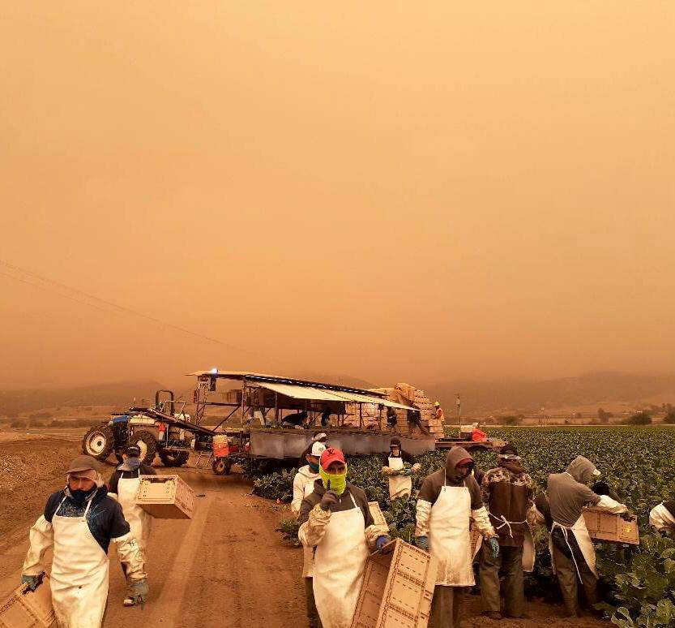
Picture Set 2
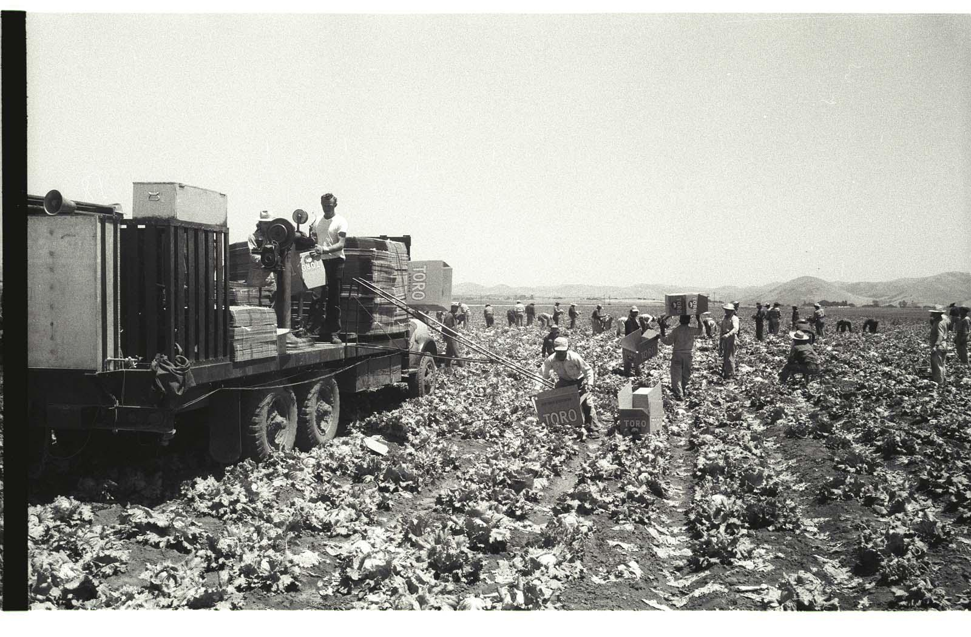  Nadel, L. (1956). Braceros load Toro lettuce boxes on a truck on a lettuce field in the Salinas Valley, California. The Leonard Nadel Collection, NMAH. https://braceroarchive.org/files/original/NAD-200401383703.jpg | United Farm Workers. (2020, September 10). Erick shared this photo arriving to work in King City CA. He shares “There is nothing heroic about what we do. We work out of necessity.” If the air quality index surpasses 150, employers must provide respiratory protection equipment such as N95 masks or similar. Twitter. https://twitter.com/UFWupdates/status/1304196728208461825/photo/1

Picture Set 3

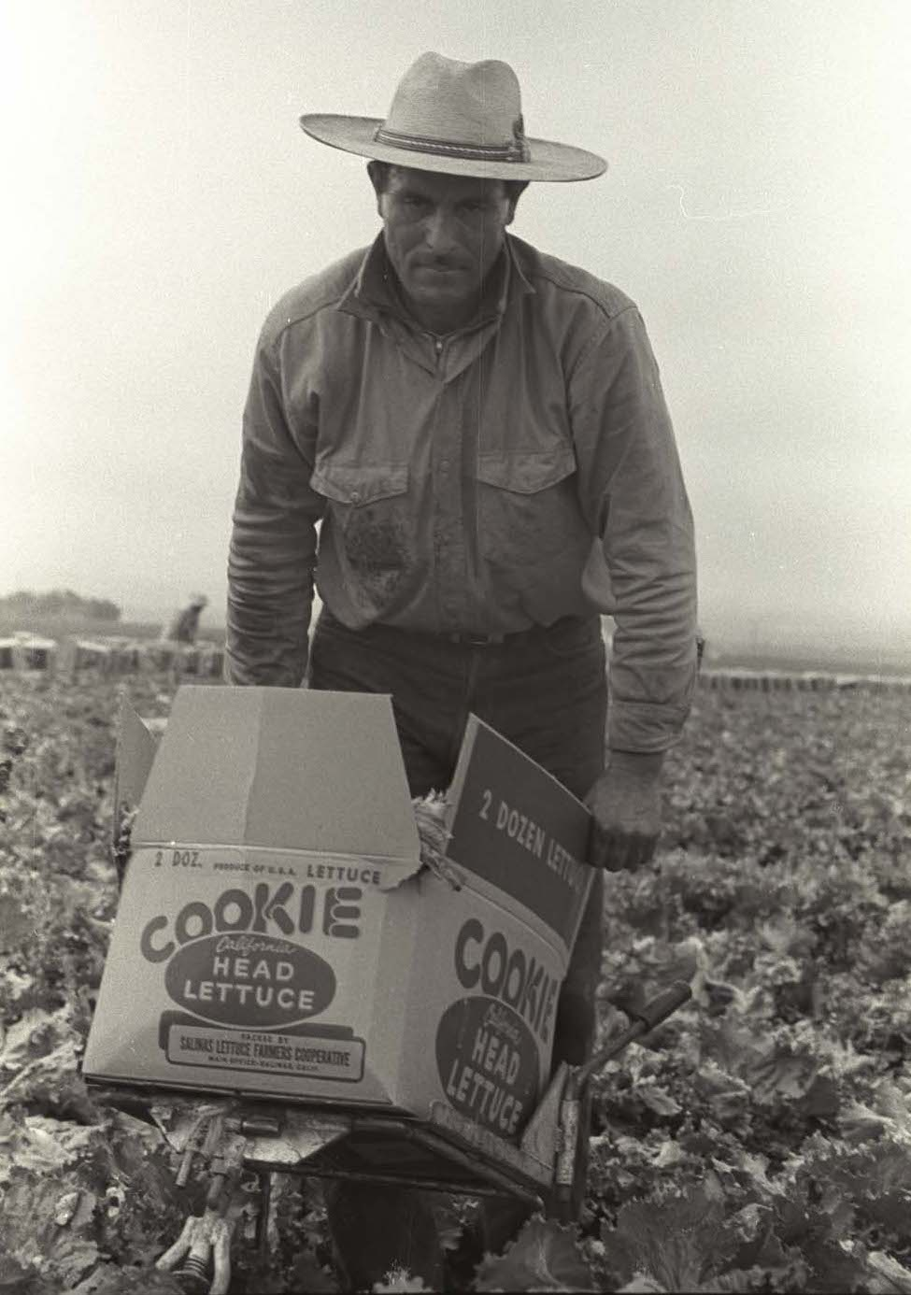  Nadel, L. (1956). A bracero carries a full Cookie Head lettuce box on a trolley in a  field in the Salinas Valley, California. The Leonard Nadel Collection, NMAH. https://braceroarchive.org/files/original/NAD-200401385634.jpg | 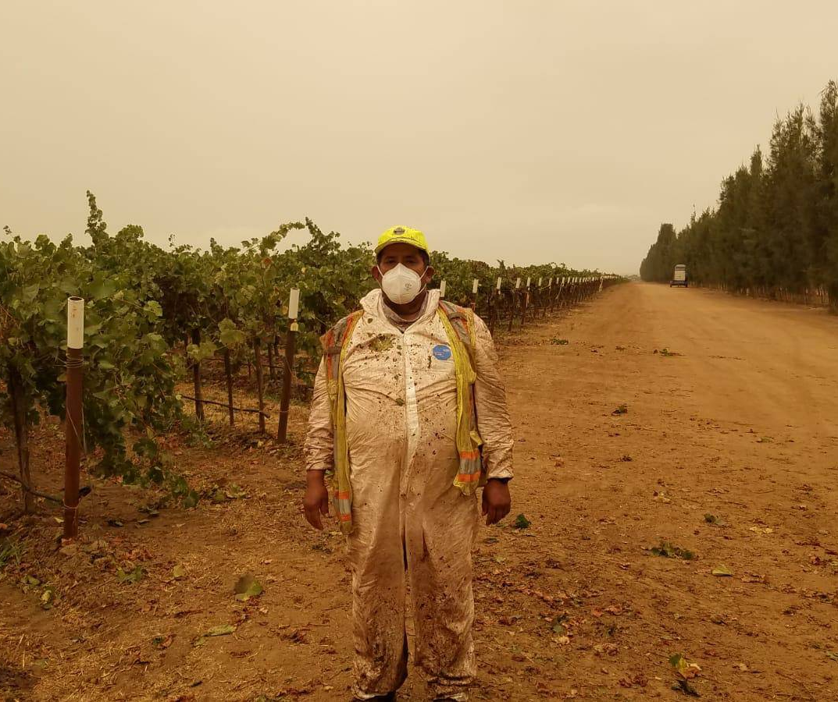  United Farm Workers. (2020, September 13). The UFW distributed P95 masks to farmworkers in Monterey County CA who are laboring despite poor air quality from nearby fires. If the air quality index exceeds 150, employers must provide protective equipment such as N95 masks or equivalent, but many are not. Twitter. https://twitter.com/UFWupdates/status/1305189651230187521/photo/1

Picture Set 4

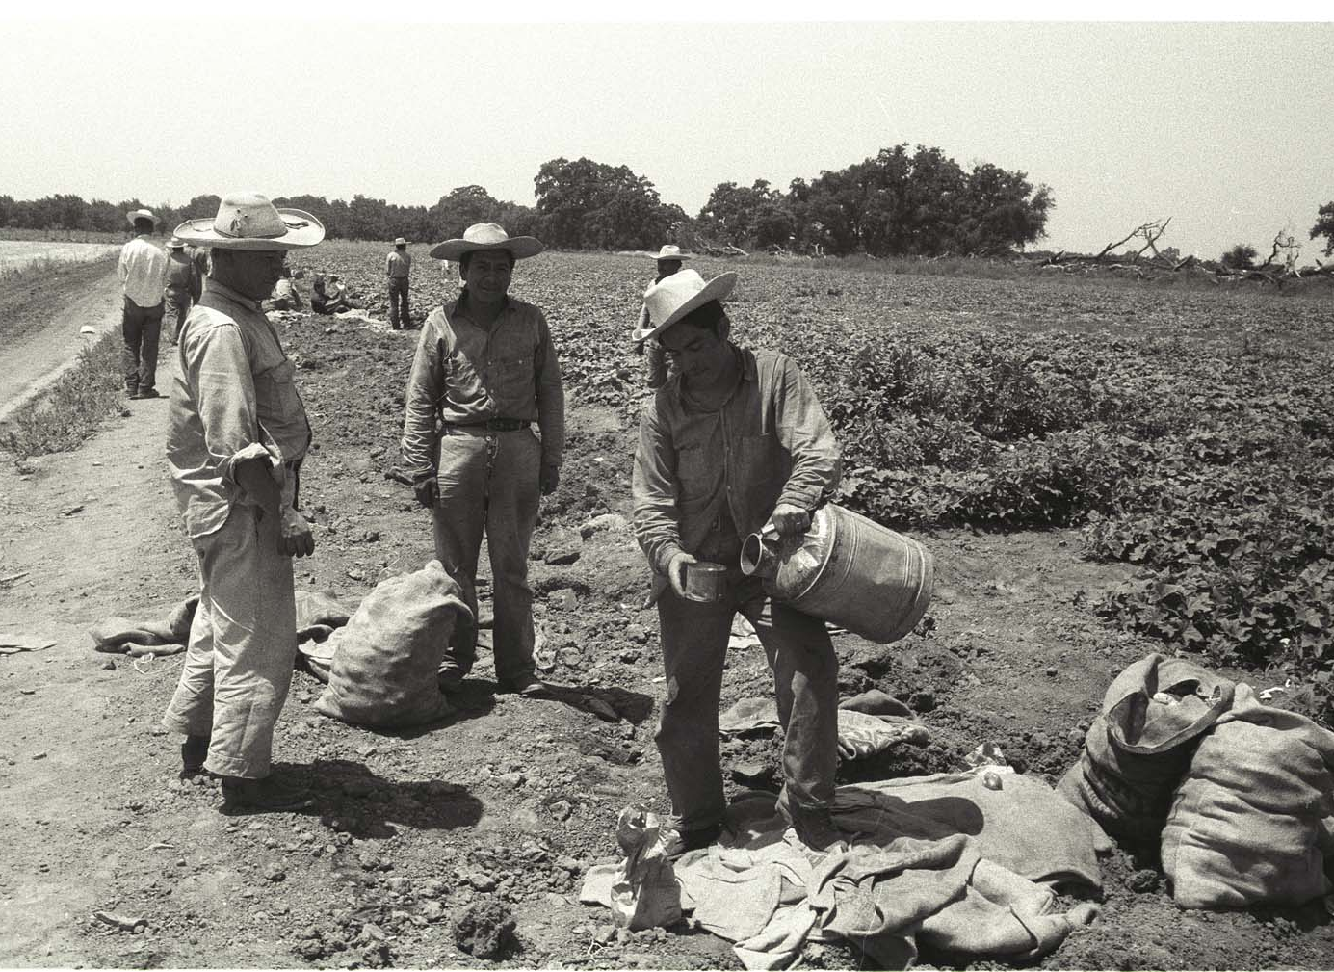  Nadel, L. (1956). A bracero fills water from a vat into a cup on the edge of a field in California. The Leonard Nadel Collection, NMAH. https://braceroarchive.org/files/original/NAD-200401384515.jpg | 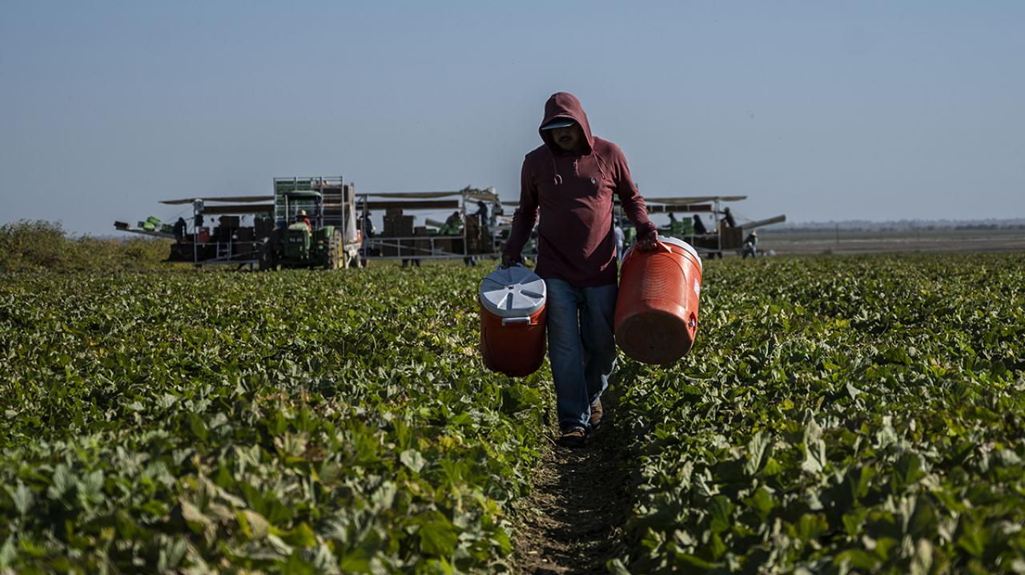  Amezcua, H. (2019, October 25). Research highlight: Stressors and psychological distress of Latino immigrant agricultural workers in California. College of Agriculture and Environmental Sciences at UC Davis. https://aghealth.ucdavis.edu/news/research-highlight-stressors-and-psychological-distress-latino-immigrant-agricultural-workers

