the USS Maine Explosion
On January 24, 1898, the USS Maine steamed out of the harbor at Key West, Florida, headed for Havana, Cuba. Captain Charles Sigsbee had received a coded message from the U.S. Consul in Havana, Fitzhugh Lee. He believed the lives and property of Americans were in danger from the Spanish who were burning sugar cane plantations. The U.S. had millions of dollars invested in Cuba, and many U.S. citizens lived there. Cuban independence was of paramount importance. The USS Maine was on its way to defend U.S. property and people.
The pride of the U.S. fleet, the USS Maine was America’s first armored warship. Made of nickel steel a foot thick, the Maine’s main armament consisted of four 10-inch guns, each equipped with 90 rounds of ammunition. Six 6-inch guns were mounted in the hull, two at the bow and stern and two amidship. Additional weaponry included anti-torpedo armament and four torpedo tubes.
Battle-ready, the Maine arrived in Havana at 10:00 a.m. on January 25. The crew were restricted to the ship. On February 15, at 9:40 p.m., the ship was severely damaged by an explosion. More than 5 tons of gunpowder detonated, obliterating the forward third of the ship where most of the crew slept.
The ship’s crew consisted of 355 members: 26 officers, 290 enlisted sailors, and 39 Marines. Of these, two officers and 251 enlisted sailors and Marines were killed by the explosion or drowned. Seven others died after rescue. In total, 260 men died. Captain Sigsbee and most of his officers survived. Their quarters were in the aft (rear) of the ship. Altogether there were 89 survivors.

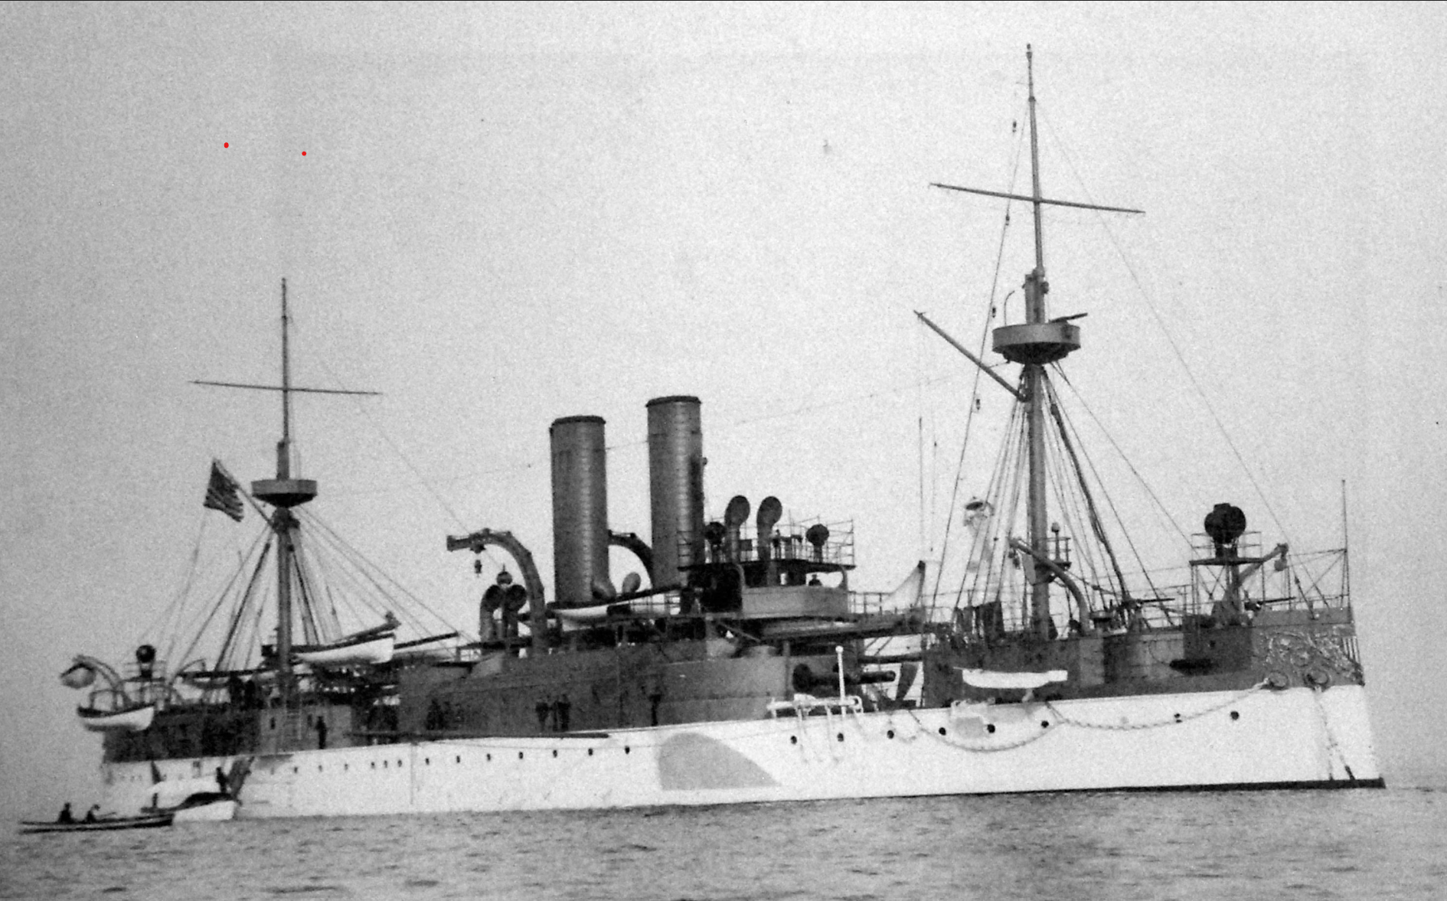

Source
Holder, J. (2017, November 15). The story of the USS Maine [Video]. YouTube. https://www.youtube.com/watch?v=1ZijF-RhWu0

