CLADOGRAM CARDS

Set A

Catfish  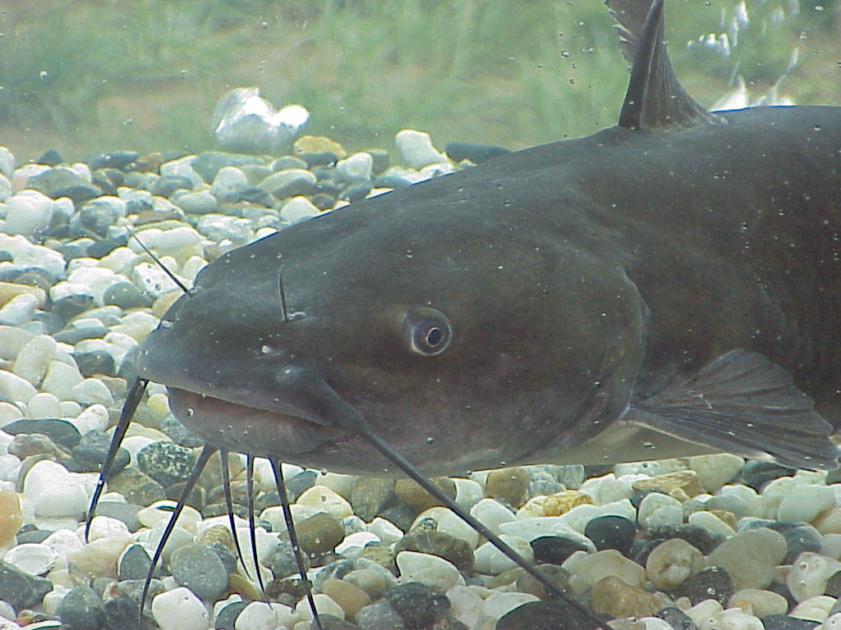  - Vertebrate  - Has jaw structure  - Breathes using gills  - No limbs  - Lays eggs  - Scavenges/searches for food | Kangaroo  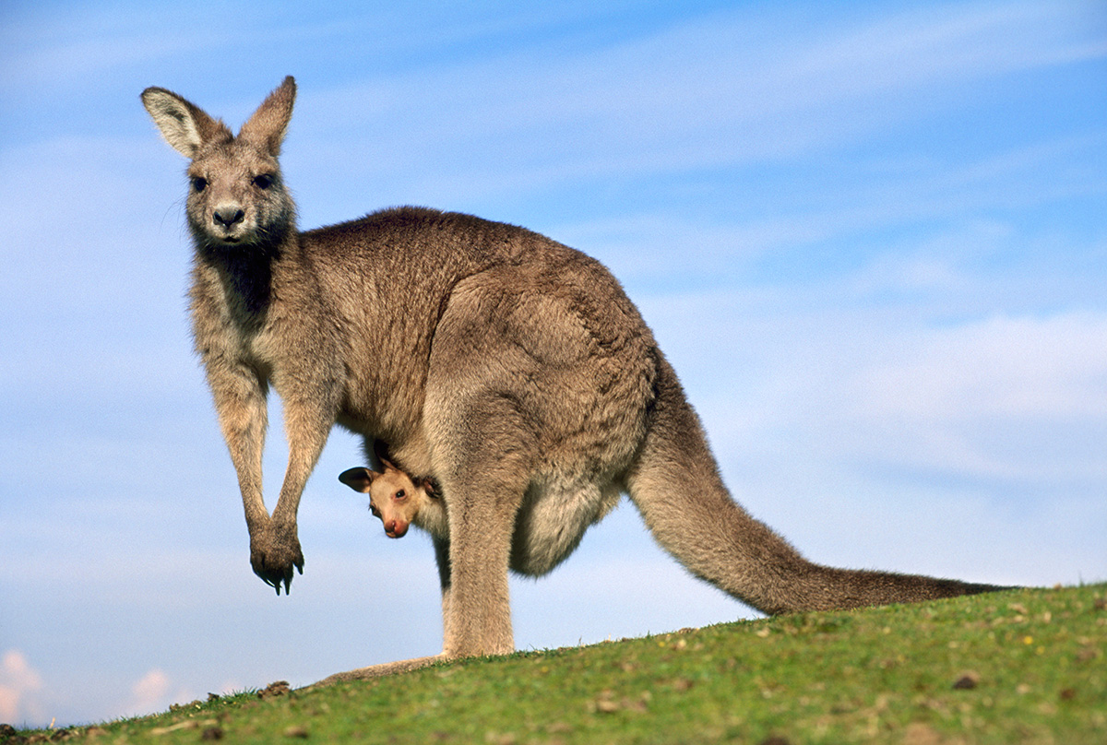  - Vertebrate  - Breathes using lungs  - Four limbs  - Live birth from sexual reproduction  - Searches/hunts for food  - Hair covers body
Bullfrog  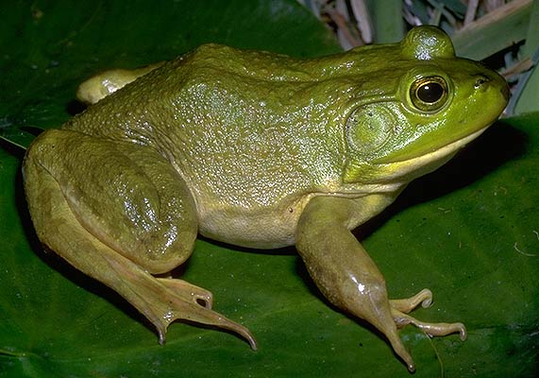  - Vertebrate  - Four limbs  - Breathes using lungs  - Lays eggs from sexual reproduction  - Searches/hunts for food | Sea Sponge  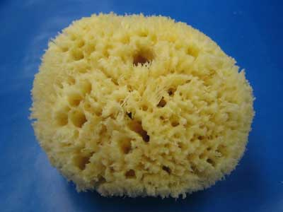  - Invertebrate  - No limbs  - “Simple” animal structure  - Direct oxygen transfer with water  - Passive feeder  - Asexual or sexual reproduction

Starfish  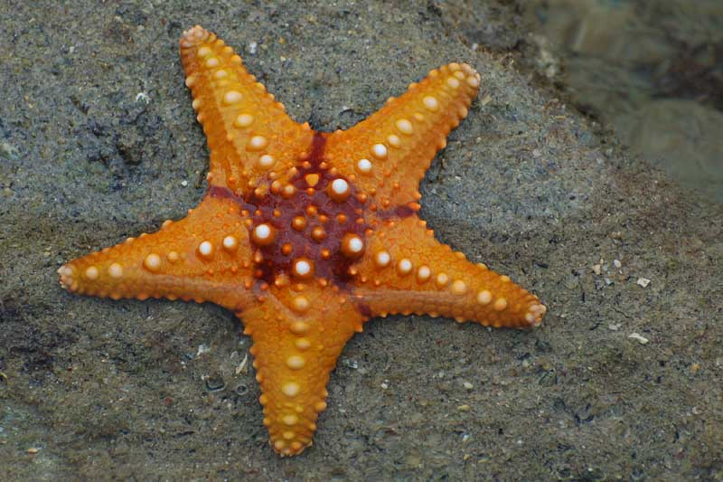  - Invertebrate  - No limbs  - “Simple” animal structure  - Direct oxygen transfer with water  - Passive feeder | Lamprey  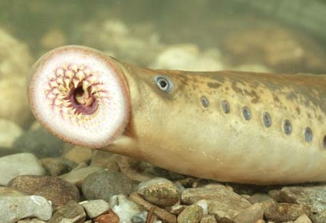  - Vertebrate  - No limbs  - Parasite/Active feeder  - Jawless
Lung fish  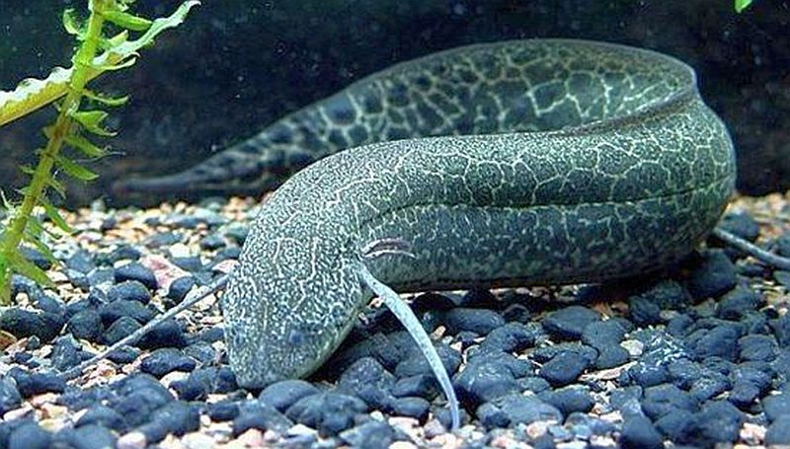  - Vertebrate  - Has jaw structure  - Breathes using lung structure  - No limbs  - Lays eggs  - Searches for food | Pangolin  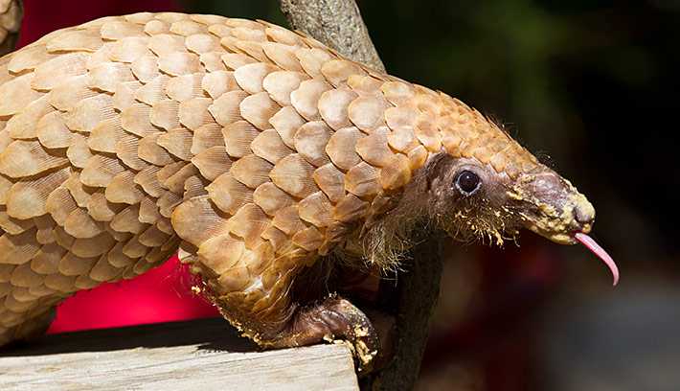  - Vertebrate  - Breathes using lungs  - Keratin scales cover body  - Four limbs  - Live birth from sexual reproduction  - Searches/hunts for food

Set B
Escherichia coli (food poisoning)  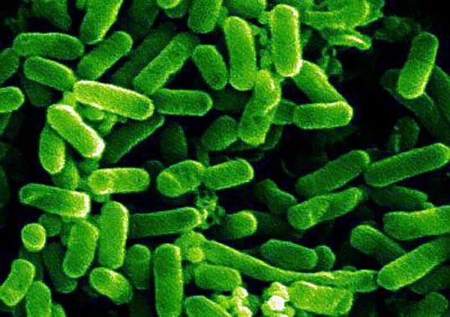  - Single circular chromosome  - Nucleus without membrane  - Unicellular  - Asexual reproduction  - Thrives in normal conditions  - Bacillus shape  - Domain Bacteria | Nanoarchaeum equitans  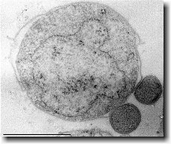  - Single circular chromosome  - Nucleus without membrane  - Asexual reproduction  - Unicellular  - Thrives in extreme cold conditions  - Domain Archaea
Streptococcal pharyngitis (strep throat)  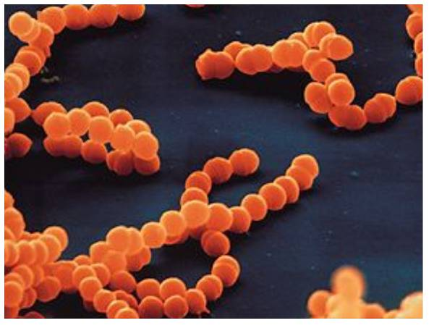  - Single circular chromosome  - Nucleus without membrane  - Asexual reproduction  - Unicellular  - Thrives in normal conditions  - Coccus shape  - Domain Bacteria | Sulfolobus solfataricus  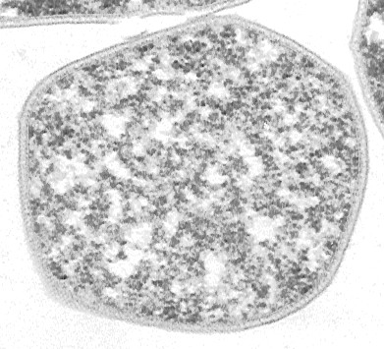  - Single circular chromosome  - Nucleus without membrane  - Asexual reproduction  - Unicellular  - Thrives in extreme hot conditions  - Domain Archaea

Original Basic Life Form  - Unicellular  - Small, single circular chromosome  - Nucleus without membrane  - Asexual reproduction | Plasmodium falciparum (malaria)  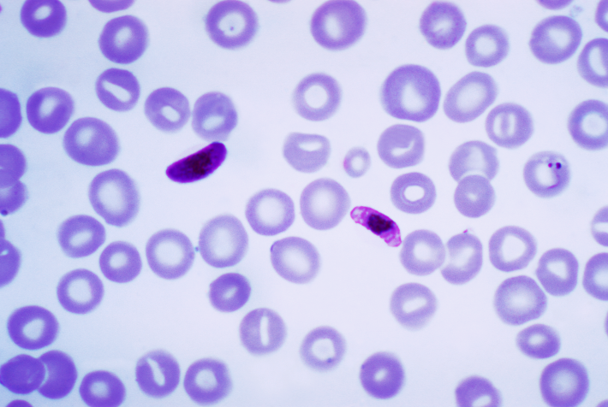  - Unicellular  - Asexual reproduction  - Membrane-bound organelles  - Domain Eukaryota  - Does not contain chloroplasts
Rhodophyta (Red Algae)  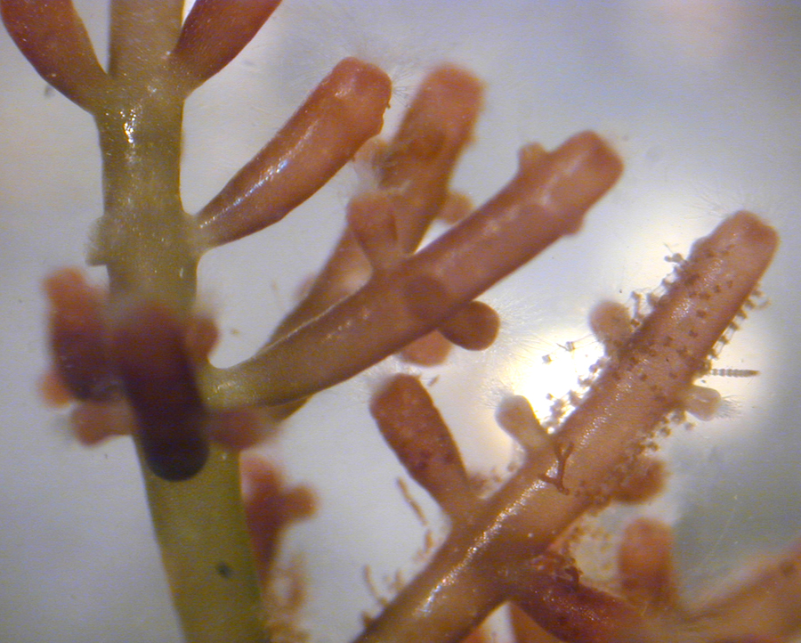  - Multicellular  - Sexual reproduction  - Membrane-bound organelles  - Domain Eukaryota  - Contains chloroplasts | Pediastrum duplex (Green algae)  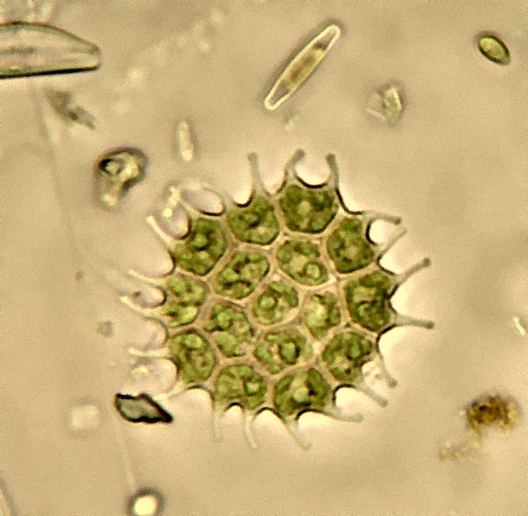  - Unicellular colonies  - Asexual reproduction  - Membrane-bound organelles  - Domain Eukaryota  - Contains chloroplasts

Sphagnum flexuosum (peat moss)  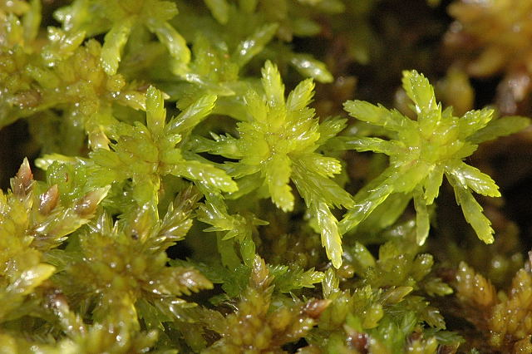  - Multicellular with complex organ systems  - Sexual reproduction  - Domain Eukaryota  - Contains chloroplasts | Sequoiadendron giganteum (Giant sequoia)  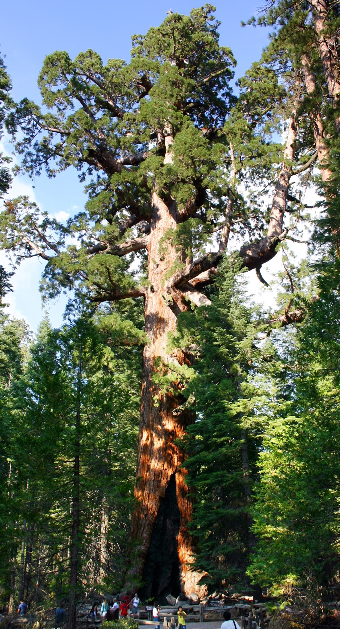  - Multicellular with complex organ systems  - Sexual reproduction  - Root system for nutrients  - Domain Eukaryota  - Contains chloroplasts

