CHEMICAL EQUATION CARD SORT
Fill in the following equations from your card sort.
Example:
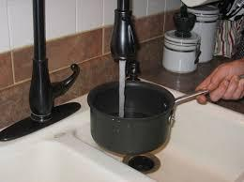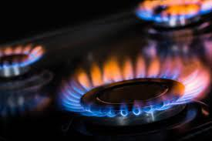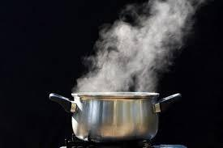
___Water______ + ______Heat_____ = __Gas (evaporated water)___
Reasoning:
Increased heat makes water molecules move faster and faster, until they move so fast, they escape as a gas.

- _________________ + _________________ = _________________
Reactant Reactant Product
Reasoning:

- _________________ + _________________ = _________________
Reactant Reactant Product
Reasoning:

- _________________ + _________________ = _________________
Reactant Reactant Product
Reasoning:

- _________________ + _________________ = _________________
Reactant Reactant Product
Reasoning:

- _________________ + _________________ = _________________
Reactant Reactant Product
Reasoning:

- _________________ + _________________ = _________________
Reactant Reactant Product
Reasoning:

- _____________ + _____________ + _____________ = ______________
Reactant Reactant Reactant Product
Reasoning:

- _____________ + _____________ + _____________ = ______________
Reactant Reactant Reactant Product
Reasoning:

- _____________ + _____________ + _____________ = ______________
Reactant Reactant Reactant Product

Reasoning:

- _____________ + _____________ + _____________ = ______________
Reactant Reactant Reactant Product
Reasoning:

