CHEMICAL EQUATION CARD SORT

Fill in the following equations from your card sort.

**Example:**

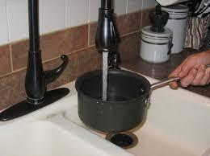** 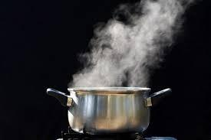

**___Water______ + ______Heat_____ = __Gas (evaporated water)___**

**Reasoning:**

**Increased heat makes water molecules move faster and faster, until they move so fast, they escape as a gas.**

1. **_________________ + _________________ = _________________**

**Reactant Reactant Product**

**Reasoning:**

1. **_________________ + _________________ = _________________**

**Reactant Reactant Product**

**Reasoning:**

1. **_________________ + _________________ = _________________**

**Reactant Reactant Product**

**Reasoning:**

1. **_________________ + _________________ = _________________**

**Reactant Reactant Product**

**Reasoning:**

1. **_________________ + _________________ = _________________**

**Reactant Reactant Product**

**Reasoning:**

1. **_________________ + _________________ = _________________**

**Reactant Reactant Product**

**Reasoning:**

1. **_____________ + _____________ + _____________ = ______________**

**Reactant Reactant Reactant Product**

**Reasoning:**

1. **_____________ + _____________ + _____________ = ______________**

**Reactant Reactant Reactant Product**

**Reasoning:**

1. **_____________ + _____________ + _____________ = ______________**

**Reactant Reactant Reactant Product**

**Reasoning:**

1. **_____________ + _____________ + _____________ = ______________**

**Reactant Reactant Reactant Product**

**Reasoning:**