CHEMICAL EQUATION CARD SORT HANDOUT
Fill in the following equations from your card sort.
Example:
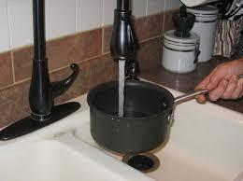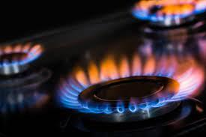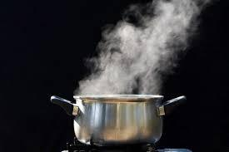
Water + Heat = Gas (evaporated water)
Increased heat makes water molecules move faster and faster until they move so fast that they escape as a gas.
Reasoning:

- _________________ + _________________ = _________________
Reactant Reactant Product
Reasoning:

- _________________ + _________________ = _________________
Reactant Reactant Product
Reasoning:

- _________________ + _________________ = _________________
Reactant Reactant Product
Reasoning:

- _________________ + _________________ = _________________
Reactant Reactant Product
Reasoning:

- _________________ + _________________ = _________________
Reactant Reactant Product
Reasoning:

- _________________ + _________________ = _________________
Reactant Reactant Product
Reasoning:

- _____________ + _____________ + _____________ = ______________
Reactant Reactant Reactant Product
Reasoning:

- _____________ + _____________ + _____________ = ______________
Reactant Reactant Reactant Product
Reasoning:

- _____________ + _____________ + _____________ = ______________
Reactant Reactant Reactant Product

Reasoning:

- _____________ + _____________ + _____________ = ______________
Reactant Reactant Reactant Product
Reasoning:

