SPECTROSCOPE ENGINEERING
Your mission is to design, build, and refine a spectroscope using diffraction material to observe light spectra. You will show off your spectroscope to other groups in a Gallery Walk.

Research
Watch two or more of the following videos that show different spectroscopes, or find your own video and write the URL. Your job is to create your own design using these or other videos for inspiration and/or see options for different parts.

CD Spectroscope Introduction | Afterschool Universe: Paper Towel Tube Spectroscope | Making Your Foldable Paper Cell Phone Spectrometer
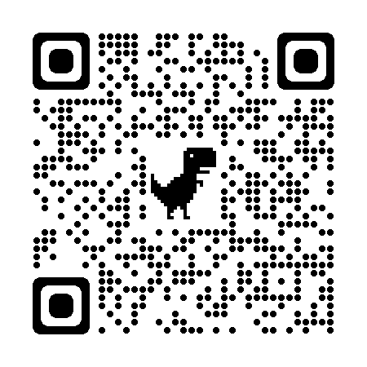  https://bit.ly/Diffraction1 | 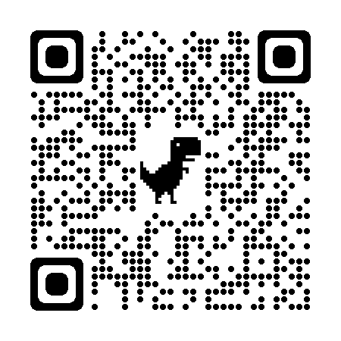  https://bit.ly/Diffraction2 | 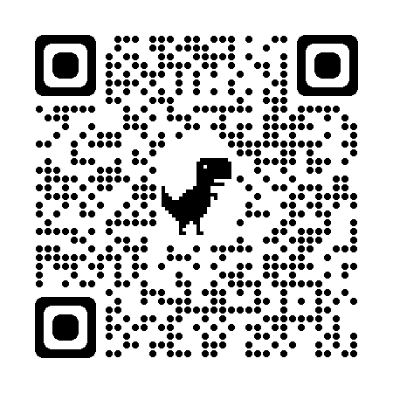  https://bit.ly/Diffraction3

URL for Video I Found:

Driving Question Board
Question I would like to research:

Answers to my question:

SPECTROSCOPE ENGINEERING
Design
- List the major components of a spectroscope and describe what its purpose is.

- What effect does the length of the spectroscope have on the spectra?

- What effect does the slit length or width have?

- What are some advantages and disadvantages of the diffraction materials you have available? Be sure to list at least one advantage and one disadvantage for each material.

- How will you know if the orientation of the diffraction material and slit is correct?

- Make a list of the materials you need to build it. Circle any that are not provided for you that you will need to provide yourself.

SPECTROSCOPE ENGINEERING
Build and Test Your Spectroscope
- Draw a model of your spectroscope. Be sure to include rays to represent the path of light.
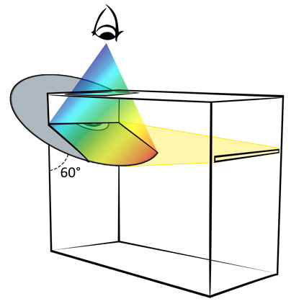

- Use your spectroscope with two different types of light sources (incandescent, fluorescent, laser, etc.). Sketch the spectra of each.

- Why are the spectra of each different?

SPECTROSCOPE ENGINEERING
Refine and Reflect
- Identify at least one refinement to your spectroscope. How did you modify your design after you started building to improve performance? Explain how the refinement improved the performance.

- If you were asked to build another spectroscope, name at least two things that worked well and you would do again.

- If you were asked to build another spectroscope, name at least two things you would do differently.

- Name at least three things you learned during this project.

- What was the best part of this project?

- What was the worst part of this project?

- On a scale of 1-10, with 10 being very much, how much do you believe this project helped you understand diffraction and how spectroscopes work? Explain.

Sources
AfterschoolUniverse. (2011). Afterschool Universe: Paper Towel Tube Spectroscope [Video]. YouTube. https://www.youtube.com/watch?v=IvwW-S0j7gg&t=164s
Exploratorium. (2015). CD Spectroscope: Introduction. Exploratorium. https://www.exploratorium.edu/video/cd-spectroscope-introduction
Noll, M. (2015). Making your foldable paper cellphone spectrometer [Video]. YouTube. https://www.youtube.com/watch?v=hZkVYuw4pJ4

