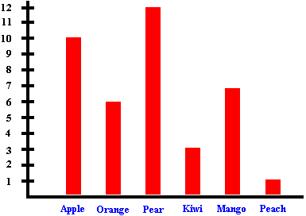
LAB REPORT FORMAT

Must include the following:

1. Title
2. Lab Drawing
3. Hypothesis:
IF, THEN
4. Variables (4):
Independent
Dependent
Control
Constant
5. Materials
6. Procedure/Steps
7. Data
Usually Data Table(s)
8. Graph(s)
9. Analysis Questions
10. Conclusion:
I accept/reject my
hypothesis because…

Reports are usually written in your notebooks but also may be typed,

written on construction paper or in a flip book—it depends on the lab.

Independent = “What ______________________________”
Dependent = “What ______________________________”
Control = “What ______________________________”
Constant = “What ______________________________”

FRAGRANT PHEROMONES: A Guided Inquiry

