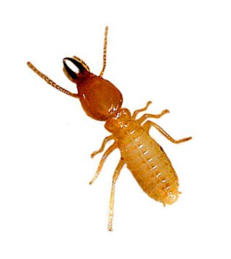
Termite Inquiry
Note: All supplies will be for groups of two.
Observation/Question
Students in a science classroom noticed that their termite aquarium had an escapee! A termite had gotten out and was stuck on the teacher’s graded papers and couldn’t get off. Interestingly enough, it kept following the same path over and over again. What could cause this interesting behavior? Could it be a particular color of ink? Could it be a particular brand of ink pen (using a different chemical formula)? Could it be the path the termite was following? Well, let’s see if it is any or none of these. Let’s conduct an experiment.
Hypothesis
If a termite is attracted to _______________________________________________ , then it will ________________________the path.
Blank 1 Choose: ink color (which?), ink brand (which?), or path shape (which?)
Blank 2 Choose: follow or not follow
Variables
Independent: _______________________________ Dependent: _______________________________
Control(s): _________________________________ Constant(s): _______________________________

Materials (per group)
- 1 termite
- 1 cotton swab
- 3 different colors of ink pens (red, black, blue)
- 3 different brands of ink pens (Bic, Papermate, Pentel)
- 3 ½ sheets of blank white paper
- 1 index card
- graph paper
Termite Health

DO NOT PICK UP YOUR TERMITE OR PUSH IT WITH YOUR COTTON SWAB.

Use the cotton swab to block the path of the termite to get it to change directions.

Move your termite by scooting it with the index card only.

Rough handling will hurt or kill your termite. Their legs are very fragile.

Directions
1. Using the blank half-pages, draw a simple pattern of three overlapping shapes (like those shown in the example above).
2. When you draw the shapes, make sure you pay close attention to the variables and your hypothesis that you have decided on.
3. Write down you experimental plan:
____________________________________________________________________________________________________________________________________________________________________________________________________________________________________________________________________________________________________________________________________________________________________________________________________________________________________________________________________________________________________________________________________________________________

4. When you have decided on your experimental design, call me over to check things for you.
Once you have my OK here, →
I will bring your termite so you can get started.
Group data
MINUTE | Ink Color | Ink Brand | Path Shape | OBSERVATIONS
0
1
2
3
4
5
6
7
8
9
10
11
12
13
14
15
Graph
Using the graph paper provided, graph your data. (Note: you may have more than one graph)
Analysis Questions

Answer these questions in complete sentences. You do not have to write the question on your lab report.

For example:

1. I would do _______, _______, and ______ differently if I were to do this experiment over again because _____.

3. I thought this experiment was a success because_________.

1. What would you do differently in this experiment? Why?
2. What went well in this experiment? Why?
3. How successful was this experiment? Why?
4. What did you learn about termites from this experiment?
5. Check with another group who did NOT do an experiment like yours. Looking at their results and combining them with your own, what do you now know about termites that you did not before?
6. True/False: Scientists observe without making any judgments; scientific observations are objective and value-free. Explain your answer.
7. True/False: If two scientists run the same experiment and have similar observations, they will develop the same explanation for the results. Explain your answer.
8. Summarize what happened during your experiment with the termite (use your observations from the data table to help with this answer).

Conclusion:
Do you accept or reject your hypothesis? What evidence do you have that supports this claim?

