Name: ___________________________________________________ Hr: _______ Date: ______________

Optic Recipe Card

INITIAL COMPREHENSION

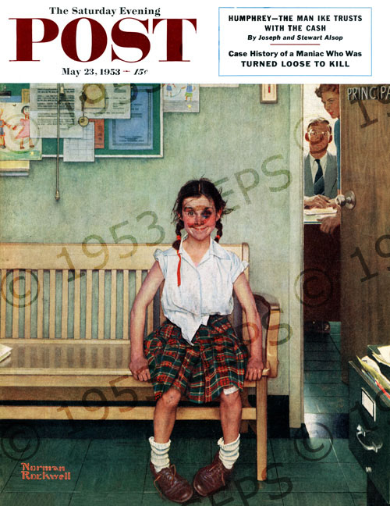
OBSERVATIONS:

_________________________________________________

_________________________________________________

_________________________________________________

_________________________________________________

_________________________________________________

_________________________________________________

_________________________________________________

_________________________________________________

_________________________________________________

_________________________________________________

_________________________________________________

Rockwell, N. (1953, May 23). The Shiner [Painting]. The Saturday Evening Post. Retrieved from http://www.saturdayeveningpost.com/2009/08/29/art-entertainment/beyond-the-canvas-art-entertainment/school-daze.html/attachment/cover_9530523

PREDICTIONS (+ evidence= INFERENCES)
•
•
•

TITLE: __________________________________________________________________________________________ CONCLUSION:

WHO: ______________________________________________________________________________

WHAT: ______________________________________________________________________________

WHEN: ______________________________________________________________________________

WHERE: _____________________________________________________________________________

WHY: ______________________________________________________________________________

HOW: _____________________________________________________________________________

FINAL COMPREHENSION

After viewing the art, write a narrative story describing the context (setting, characters, plot/conflict) of the picture. Support your position with evidence from the text.

EVALUATE
How was your initial comprehension (before using OPTIC) different from your final comprehension? How did using reading strategies enhance your comprehension?

