Wave Addition Simulation (Teacher’s GuidE)
This simulation has many features and options which make it a powerful tool for investigating waves, but most are beyond the needs of this lesson. The following guide outlines those most relevant to students’ exploration and makes recommendations for ease of use.

Visualization
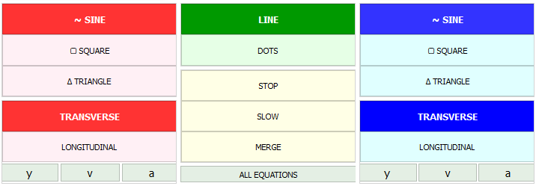
By default, there are 3 waves shown on the simulation: wave 1 (red), wave 2 (blue), and wave 1+ 2 (wave sum; purple).

Waves 1 and 2
- Keep the default wave settings (bolded) for both lines. See the teacher note in the lesson narrative about square and triangle waveshapes for this activity.
- Do not use the variable buttons beneath “longitudinal.”

Visuals (Green)
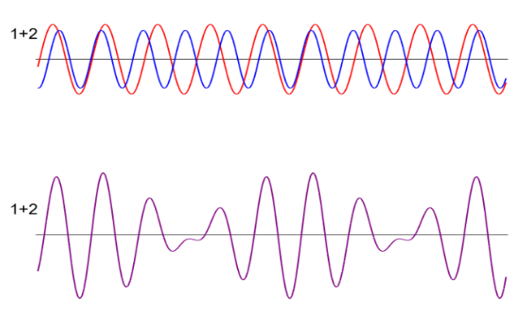
- Keep the default “line” setting. The “dots” feature shows points along the entire wave, not just nodes and antinodes, so it is not recommended for this activity unless students want to see precisely where the two waves are interacting.
- Encourage students to use “stop” and “slow” to more easily observe wave interactions.
- “Merge” (pictured on the right) shows wave 1 and wave 2 superimposed on one another rather than on separate lines. Encourage students to use this feature.
- Do not use the “all equations” feature.

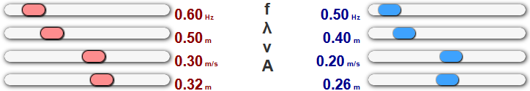
Variables
All four variables can be manipulated independently for each wave. Frequency (f), wavelength (λ), and velocity (v) will move proportionally to one another automatically (e.g., changing wavelength will also change frequency to maintain the same velocity value).

Wave Features and Modes

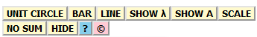
Wave 1 Side
The options on the Wave 1 side are primarily to show additional feature on top of the wave visualizations.
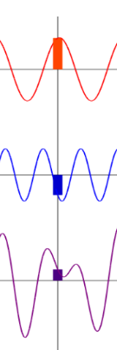
- “Bar” and “line” (pictured together on the right) each add additional features to the waves to help with interpretation. Bar shows the magnitude of displacement of each wave at a specific point, and line adds a vertical line through all three waves to show their precise alignment.
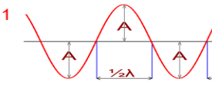
- “Show λ” and “show A” (pictured together below) add visual annotations for a half-wavelength and amplitudes of each peak and trough, respectively.
- It is not recommended that students use the remaining features for this activity.

Wave 2 Side
The options on the Wave 2 side are primarily for simulating different states of wave behavior.
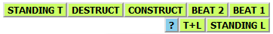
- As noted in the lesson narrative, students should experiment with the “Standing T” (produces a standing sine wave), “Destruct” (shows destructive interference), and “Construct” (shows constructive interference) modes.
- It is not recommended that students use the remaining features for this activity.

Adapted from The Physics Classroom. (n.d.). Using the Interactive. Physics Simulation: Wave Addition and Interference. https://www.physicsclassroom.com/Physics-Interactives/Waves-and-Sound/Wave-Addition/Wave-Addition-Interactive

