SEQUENCING
Directions: Cut out pictures. Glue them in the correct order.

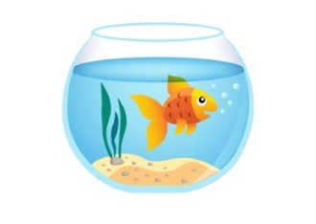 | 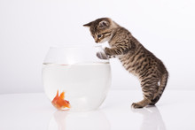 | 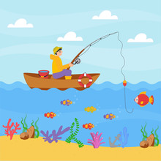 |  | 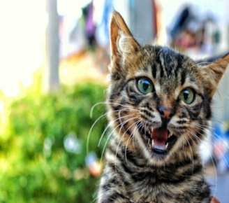

https://orig00.deviantart.net/5ab0/f/2016/211/9/9/goldfish_aquarium_free_vector_illustration_by_superawesomevectors-dabxj5w.jpg https://as2.ftcdn.net/jpg/03/15/38/37/220_F_315383766_eco2ezwGziyicUy0Rz8L6Nty5OjCTcgx.jpg https://as1.ftcdn.net/jpg/00/23/56/06/220_F_23560646_vpBL76Q4h8TZVPDCa8J5Vsl8BYu8cCyN.jpg
https://www.publicdomainpictures.net/pictures/160000/velka/chaton-mignon-qui-miaule.jpg
https://pre00.deviantart.net/2fa6/th/pre/f/2009/116/6/4/happy_sunrise_by_foozface.jpg

