Mr. Bee-Bot wants to make a rectangle. | 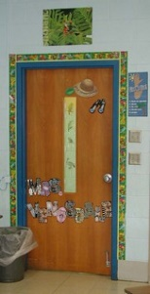  Mr. Bee-Bot is going to the door.
Mr. Bee-Bot wants to go to the table.  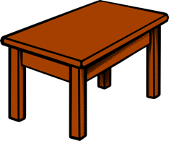 | Mr. Bee-Bot wants to look outside.  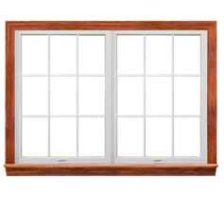  Help him find his way to the window.
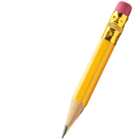  Mr. Bee-Bot lost his pencil. Help him find his way to a new pencil. | 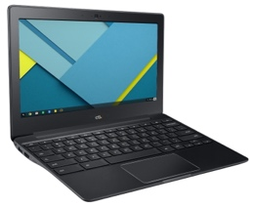  Mr. Bee-Bot wants to use the computer.  How should he get there?
Mr. Bee-Bot wants to walk and then rest and then walk some more. | Mr. Bee-Bot wants to walk through see some animals? Place 4 animals in a path and then help him move to all 4 animals.
TASK CARDS FOR DEAR MR. BEE-BOT

Sources:

Door https://live.staticflickr.com/3099/2656155994_677764295d_n.jpg
Table https://cdn.pixabay.com/photo/2016/04/01/12/08/table-1300555_1280.png
Window https://pngimg.com/uploads/window/window_PNG17705.png
Pencil https://freepngimg.com/thumb/pencil/3-2-pencil-png.png
Computer https://1.bp.blogspot.com/-lhckbqOZNjE/WI1fTzLIb6I/AAAAAAABJjA/EWYWY157T-gn464uUhI51_vROYulnN37QCLcB/s1600/j4.jpg
Bears https://freesvg.org/img/lemmling-Gummy-bear-sort-of.png

