Image Cut-outs for “If You Give a Mouse a Cookie”

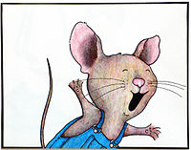 | 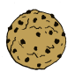
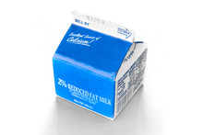 | 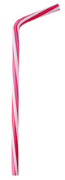
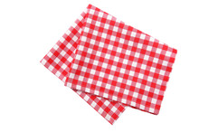 | 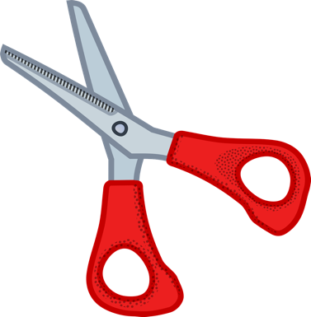
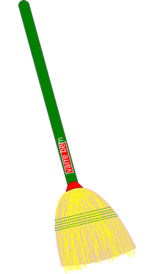 | 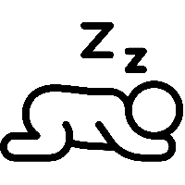
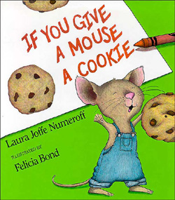 | 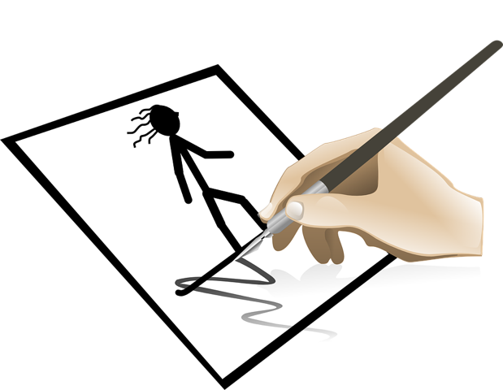
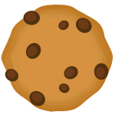

Mouse:https://upload.wikimedia.org/wikipedia/commons/thumb/2/23/If_You_Give_a_Mouse_a_Cookie_(11)%2C_illustrated_by_Felicia_Bond.JPG/200px-If_You_Give_a_Mouse_a_Cookie_(11)%2C_illustrated_by_Felicia_Bond.JPG
Cookie: https://www.geeksvgs.com/files/2019/04/4f1d1_bitten_cookie.thumb.png
Milk: https://as1.ftcdn.net/jpg/00/11/13/96/220_F_11139684_QrIkg1zHIdOSKeZWyhp5ExWwpCQ6AJBQ.jpg
Straw: https://as2.ftcdn.net/jpg/02/04/10/61/220_F_204106166_H1Ck2nvU8biYcFM38ydVPOCIokzTjV0r.jpg
Napkin: https://as1.ftcdn.net/jpg/03/08/04/66/220_F_308046669_CUKuzoAFPri3oKk7aY3sZCTG8I0bo0Xq.jpg
Scissors: https://cdn.pixabay.com/photo/2016/03/31/19/28/cut-1295044_1280.png
Broom: https://pixabay.com/static/uploads/photo/2016/03/31/15/41/broom-1293475_960_720.png
Nap: https://freepngimg.com/thumb/sleep/40356-5-nap-free-hq-image-thumb.png
Book: https://upload.wikimedia.org/wikipedia/en/3/3c/If_you_Give_a_Mouse_a_Cookie.jpg
Picture: https://cdn.pixabay.com/photo/2014/04/03/10/30/stick-figure-310712_960_720.png
Cookie : https://freesvg.org/storage/img/thumb/1548612994.png

