INFORMATIVE WRITING
My writing prompt:
_________________________

It’s time to brainstorm!
Here is everything I know about my topic.

- Brainstorm? | - Organize? | - First Draft? | - Revise & Edit? | - Final Draft?

INFORMATIVE WRITING
Organize your thoughts. . .
Title: Be Creative
Topic Sentence: Introduce your topic.
Body: Tell us what you know. Use the facts about your topic from your brainstorming activities.

Closing Sentence: Finish your writing with a few different words about your topic.

- Brainstorm? | - Organize? | - First Draft? | - Revise & Edit? | - Final Draft?
INFORMATIVE WRITING
First Draft: Use what you wrote in the organizing boxes to write your first draft.

Title

- Brainstorm? | - Organize? | - First Draft? | - Revise & Edit? | - Final Draft?
INFORMATIVE WRITING
Revise & Edit
- Use this checklist to make sure that you have written your sentences correctly.
- Use the editing marks below to correct your errors on your first draft.

- I introduced my topic in the first sentence.
- I used facts to tell about my topic.
- I used good linking words to connect my facts together (and, also, another, but).
- I used complete sentences.
- I used correct spelling.
- I began each sentence with a capital letter.
- I ended each sentence with the correct punctuation mark.
- I wrote using my best handwriting.

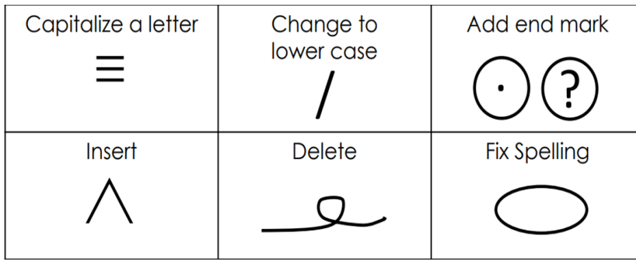

- Brainstorm? | - Organize? | - First Draft? | - Revise & Edit? | - Final Draft?

INFORMATIVE WRITING
Final Draft
- Brainstorm? | - Organize? | - First Draft? | - Revise & Edit? | - Final Draft?

