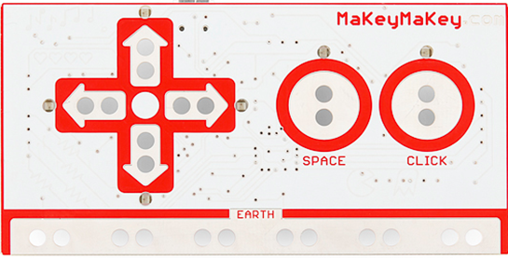
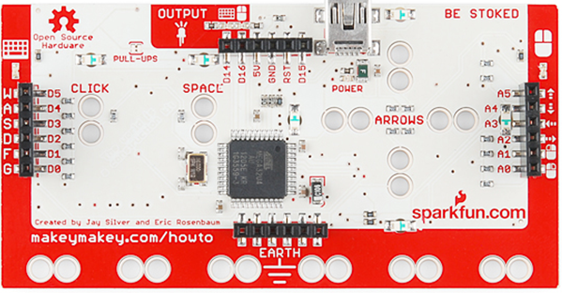
The Makey Makey is a printed circuit board built on top of the Arduino. It allows you to easily turn anything that conducts electricity (even just a very small current) into a key, button, or gamepad. Out of the box, it works with the arrow keys, spacebar, and mouse left click, which allows you to play a whole range of awesome games without any programming required. On the back of the board, you can find the keys W, A, S, D, F, G, and commands for mouse movements and clicks. Additionally, there are 6 outputs for using the board in 'Arduino mode', where it can perform tasks such as controlling motors or LEDs. If you wish to use a different set of keys or change the behavior of your Makey Makey, you can reprogram it using the Arduino environment. The front is set up for easy alligator clipping, while the back can be accessed with jumper wires or safety pins/paper clips.

