DOPPLER EQUATION

Formula for Doppler Effect
v_{o} is positive if the observer is moving toward the source and negative if moving away.
v_{s} is positive if the source is moving toward the observer and negative if moving away.
v, the speed of sound is 343 m/s at room temperature.

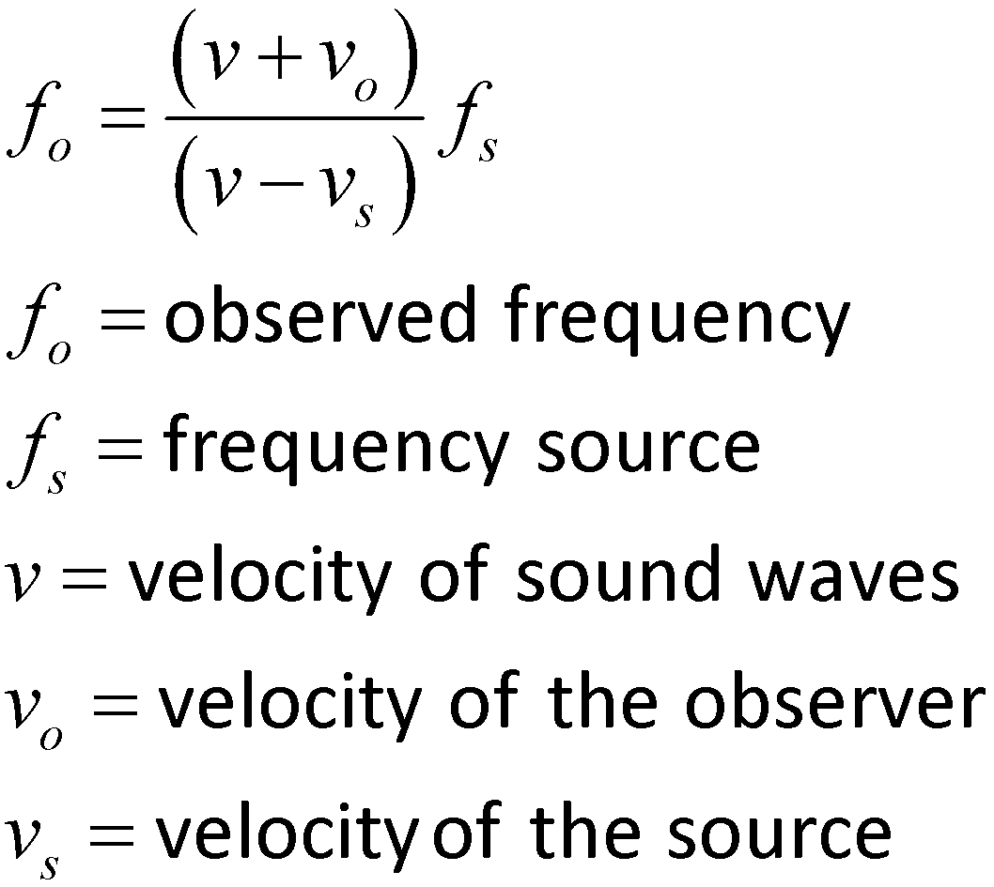

- What variable is known if the…

  - observer is stationary?

  - source is stationary?

  - sound is traveling through room temperature air?

- A siren with a frequency of 570 Hz is moving toward a driver in a car at 45 m/s.

  - Sketch a model

  - Predict if the observed sound will be higher or lower frequency.

  - Complete the chart with known values. Place a “?” for the unknown.

v = | v_{o} = | f_{o} =
 | v_{s} = | f_{s} =

  - What is the apparent frequency of the siren as it moves toward the driver and away from the driver?

Answer the following questions.
Start by listing the knowns and unknowns. Show your work!

- A police car's siren has a frequency of 700 hertz. If you are standing on the sidewalk as it approaches you at a speed of 15.0 m/s, what frequency would you hear?

- In the previous problem, what frequency would you hear if the police car was moving away from you at a speed of 25 m/s?

- A security alarm is wailing with a frequency of 1200 hertz. What frequency does a police officer hear if they are driving toward the alarm at a speed of 40.0 m/s?

- In the previous problem, what frequency would the burglar hear, if they were running away from the alarm at a speed of 10 m/s?

