I Used to Think, But Now I Know
I Used to Think…
- Look at each image in the right column
- In the center column, write down the emotions these people feel or the things that motivate them.
…But Now I Know
- At the end of the lesson, revisit the images.
- In the far-right column, write down your thoughts about how each might have changed or any clarifications you now have.
Image | I Used to Think… | But Now I Know
What are these people doing and why?
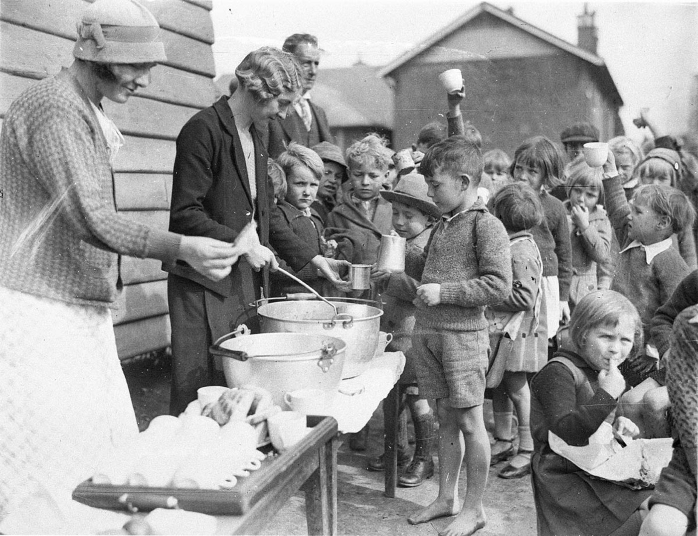
What is motivating the adults and children?
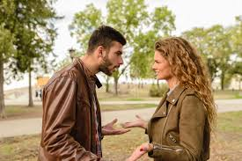
What is motivating this couple?
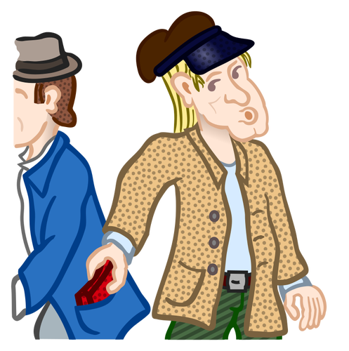
What do you see in this image?
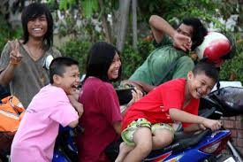
How do you think these people are feeling?
How do you think this couple is feeling?

