A TRAIT ACCOMPLI—Poster Presentation & Gallery Walk  
***NOTE: You will work with your clock partner from the “A Trait Accompli Lab” to make one poster presentation of your results.***

## Materials

* Poster-Size Paper
* Each Person’s ***Completed*** Data Table
* Two Sheets Graph Paper
* Colored Pencils
* Scissors
* Colored Markers
* Glue Sticks or Tape

## DIRECTIONS

1. Complete the two graphs of your collected data, as required by the “A Trait Accompli” Activity. Use the colored pencils to represent different types of traits and genders.

## ON THE POSTER:

***NOTE: Make sure you are writing big enough and in color. Use the materials provided to create your poster.***

2. A Title

3. Data Table for Student 1 and Data Table for Student 2

4. Graphs 1 and 2 with titles, appropriately labeled axes, and with a key.

5. Analysis Questions 1 through 9.

a. Write the answers as a statement and you do not have to write the question.

b. For questions 5 and 6, make a T-chart with each of the names of people in your group at the top. Answer 5 and 6 below (see example).

6. Place a star next to your answer for question 10 (as on the activity instructions).

## POSTER SET-UP EXAMPLE

****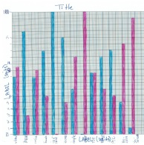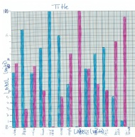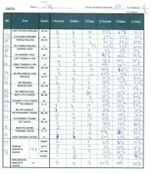

**1. The most prevalent trait for the class is…**

**2. The least prevalent trait for the class is…**

**3. The most prevalent trait for girls is… and for boys is…**

**4. The least prevalent trait for girls is… and for boys is…**

|  |  |  |
| --- | --- | --- |
|  | **Student 1 Name** | **Student 2 Name** |
| **5.**  **6.** | **Type A = %**  **Type B = %**  **Majority = %**  **Minority = %** | **Type A = %**  **Type B = %**  **Majority = %**  **Minority = %** |

**7. Hypothesis 1 =**

**Hypothesis 2 =**

**8. The results our class got are __________ because…**

**9. Conclusion 1 =**

**Conclusion 2 =**

**Conclusion 3 =**

**10. Organisms look the way they do because…**

**Student 1 Student 2**