A TRAIT ACCOMPLI—Poster Presentation & Gallery Walk
NOTE: You will work with your clock partner from the “A Trait Accompli Lab” to make one poster presentation of your results.

Materials
- Poster-Size Paper
- Each Person’s Completed Data Table
- Two Sheets Graph Paper
- Colored Pencils
- Scissors
- Colored Markers
- Glue Sticks or Tape

DIRECTIONS
- Complete the two graphs of your collected data, as required by the “A Trait Accompli” Activity. Use the colored pencils to represent different types of traits and genders.

ON THE POSTER:
NOTE: Make sure you are writing big enough and in color. Use the materials provided to create your poster.

2. A Title
3. Data Table for Student 1 and Data Table for Student 2
4. Graphs 1 and 2 with titles, appropriately labeled axes, and with a key.
5. Analysis Questions 1 through 9.
a. Write the answers as a statement and you do not have to write the question.
b. For questions 5 and 6, make a T-chart with each of the names of people in your group at the top. Answer 5 and 6 below (see example).
6. Place a star next to your answer for question 10 (as on the activity instructions).

POSTER SET-UP EXAMPLE
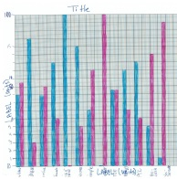
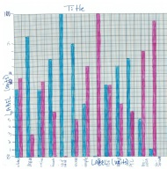
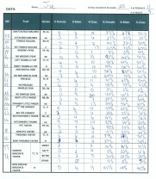
1. The most prevalent trait for the class is…
2. The least prevalent trait for the class is…
3. The most prevalent trait for girls is… and for boys is…
4. The least prevalent trait for girls is… and for boys is…

 | Student 1 Name | Student 2 Name
5.  6. | Type A = %  Type B = %  Majority = %  Minority = % | Type A = %  Type B = %  Majority = %  Minority = %
7. Hypothesis 1 =
Hypothesis 2 =
8. The results our class got are __________ because…
9. Conclusion 1 =
Conclusion 2 =
Conclusion 3 =

10. Organisms look the way they do because…
Student 1 Student 2

