A TRAIT ACCOMPLI—Research Assignment & Slideshow Presentation
NOTE: You must work with a different partner from the person you worked with on the “A Trait Accompli Lab.” New clock partners will be assigned. As partners, you will make one slideshow presentation of your results. Once you have your partners, wait for the teacher to assign you a research topic.

Materials ON THE SLIDESHOW:
SLIDE 1
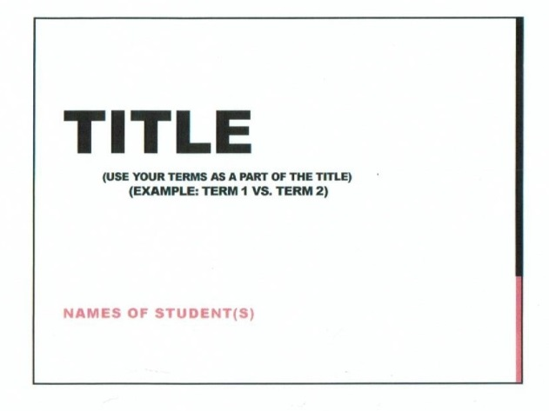
- Template for slideshow
- Internet access
- Chromebook/laptop/computer

GROUPS

Group 1 – Homologous Chromosome(s) vs. Locus Group 2 – Sex Chromosomes vs. Autosomes
Group 3 – Gene vs. Allele Group 4 – Homozygous vs. Heterozygous
Group 5 – Dominant vs. Recessive Group 6 – Genotype vs. Phenotype

SLIDESHOW DIRECTIONS
1. Student groups will go online and research their assigned topic(s).
SLIDE 2
2. Using the slide template instructions below, students will research their topic and create a
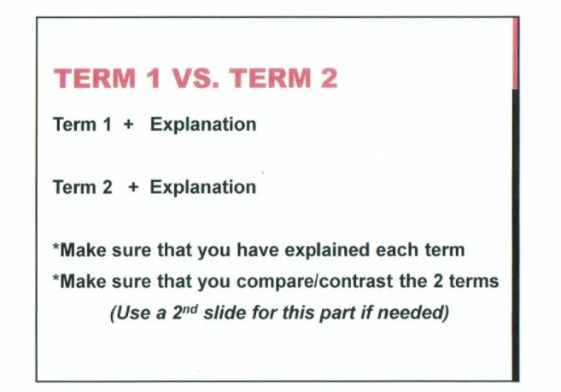
slideshow using that information and the guide below.
3. Students will present their slideshows to the class as if they were the teacher,
so make sure to understand your research topic well!
4. Students not presenting will take notes in their notebooks as each group presents.

NOTES/NOTE BOOK DIRECTIONS
Can look something like this:

NAME
Title
of Unit
Topic
Essential Question:

Why do organisms look the way they do?

Notes for all groups
(As many pages as it takes)
Essential Question ANSWER:

Class Consensus Answer at end of notes.

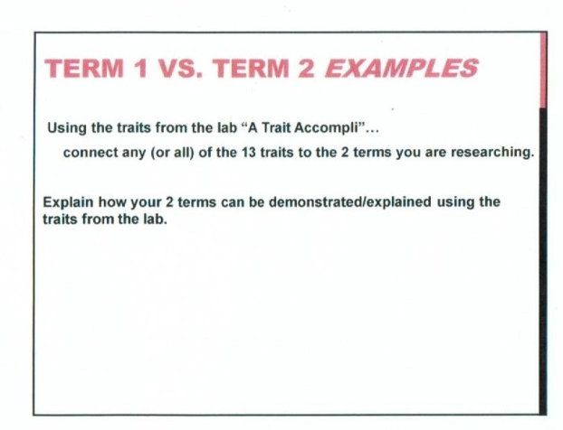
SLIDE 3

SLIDE 4
