Energy Pyramid Game Teacher Guide

Setup

Number of Cards
The base game includes 20 unique trophic level cards (8 producers, 6 primary consumers, 4 secondary consumers, and 2 tertiary consumers) and 24 sun cards.
Each student should receive one trophic level card. See the table below for scaling the class size up or down. If you add additional cards, you should have no more than two copies of each.
 | Number of Students
Trophic Level Cards | 10 | 15 | 20 | 25 | 30 | 35
Producer | 4 | 6 | 8 | 10 | 12 | 14
Primary Consumer | 3 | 5 | 6 | 8 | 9 | 11
Secondary Consumer | 2 | 3 | 4 | 5 | 6 | 7
Tertiary Consumer | 1 | 1 | 2 | 2 | 3 | 3

Card Printing
- Print each trophic level on a different colored paper or highlight the trophic levels at the top of the cards in different colors.
  - For every primary producer page (pgs. 1, 3, 5, 7), print the sun cards (pgs. 2, 4, 6, 8) on the page immediately after it. For example, if you make two copies of page 3 also make two copies of page 4.
- Modify the lesson slides to reflect your color choices.
- Cut out and distribute trophic cards to students.
- Cut out the sun cards and place them in a central location or around the room.

Card Details

Trophic Level Sets
- Initial energy values (“Starting Energy”) for the 20-card set are calculated to reproduce the 10% transfer of energy up each trophic level in the pyramid.
  - For example, if you add the Round 1 Energy Value for all producers, it will total 100,000 kilocalories. Primary consumers total 10,000 kcal, secondary consumers 1,000 kcal, and tertiary consumers 100 kcal.
  - The values of the sun cards were selected so the primary producers, as a group, end the game at approximately the same 100,000 kcal with which the game began.

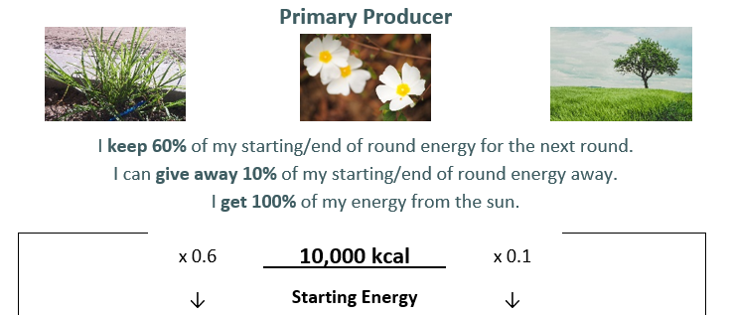
Card Features: Top
- Trophic Level
- Examples of organisms at the given trophic level
- Information about energy
- Starting Energy in kilocalories

Card Features: Left Side
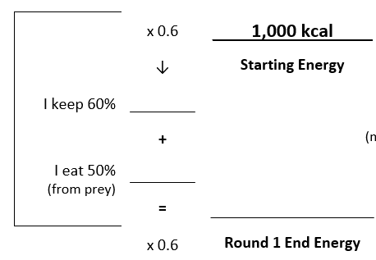
- Students multiply their Starting Energy by 0.6 to get the 60% energy they keep for next round.
- Students write in the amount of energy they get from their prey/sun.
  - For producers, this is 100% of the kcal listed on their sun(s).
  - For consumers, this value will be either 50% or 70%. Students calculate this from their prey’s “I give away 10%” value.
- Students add the “I keep 60%” and “I get/eat %” values and write their total on the “Round # End Energy” line.
- The students then multiply their “Round # End Energy” by 0.6 to continue the next round.

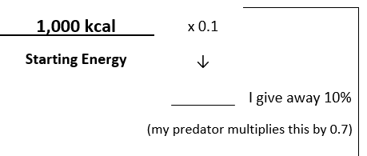
Card Features: Right Side
- Students multiply their Starting Energy by 0.1 to get the 10% energy they have available to give to their predators.
  - Predators will multiply this value found on their prey’s card by either 0.5 or 0.7. The number they calculate will go on the “I eat %” line on the left side of their own card.
  - For example, if a producer (prey) can give away 1,000 kcal, a primary consumer (predator) would write down 500 kcal on their “I eat 50%” line for the round. If a primary consumer (prey) can give away 100 kcal, a secondary consumer (predator) would write down 70 kcal on their “I eat 70%” line for the round.
- Students multiply their “Round # End Energy” by 0.1 for subsequent rounds.
- Note that the Tertiary Consumers do not give away energy because nothing eats them.

Playing the Game

Game Notes
- During development, the game was played with class sizes of 10-30 and trophic energy transfer between levels consistently varied from 8%-14%.
- In the game, consumers can only take a percentage of the total energy being “given away” by their prey. This is a mathematical feature of the game to ensure that the percentages of energy transferred up the energy pyramid totals approximately 10%.
  - This can be explained to students in terms of competition. For example, grass in an ecosystem may be able to provide 1,000 kcal to herbivores, but multiple herbivores are eating that grass (e.g., deer, grasshoppers). As a group, deer will not receive all 1,000 kcal available because the grasshoppers are also consuming the same resource.

Round 1 (Slide 6)
- Direct students to fill out the “I keep” and “I give away” values from their starting energy.
- Next, direct:
  - consumers to find a partner in the trophic level directly below them. (This may result in groups of 3 or 4 depending on the timing of trophic level students finding each other.)
  - producers to pick up one sun card. (They should hold onto this card for the rest of the game, so cards are not used more than once.)
- Once students find their trophic level partners, they should calculate and record the amount of energy they get from the sun or “eating” their prey.
- To end the round, direct students to calculate their:
  - end of round energy (I keep + I eat/get),
  - energy kept from round 1 (round end energy x 0.6), and
  - energy to give away in round 2 (round end energy x 0.1).

Rounds 2 & 3 (Slide 7)
- Direct consumers to find a new partner in the trophic level directly below them, and for producers to pick up a new sun card.
- Consumers calculate and record the amount of energy they get from eating their prey, and producers record the energy they get from the sun.
- Everyone calculates their end of round energy, energy kept from the round, and energy to give away in the next round.
  - Round 3 only requires an end of round energy calculation.

Calculating Energy Flow (Slide 9)
- Have each trophic level, as a group, calculate their total energy at the end of round 3. How you do this is at your discretion. Edit the slide accordingly.
  - You might consider having each trophic level get into one group to count together or have each student list their end of round 3 energy on the board/in a spreadsheet and designate someone to add up the total(s) in kilocalories.
- Have students calculate what percentage of energy moved up each trophic level by the end of the game. There will be some variation, but the values should be approximately (or will round to) 10%.
  - If students cannot figure out how to do this calculation for themselves, it is okay to tell them how. The point is that they can make sense of the final values.

