Separate but Equal
All images (and more) can be found in the Library of Congress Index located at: http://www.loc.gov/rr/print/list/085_disc.html
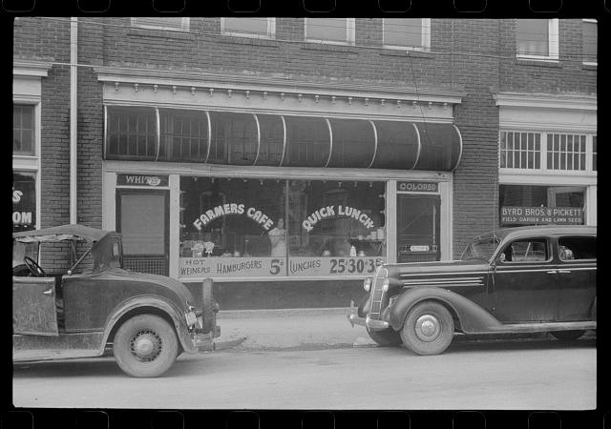  Delano, J. (1940, May). A cafe near the tobacco market. Retrieved from http://hdl.loc.gov/loc.pnp/fsa.8a33793 |  |  | 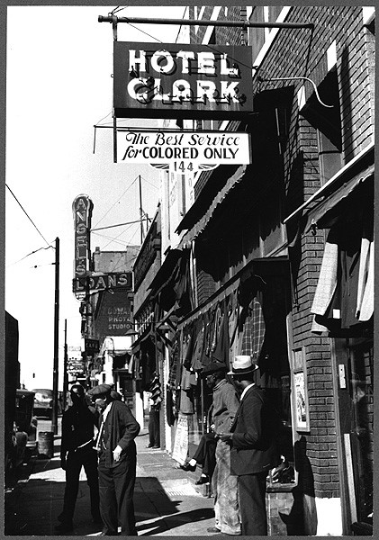  Walcott, M. P. (1939, October). Secondhand clothing stores and pawn shop on Beale Street [Image]. Retrieved from http://hdl.loc.gov/loc.pnp/ppmsc.00197
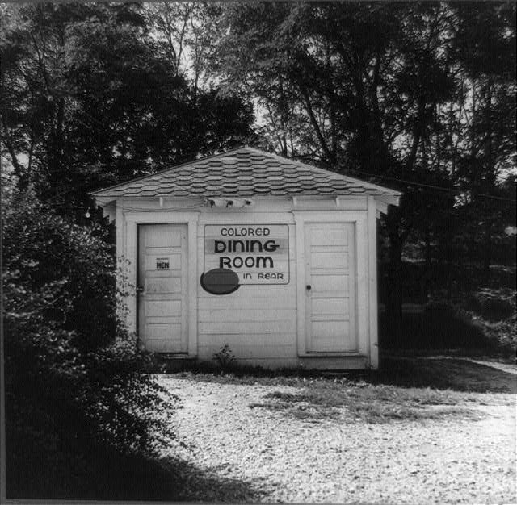  Bubley, E. (1943, September). A rest stop for Greyhound bus passengers on the way from Louisville, Kentucky to Nashville, Tennessee, with separate accommodations for colored passengers [Image]. Retrieved from http://hdl.loc.gov/loc.pnp/cph.3b46051 | 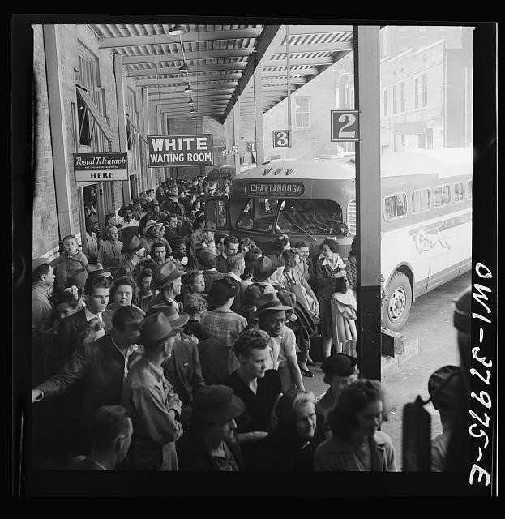  Bubley, E. (1943, September). People waiting for a bus at the Greyhound bus terminal [Image]. Retrieved from http://hdl.loc.gov/loc.pnp/fsa.8d33402
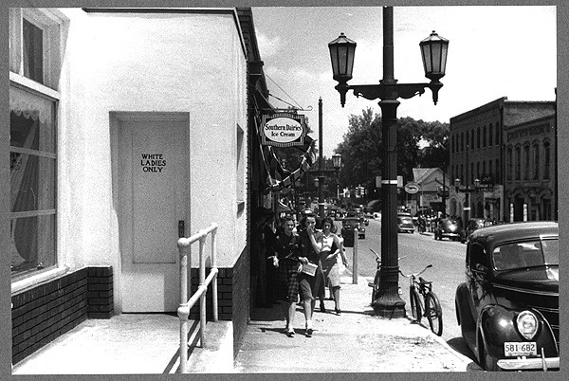  Delano, J. (1940, May). A street scene near the bus station [Image]. Retrieved from http://hdl.loc.gov/loc.pnp/ppmsc.00198 |  | 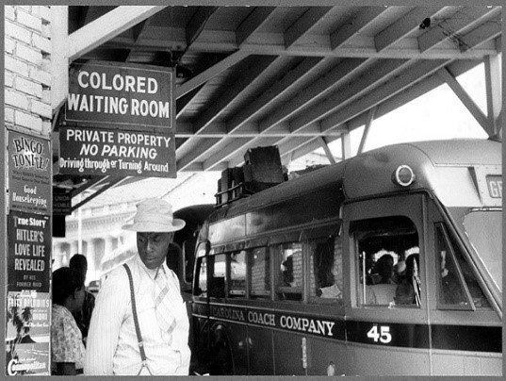  Delano, J. (1940, May). At the bus station [Image]. Retrieved from http://hdl.loc.gov/loc.pnp/ppmsc.00199

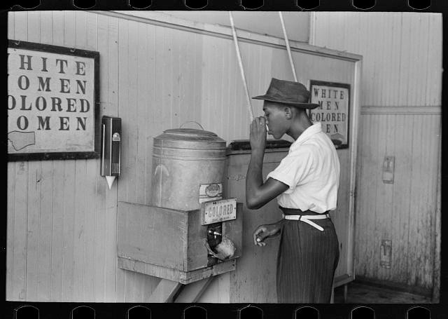
Lee, R. (1939, July). Man drinking at a water cooler in the street car terminal [Image]. Retrieved from http://hdl.loc.gov/loc.pnp/fsa.8a26761

