Closing Arguments Task Cards teacher guide
Given: ∠4 ≅ ∠6  Prove: ∠5 ≅ ∠6  Statement: Reason:  1. ∠4 ≅ ∠6 1. Given  2. ∠5 ≅ ∠4 2. Vertical Angles Theorem  3. ∠5 ≅ ∠6 3. Transitive Property  *A paragraph proof has the same information as a two-column proof, but the statements and reasons are phrased in complete sentences. | 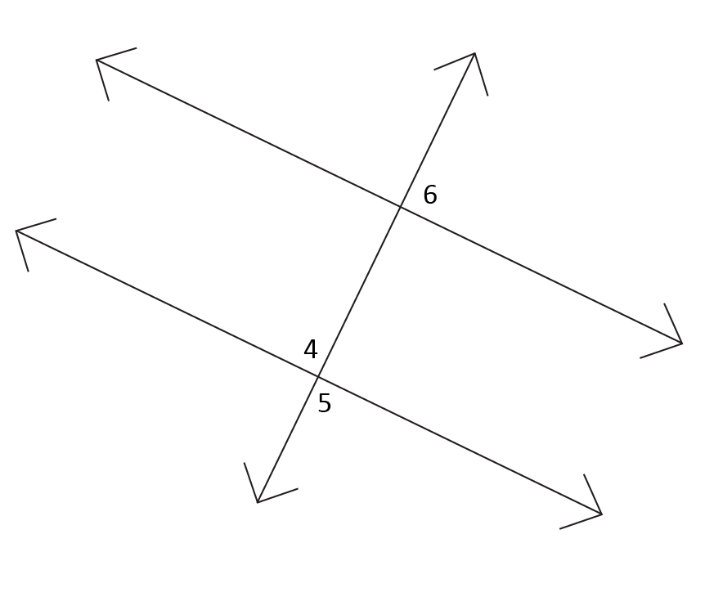
Given: ∠1 ≅ ∠3  Prove: ∠2 ≅ ∠4  Statement: Reason:  1. ∠1 ≅ 3 1. Given  2. m∠1 + m∠2 = 90° 2. Definition of Right Angles  3. m∠3 + m∠4 = 90° 3. Definition of Right Angles  4. m∠1 + m∠2 = m∠3 + m∠4 4. Transitive Property  5. ∠2 = ∠4 5. Subtraction Property  6. ∠2 ≅ 4 6. Definition of Congruent Angles | 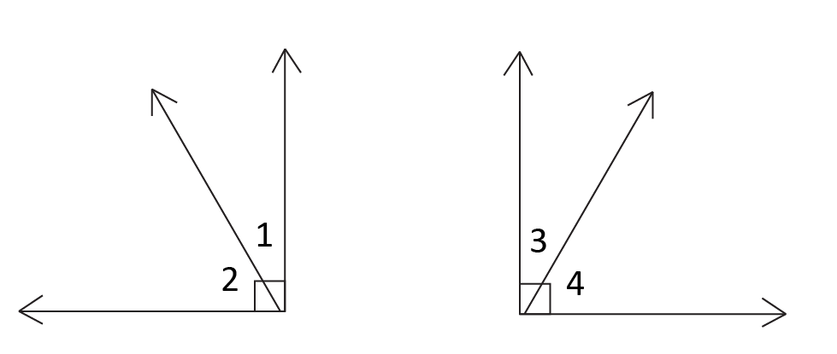

Given: ∠AEC is a right angle  ∠BED is a right angle  Prove: ∠AEB ≅ ∠CED  Statement: Reason:  1. ∠AEC is a right angle 1. Given  2. ∠BED is a right angle 2. Given  3. m∠AEB + m∠BEC = ∠AEC 3. Angle Addition Postulate  4. m∠AEB + m∠BEC = 90° 4. Definition of Right Angles  5. m∠BEC + m∠CED = ∠BED 5. Angle Addition Postulate  6. m∠BEC + m∠CED = 90° 6. Definition of Right Angles  7. m∠AEB + m∠BEC = m∠BEC + m∠CED 7. Transitive Property  8. m∠AEB = m∠CED 8. Subtraction Property  9. ∠AEB ≅ ∠CED 9. Definition of Congruent Angles | 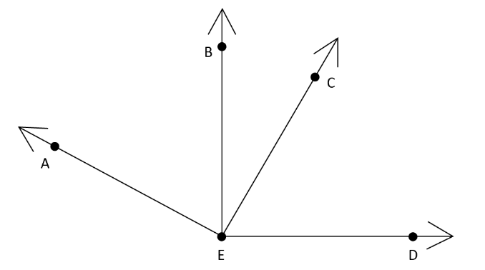
Given: bisects ∠ DGF  intersects and  Prove: ∠1 ≅ ∠2  Statement: Reason:  1. bisects ∠ DGF 1. Given  2. m∠3 = m∠2 2. Definition of Angle Bisector  3. m∠3 = m∠1 3. Vertical Angles Theorem  4. m∠1 = m∠2 4. Transitive Property  5. ∠1 ≅ ∠2 5. Definition of Congruent Angles | 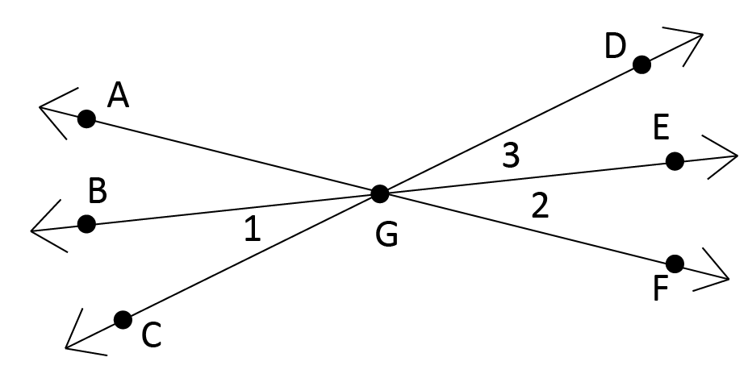
Given: ∠3 ≅ ∠4  Prove: ∠1 ≅ ∠2  Statement: Reason:  1. ∠3 ≅ 4 1. Given  2. ∠1 and ∠3 make a Linear Pair 2. Given  3. ∠4 and ∠2 make a Linear Pair 3. Given  4. m∠1 + m∠3 = 180° 4. Definition of Linear Pair  5. m∠4 + m∠2 = 180° 5. Definition of Linear Pair  6. m∠1 + m∠3 = m∠4 + m∠2 6. Transitive Property  7. m∠1 + m∠3 = m∠3 + m∠2 7. Substitution Property  8. m∠1 = m∠2 8. Subtraction Property  9. ∠1 ≅ ∠2 9. Definition of Congruent Angles | 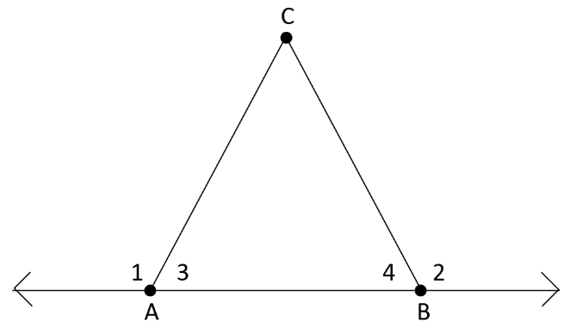
Given: ∠1 ≅ ∠4  Prove: ∠2 ≅ ∠3  Statement: Reason:  1. ∠1 ≅ ∠4 1. Given  2. ∠1 and ∠2 are Vertical Angles 2. Given  3. ∠3 and ∠4 are Vertical Angles 3. Given  4. m∠2 = m∠1 4. Vertical Angles Theorem  5. m∠4 = m∠3 5. Vertical Angles Theorem  6. m∠2 = m∠3 6. Transitive Property  7. ∠2 ≅ ∠3 7. Definition of Congruent Angles | 