Word | Definition/Meaning
Proof | Logical Argument that shows a statement is true
Justify | Layout your mathematical thought process step by step
Geometric Proof | Given Geometry based statements that prove a mathematical concept is true
Types of Proofs | Two-Column and Paragraph

Reasons: (Copied from slide 18. Students will have additional reasons on their paper)
Definitions | Properties
- Definition of Angle Bisector  - Definition of Complementary Angles  - Definition of Congruent Angles  - Definition of Congruent Segment  - Definition of Midpoint  - Definition of Right Angles  - Definition of Segment Bisector  - Definition of Supplementary Angles  - Definition of Vertical Angles | - Addition Property of Equality  - Distributive Property  - Division Property of Equality  - Multiplication Property of Equality  - Reflexive Property  - Substitution Property of Equality  - Subtraction Property of Equality  - Symmetric Property  - Transitive Property
Postulates | Theorems
- Angle Addition Postulate  - Linear Pair Postulate  - Segment Addition Postulate | - Alternate Exterior Angles Theorem  - Alternate Interior Angles Theorem  - Angle Bisector Theorem  - Consecutive Interior Angles  - Corresponding Angles Theorem  - Midpoint Theorem  - Vertical Angles Theorem

Creating the proof
C
B
A
Given: AC = AB + AB
Prove: AB = BC
Statement | Reason
1. AC = AB + AB | 1. Given
2. AB + BC = AC | 2. Segment Addition Postulate
3. AB + BC = AB + AB | 3. Transitive Property
4. BC = AB | 4. Subtraction Property

Sample explanation of creating the proof:

We should always start a proof by filling out the given information. You will be surprised how much of your proof is already done with the given information included. The first statement of every proof is the “given” statement from the question. The last statement of every proof is the “prove” statement from the question. The first reason of every proof is “Given”.
I know that this question is asking me to prove that each ‘half’ of this segment is equal, so I have to do 2 things:
1. Prove that point B is the midpoint of this segment for that to be true.
2. Get to a place where BC is a statement in the proof before line 4.
We have learned about the segment addition postulate, so let’s use that for the given picture.

Statement | Reason
1. ∠KMN = 28° | 1. Given
2. ∠JMK and ∠KMN are complementary angles | 2. Given
3. ∠JMK + ∠KMN = ∠JMN | 3. Angle Addition Postulate
4. ∠JMK + ∠KMN = 90° | 4. Definition of complementary angles
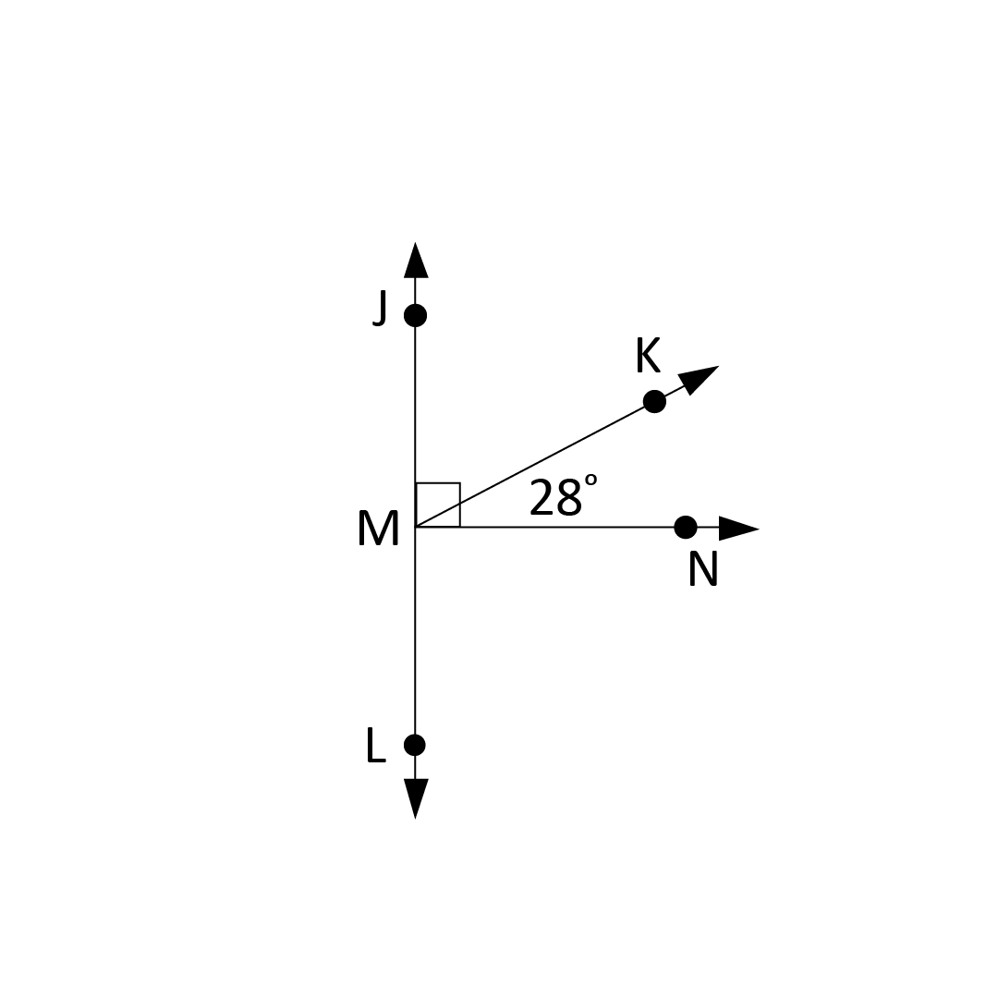
Completing the proof
Given: ∠KMN = 28°
Prove: ∠JMN = 90°

Sample explanation for completing the proof:

In math, we usually complete the proof more than creating the proof because it provides more guidance to you guys and helps train you to take the direct route to answer a problem and not waste your time providing too much information.
To start our proof there are 3 lines we can add that requires no thought on your part. (Statement 1 & 4, Reason 1) Copy the Given and Prove into your statements and the first reason will always be Given.
At this point, you only have to come up with 2 reasons and you’re done! Let’s look at the statements and give them a reason just as we did with Elle’s argument.
Statement 2: angle + angle = a larger angle. You should notice that this is like line 2 of the last proof except it is naming angles instead of segments. This is the angle addition postulate.
Looking at statement 2 and 3 you will notice that JMK + KMN added together equal 90 degrees but added together they also equal JMN. Since the left side of both of those equations are the same, I can use the Transitive Property to take out the repeated parts and set the right side of each equation equal to each other.

