Word | Definition and meaning
Proof | Logical argument that shows a statement is true
Justify | To lay out your mathematical thought process step-by-step
Geometric Proof | Given, geometry-based statements that prove a mathematical concept is true
Types of Proofs | Two types of proofs are two-column and paragraph

Reasons: (Copied from slide 18. Students will have additional reasons on their papers.)
Definitions | Properties
- Definition of Angle Bisector  - Definition of Complementary Angles  - Definition of Congruent Angles  - Definition of Congruent Segment  - Definition of Midpoint  - Definition of Right Angles  - Definition of Segment Bisector  - Definition of Supplementary Angles  - Definition of Vertical Angles | - Addition Property of Equality  - Distributive Property  - Division Property of Equality  - Multiplication Property of Equality  - Reflexive Property  - Substitution Property of Equality  - Subtraction Property of Equality  - Symmetric Property  - Transitive Property
Postulates | Theorems
- Angle Addition Postulate  - Linear Pair Postulate  - Segment Addition Postulate | - Alternate Exterior Angles Theorem  - Alternate Interior Angles Theorem  - Angle Bisector Theorem  - Consecutive Interior Angles  - Corresponding Angles Theorem  - Midpoint Theorem  - Vertical Angles Theorem

Algebraic Proof
 | Given: 2x + 5 = 20 – 3x | Statement | Reason
 | Prove: x = 3 | 1. 2x + 5 = 20 – 3x | 1. Given
 |  | 2. 5x + 5 = 20 | 2. Addition Property
 |  | 3. 5x = 15 | 3. Subtraction Property
 |  | 4. x = 3 | 4. Division Property

Creating a Proof
Paragraph Proof

____________________________________________________________________________________________________________________________________________________________________________________________________________________________________________________________________________________________________________________________________________________________

 | Given: AC = AB + AB | 
 | Prove: AB = BC
Statement |  | Reason
1. AC = AB + AB |  | 1. Given
2. AB + BC = AC |  | 2. Segment Addition Postulate
3. AB + BC = AB + AB |  | 3. Transitive Property
4. BC = AB |  | 4. Subtraction Property

Sample Proof Explanation
I completed the first section of the proof with the given information because I know we should always begin a proof with the given information from the question, using “Given” as the reason. I completed the last statement of the proof with the information I am supposed to prove because that is always the last statement of every proof.
The question is asking me to prove that each half of this segment is equal, so I must do two things: Prove that point B is the midpoint of the segment for this statement to be true and make BC a statement in the proof before line 4.
I chose to use the Segment Addition Postulate because that relates to the given picture.

Completing a Proof
 | Given: m∠KMN = 28° | Statement | Reason
 | Prove: m∠JMN = 90° | 1. ∠KMN = 28° | 1. Given
 | 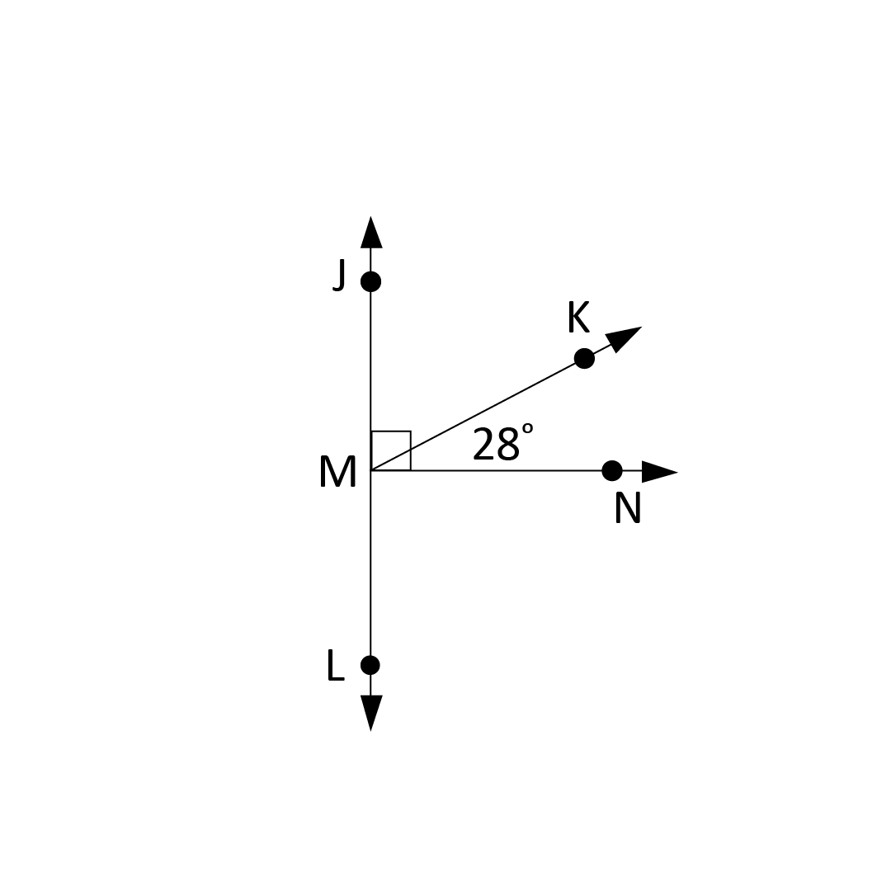 | 2. ∠JMK and ∠KMN are complementary angles | 2. Given
 |  | 3. ∠JMK + ∠KMN = ∠JMN | 3. Angle Addition Postulate
 |  | 4. ∠JMK + ∠KMN = 90° | 4. Definition of Complementary Angles
 |  | 5. m∠JMN = 90° | 5. Transitive Property

Sample Proof Explanation
I completed the first section of the proof with the given information because I know we should always begin a proof with the given information from the question, using “Given” as the reason. I completed the last statement of the proof with the information I am supposed to prove because that is always the last statement of every proof. For that section, I used “Prove” as the reason.
There are now two reasons left to complete. Statement 2 can be reduced to angle + angle = larger angle. This is similar to line 2 of the last proof, except this statement is naming angles instead of segments. This is the Angle Addition Postulate.
In statements 2 and 3, JMK and KMN are added together to equal 90 degrees, but they will also equal the angle JMN. Because the left side of both of those equations are equal, I can use the Transitive Property to remove the repeated portions of the equations and set the right sides of the equations equal to each other.

