Word | Definition & Meaning
Proof
Justify
Geometric proof
Types of proofs

Reasons
Definition | Properties
- Definition of Angle Bisector  - Definition of Complementary Angles  - Definition of Congruent Angles  - Definition of Congruent Segments  - Definition of Linear Pair  - Definition of Midpoint  - Definition of Right Angles  - Definition of Segment Bisector  - Definition of Supplementary Angles  - Definition of Vertical Angles | - Addition Property of Equality  - Distributive Property  - Division Property of Equality  - Multiplication Property of Equality  - Reflexive Property  - Substitution Property of Equality  - Subtraction Property of Equality  - Symmetric Property  - Transitive Property
Postulates | Theorems
- Angle Addition Postulate  - Linear Pair Postulate  - Segment Addition Postulate | - Alternate Exterior Angles Theorem  - Alternate Interior Angles Theorem  - Angle Bisector Theorem  - Consecutive Interior Angles Theorem  - Corresponding Angles Theorem  - Midpoint Theorem  - Vertical Angles Theorem

Algebraic Proof
 | Given: 2x + 5 = 20 – 3x | Statement | Reason
 | Prove: x = 3 | 1. 2x + 5 = 20 – 3x | 1.
 |  | 2. | 2.
 |  | 3. | 3.
 |  | 4. x = 3 | 4.

Creating a Proof
Paragraph Proof

____________________________________________________________________________________________________________________________________________________________________________________________________________________________________________________________________________________________________________________________________________________________

 | Given: AC = AB + AB | 
 | Prove: AB = BC
Statement |  | Reason
1. |  | 1.
2. |  | 2.
3. |  | 3.
4. |  | 4.

Completing a Proof
 | Given: m∠KMN = 28° | Statement | Reason
 | Prove: m∠JMN = 90° | 1. | 1.
 | 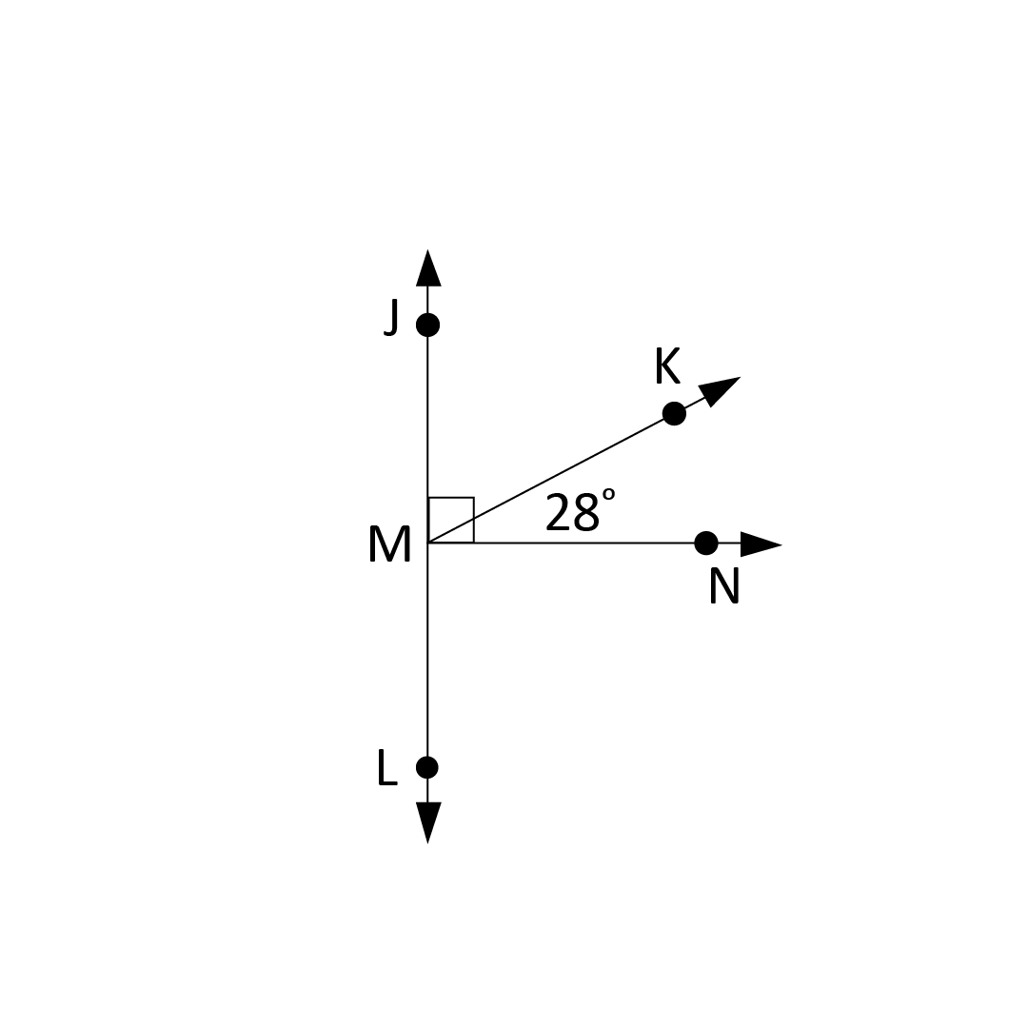 | 2. ∠JMK and ∠KMN are complementary angles | 2. Given
 |  | 3. ∠JMK + ∠KMN = ∠JMN | 3.
 |  | 4. ∠JMK + ∠KMN = 90° | 4. Definition of Complementary Angles
 |  | 5. | 5.

