Definition:  An up-and-coming NBA team in the Western Conference, the Oklahoma City Thunder are considered one of the top three professional basketball teams in the country.  Key Term:  OKC Thunder | Origin:  The Oklahoma City Thunder was originally the Seattle Supersonics of Seattle, Washington.
Visual Aid:  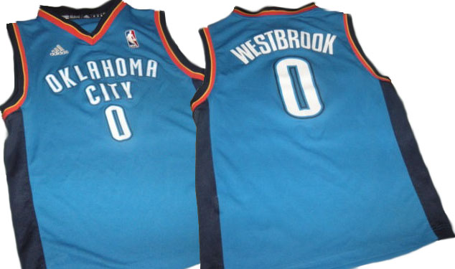  teeznthings. (2016). RUSSELL WESTBROOK OKLAHOMA CITY THUNDER ADIDAS Basketball JERSEY Boys Medium [Images]. Retrieved from http://www.ebay.com/itm/RUSSELL-WESTBROOK-OKLAHOMA-CITY-THUNDER-ADIDAS-Basketball-JERSEY-Boys-Medium-/262550639002?hash=item3d213cd19a:g:ZioAAOSwTZ1XmmDF | Key People:  Russell Westbrook, Steven Adams,  Serge Ibaka, Sam Presti, Billy Donovan

Frayer Model – OKC Thunder

