Maze Answer Sheet

Name __________________

Monkey Maze  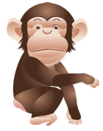 | Box
Dog Maze | Box
Snake Maze  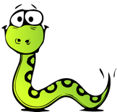 | Box
Chicken Maze  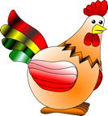 | Box
Cat Maze  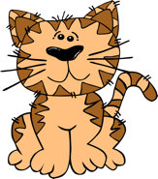 | Box
Make your own | Box

Cut off before giving to students

Answer Key for the Teacher:
Monkey Box 3, Dog Box 2, Snake Box 3, Chicken Box 2, Cat Box 1

Maze Answer Sheet

Name __________________

Monkey Maze | Box
Dog Maze | Box
Snake Maze | Box
Chicken Maze | Box
Cat Maze | Box
Make your own | Box

