Law of Sines: Guided Notes

# Ambiguous Case: SSA

| When the Given Angle is Acute | When the Given Angle is Right or Obtuse |
| --- | --- |
|  |  |
| When the ***(1st side) < (height)***,  then there are **0 triangles**. | When the ***(1st side) ≤ (2nd side)***, then there are **0 triangles**. |
| When the ***(1st side) = (height) or  (1st side) ≥ (2nd side)***,  then there is **1 triangle**. |
| When the ***(1st side) > (2nd side)***, then there is **1 triangle**. |
| When the ***(height) < (1st side) < (2nd side)***,  then there are **2 triangles**. |

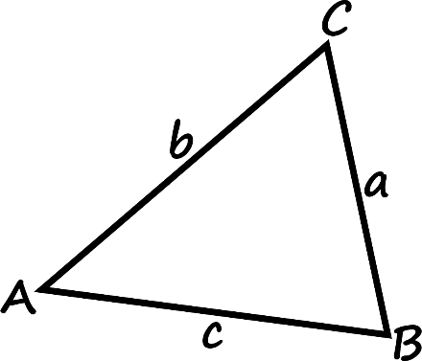

# Law of Sines



# Proof

 

*Repeat with other angles and sides.*

Use **Law of Sines** to solve any oblique (non-right) triangle, if you are given AAS, ASA, or SSA. Remember SSA is the ***ambiguous case***, so be sure to consider the number of possible solutions.

# Examples

Find all solutions (missing side length and angle measurements) for the given triangle, if possible. If no solution exists, write no solution. Round angle measurements to the nearest degree and side lengths to the nearest tenth.

**1)** 



**2)** 



**3)** 



**4)** 

