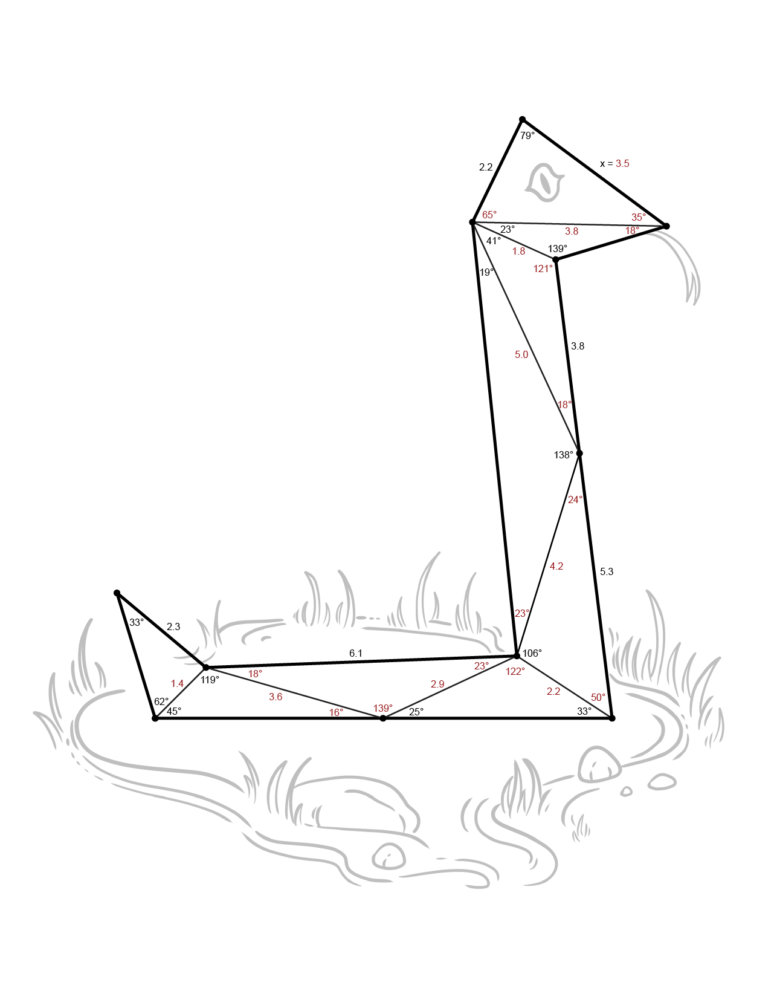Using Law of SSSSines

Use what you have learned about the Law of Sines and the given information to determine the value for *x*. Round angle measurements to the nearest degree and lengths to the nearest tenth.

**1)** 

**2)** 

**3)** 

**4)** 

**5)** 

**6)** 

**7)** 

**8)** 

**9)** 