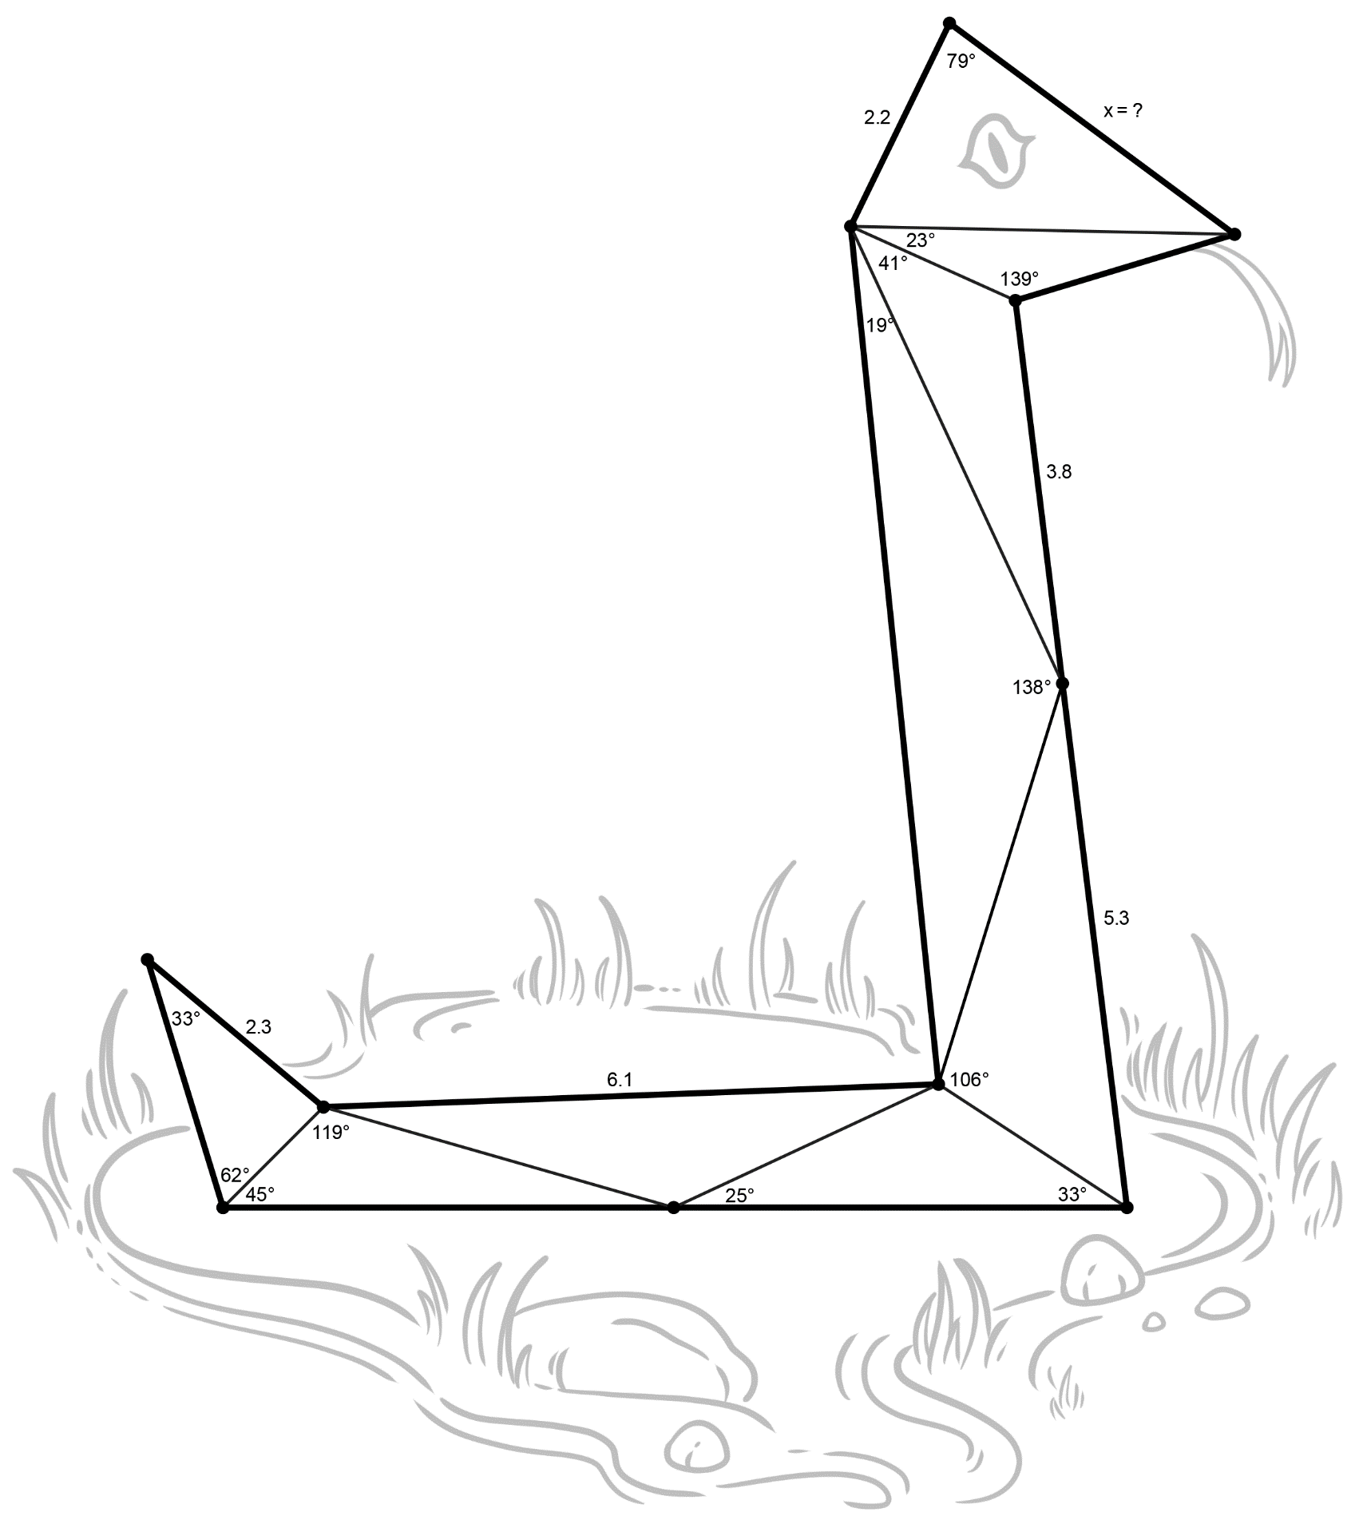
Using Law of SSSSines
Use what you have learned about the Law of Sines and the given information to determine the value for x. Round angle measurements to the nearest degree and lengths to the nearest tenth.

