historical mingle cards
Drafted Soldier
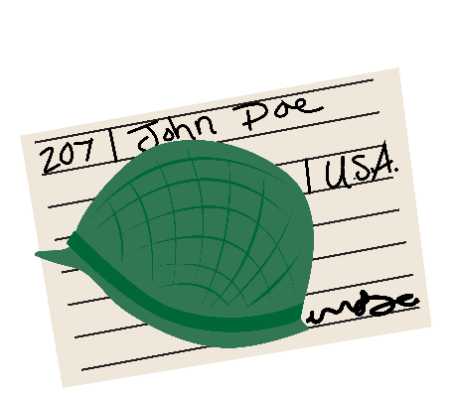 | - I registered for Selective Service, which is the military draft, because I am 21.  - My draft number was read by the President, and I had to report for service.  - I am going to be sent to the war after seventeen weeks of boot camp training.  - I was given a uniform, equipment, and a serial number.  - I became an important part of my unit.  - I made one mistake, so I got kitchen duty.

Rationing
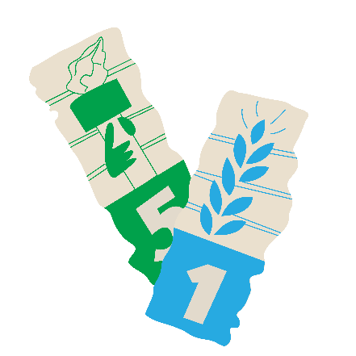 | - I participate in the government’s ration system.  - I have a book of stamps that I have to use when I go grocery shopping.  - Rationed items such as sugar, coffee, and meat are hard to find, and I can only buy those items if I have enough stamps.  - To stretch the small amount of coffee I’m allowed, I often reuse the grounds.

Victory Garden
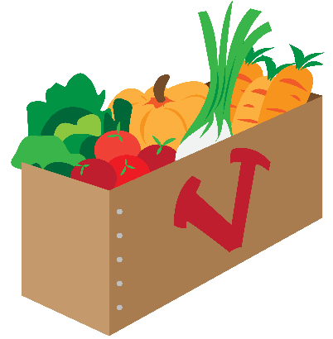 | - I made a garden in my backyard to grow vegetables and fruits for my family.  - Food grown by large farmers can go to the soldiers fighting the war.  - I planted packets of “Victory Seeds.”  - I was given instructions by an expert on how to plant and care for my garden.  - I grow beets, broccoli, parsnips, and spinach.  - I’m taking my produce and canning it to save food for the future.

War Bonds
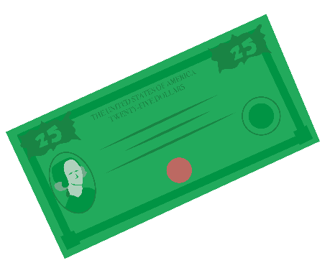 | - I bought bonds from the government.  - I paid $18.75 (worth $333.95 today) for a $25.00 (worth $412.39 today) bond.  - The government uses the money for war expenses.  - In ten years, I can cash in the bond and get $25.00 from the government.  - I bought my war bond at a booth in Woolsworth’s Five and Dime Store.

Scrapping and Salvaging
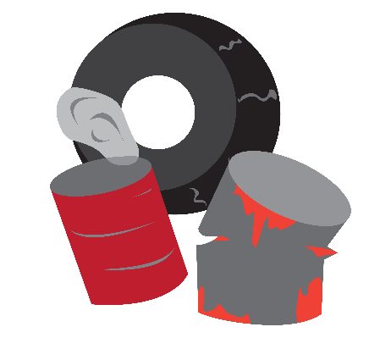 | - I organized a Salvage for Victory campaign in my neighborhood.  - We collected materials such as metal, rags, rubber, and even animal fat.  - Our New York Sanitation Department picks up our items on an alternating schedule.  - A lot of the school children help with the collection.  - The materials are recycled and turned into items for the war such as tanks, guns, bombers, and gas masks.

Car Sharing
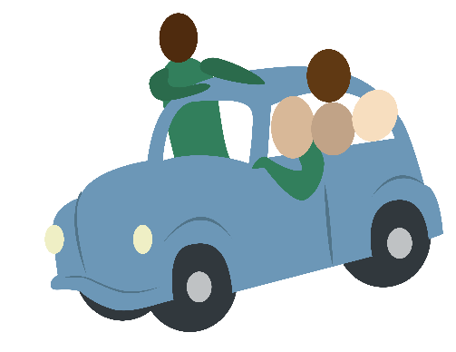 | - There is a shortage of rubber for tires because Japan has cut off America’s access to rubber plantations in southeast Asia.  - I have been carpooling with my neighbors to and from work.  - By sharing cars, we can make our tires last longer.  - I want to move closer to my job for a shorter commute.  - I got my car inspected and filled out an application for new tires.  - I recycle worn out hot water bottles, inner tubes, and rubber scraps.

Soldier
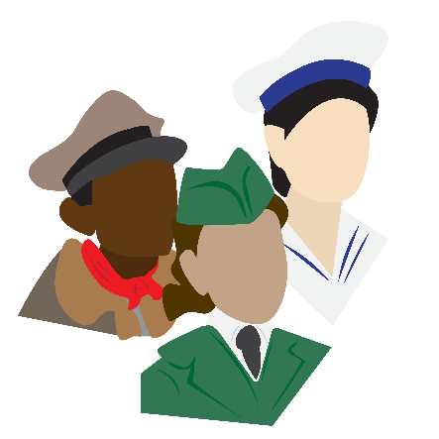 | - I signed up for the army and was assigned to the all-Black 370th Infantry due to segregation.  - I fought in France.  - We fought with the French military against the Germans.  - We became known to the Germans as the “Fighting Black Devils.”  - I will receive a Medal of Honor for my part in the war.

Nurse
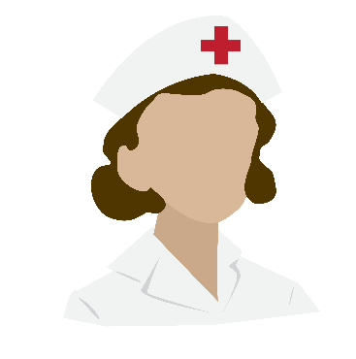 | - Because women aren’t allowed to fight in the war, I joined the Army Nurse Corps.  - I completed training.  - I was sent overseas to Europe by the Red Cross.  - I care for injured soldiers in a Clubmobile unit.  - I will receive a Bronze Star for my bravery during the Battle of Bastogne.

Sailor
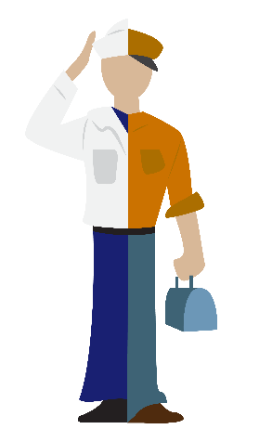 | - I joined the Navy voluntarily, just hours after the attack on Pearl Harbor.  - I am only twelve, but I lie and say I am sixteen.  - I am a gunner on the USS South Dakota.  - I fought in the Battle of Santa Cruz and Naval Battle of Guadalcanal where we sustained damage.  - I was present when Japan gave their Formal Surrender.

Factory Worker
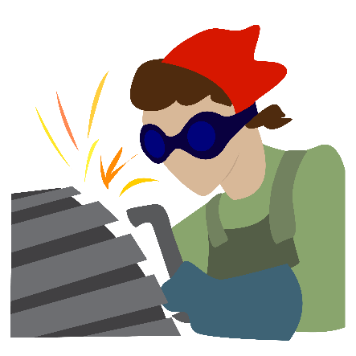 | - I took a job in an airplane factory.  - I used to be a secretary.  - I installed rivets and made sure each one fit just right.  - It was a very tough job, and I didn't want a mistake to cause a death.  - I worked on B-17, B-24, and B-29 aircrafts.

Baseball Player
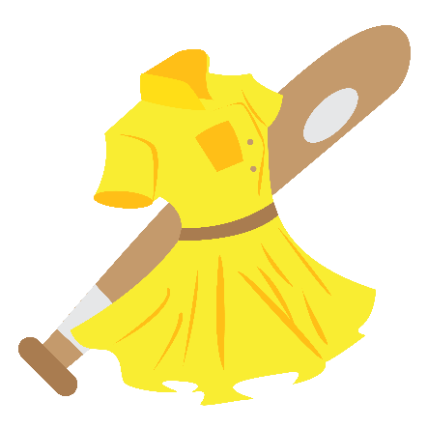 | - I played in the All-American Girls Professional Baseball League.  - With baseball players off to war, the League gave Americans something to cheer for and be excited about.  - I played for the Rockford Peaches, out of Illinois.  - I pitched the League's first no-hitter game.  - I played my heart and soul out.  - Attendance just kept going up.

Drafted Soldier
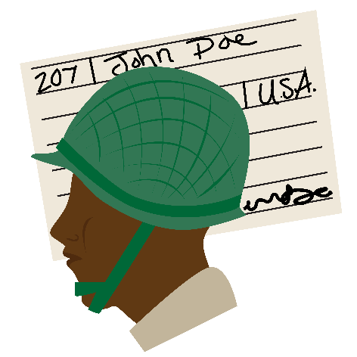 | - I signed up for the draft.  - I was drafted and trained at Camp Claiborne.  - I fought in the 761st Tank Battalion, known as the Black Panthers.  - I have to fight in a segregated unit because I am African American.  - My unit fought hard to capture the German town of Morville-les-Vic.

Code Talker
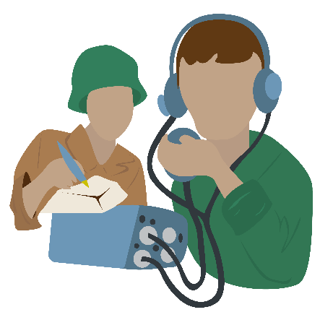 | - I am a Native American of the Navajo tribe.  - I was recruited and trained to be a Code Talker by the US Marines.  - I use my tribal language to send secret communications.  - I work with a partner. He operates the portable radio, and I would receive, send, and translate the messages.  - We played a huge part in the Battle of Iwo Jima.

Soldier
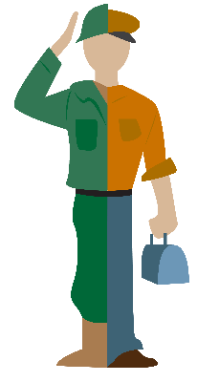 | - I signed up for the army.  - My family supports me in voluntarily joining because we were all angry about Pearl Harbor.  - I was trained and equipped with a uniform.  - I was immediately deployed overseas.  - I flew a Douglas SBD-6 Dauntless aircraft.  - I flew during the Battle of Midway.

Factory Worker
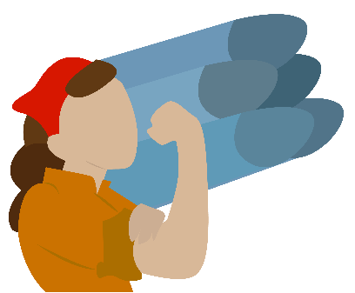 | - I took a job in a bomb factory.  - I work for General Motors (GM).  - I was needed to help make materials for the war.  - My work was very dangerous.  - It required two hands to carefully put the fuses together.

