Welcome to AWARE
(Advanced Weather Awareness & Response Education)!
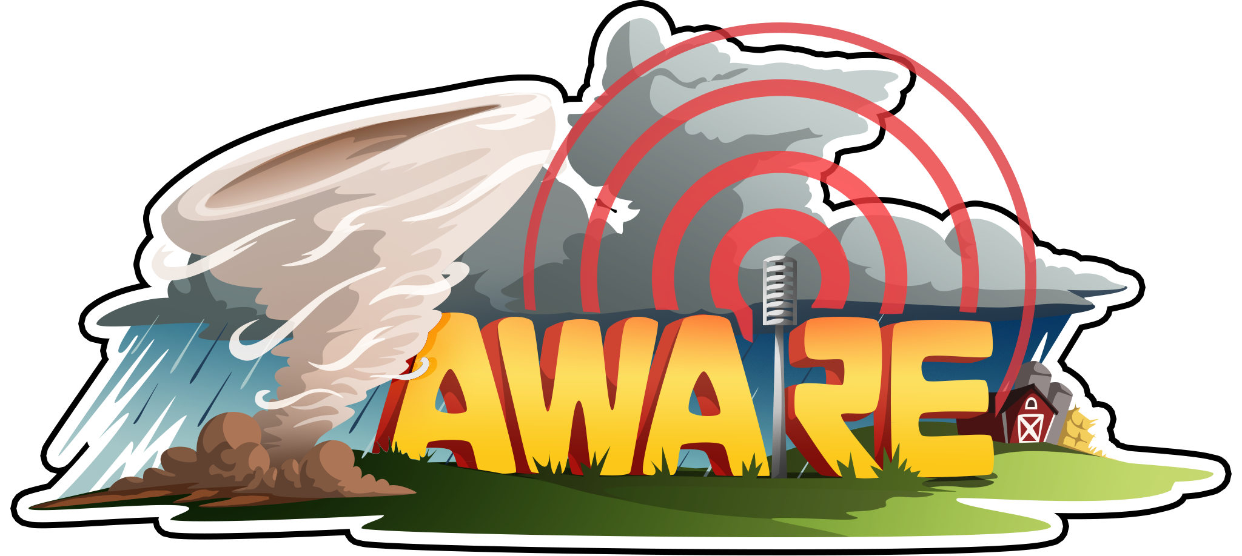

Use the following graphic organizer to collect information about the weather event in your turn. You will use this information to create your own multimedia message about the event.
Era __, Turn __
Fill in the blank spaces above with your assigned era and turn and collect the following information before you finish your turn:

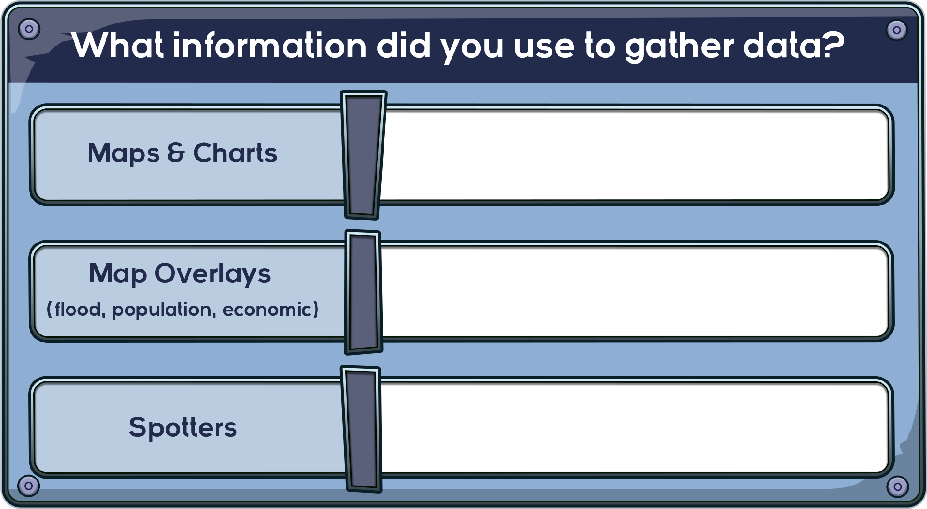

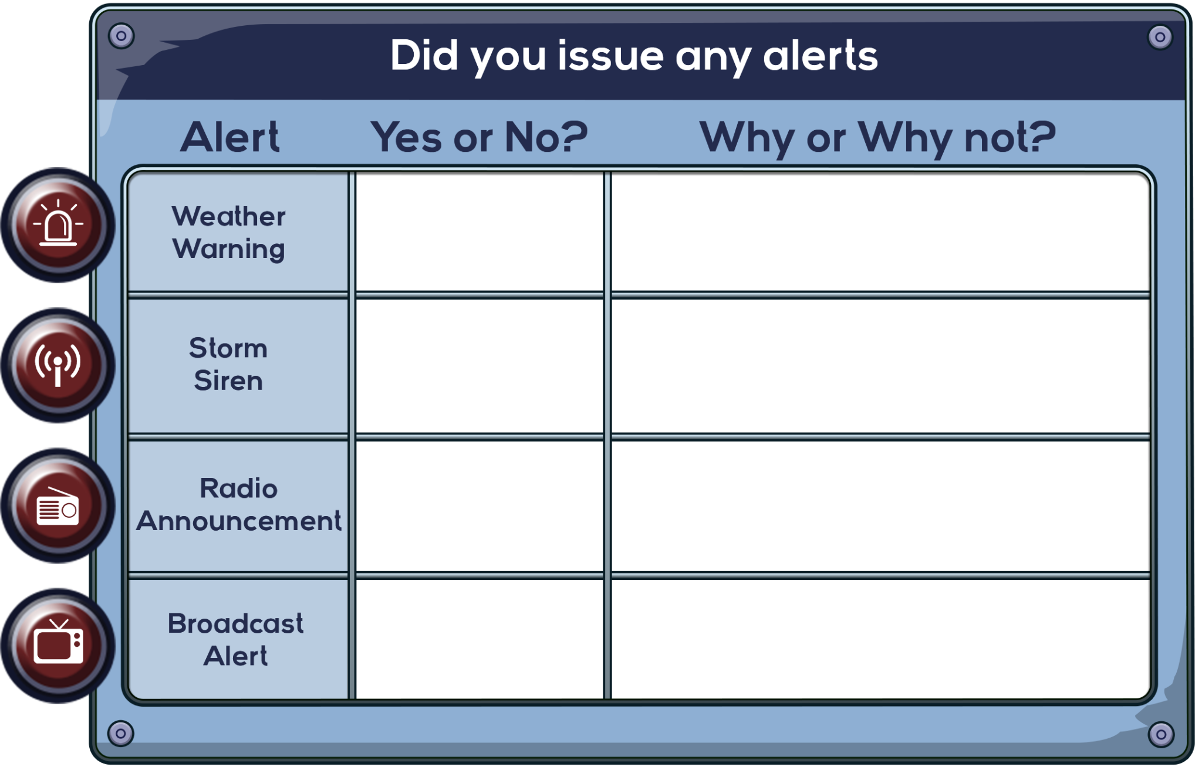

Collect the following information after you finish your turn:

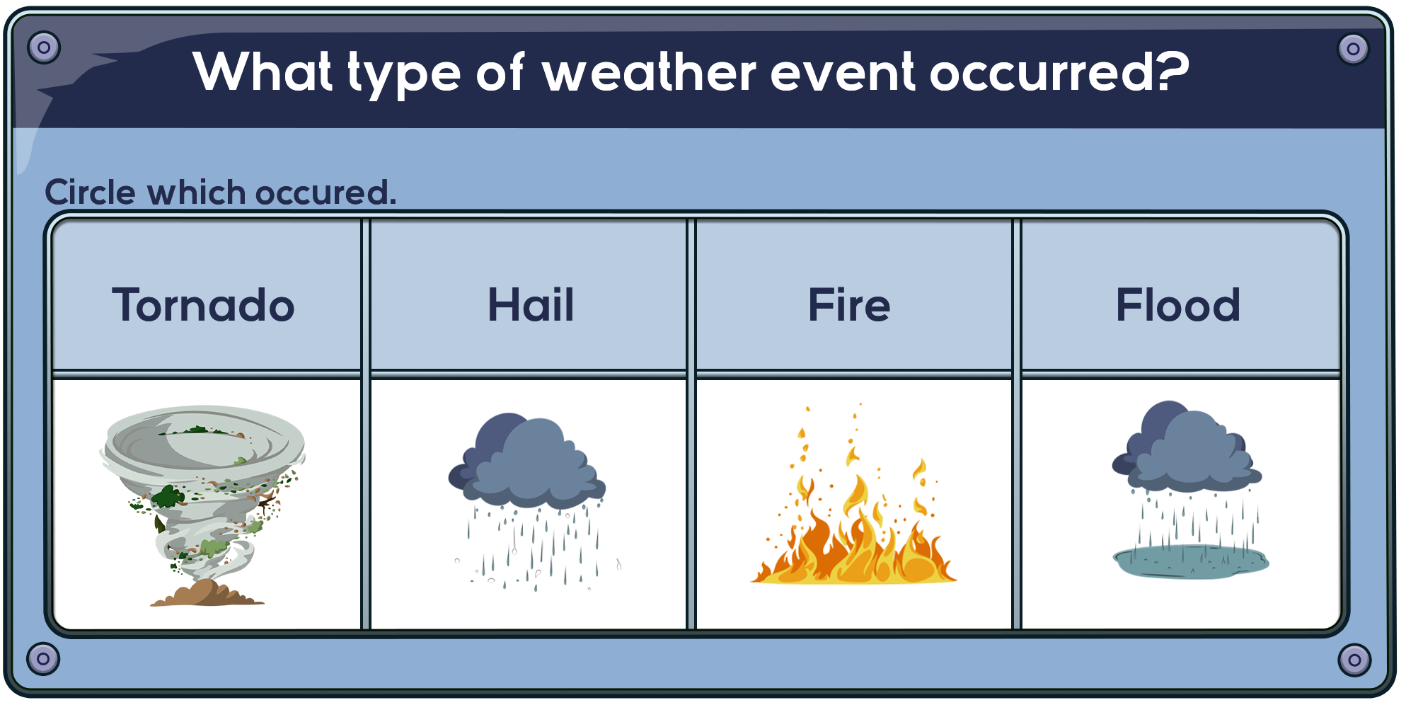

Circle the area in which the weather event occurred.
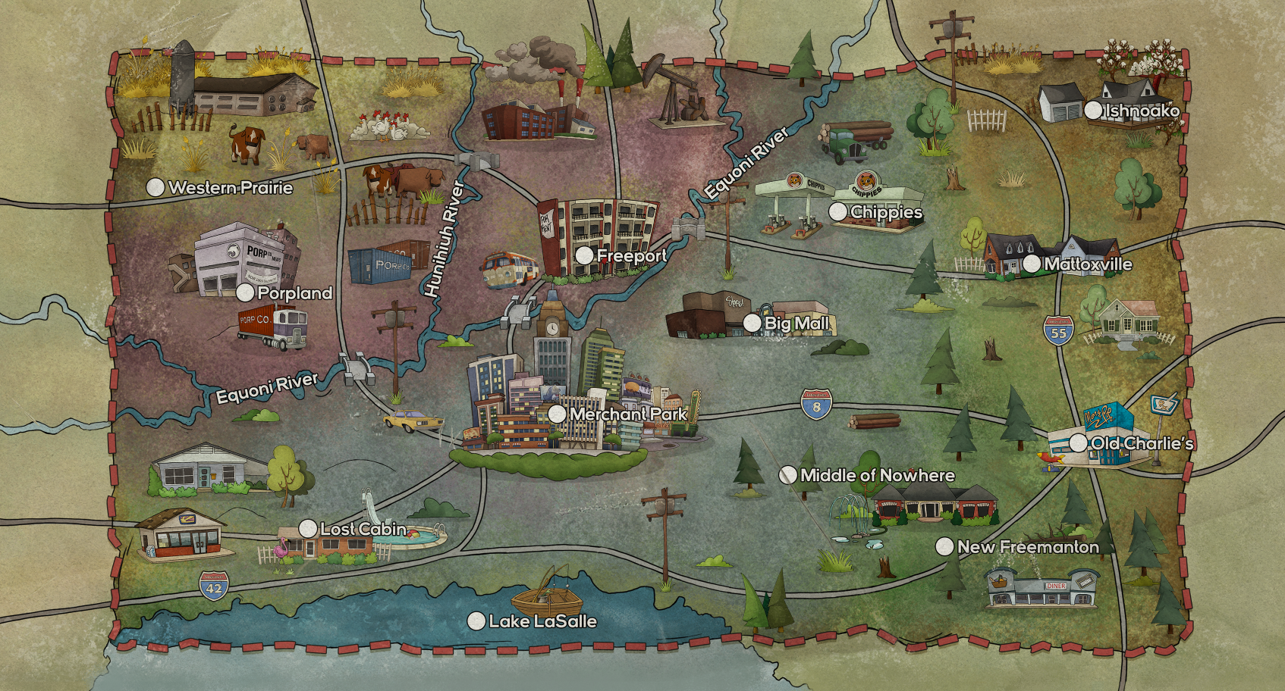

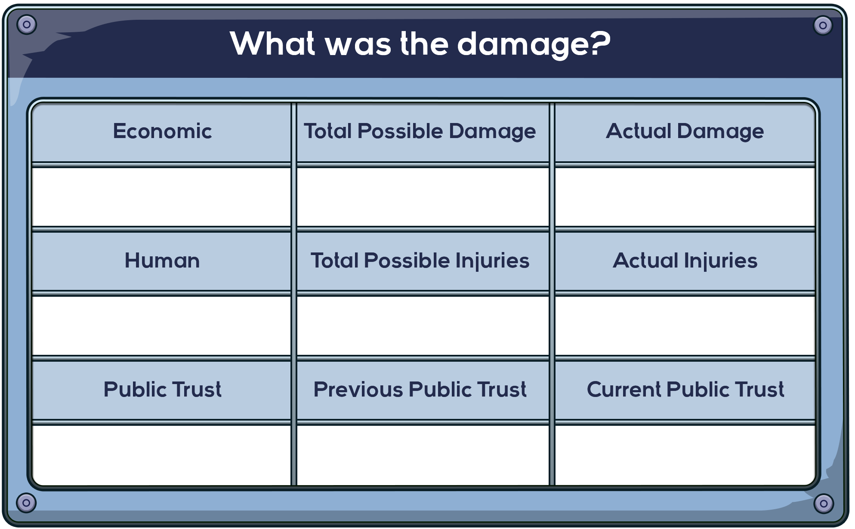

What did your advisors say? Summarize their reports below.
If you could change your previous actions, would you? Why or why not? If you answered yes, what would you have done?
What is the most important information to provide to the public?

