“AWARE” Walkthrough

Table of Contents
Tutorial 2
Era 1 3
Era 2 6
Era 3 12
Era 4 15
Era 5 19

Tutorial
- Place the weather station in Merchant Park.
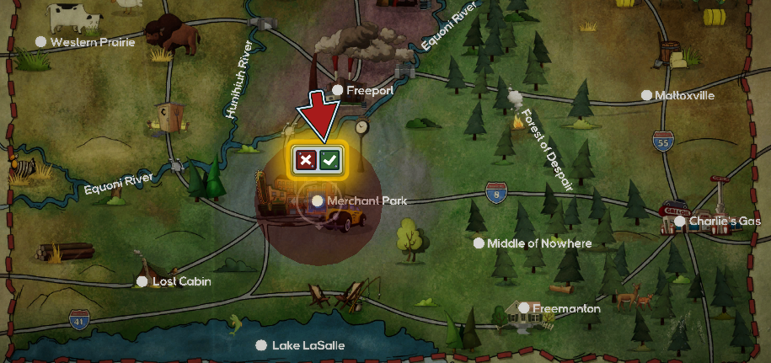
- Hire one Data Sciences staff. This allows students to research Tornado Forecasting.
- Research Tornado Forecasting (Earth Sciences). This unlocks radio alerts.
- End turn.

Era 1
Turn 2: The Nado
- Statement of AWAREness (SoA): Select “Yes, let’s get the word out!” This increases Public Trust.
- Hire one Engineering and one Public Safety staff. This allows students to research Storm Sirens.
- Research Storm Sirens (Construction). This lets students build the storm siren structure.
- Open the Build menu to see the new structure that has been unlocked.
- Open the SoA again. Issue a Warning, a Siren, and a Radio alert. These alert citizens of a storm.
- Open the Build menu again. Build two more weather stations and four storm sirens around Merchant Park:
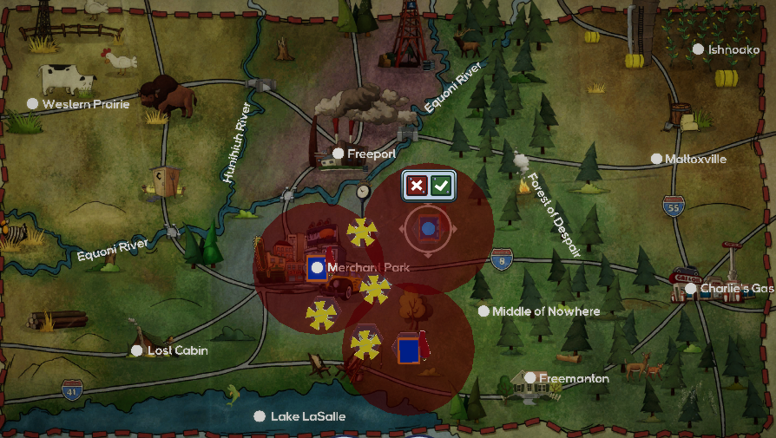
- End turn.

Turn 3:
- Hire one of each staff.
- Research Station Models (Earth Sciences). This unlocks the Dew Point and Air Temp maps.
- Research Modern Firefighting (Public Safety). This lets students build the fire station structure.
- Open the Build menu to see the new structure that has been unlocked.
- End turn.

Turn 4: FirstHail
- SoA:
  - Select “Yes, please show me again.” This allows students to review the Dew Point and Air Temp instructional message.
  - Follow the dialog to read through this message.
- Select “Based on what I’m seeing, I’d say hail.” This increases Public Trust.
- Issue a Warning and a Radio alert. These alert citizens of a storm.
- Hire one Engineering and one Public Safety staff. This allows students to research Modern Firetruck.
- Research Modern Firetruck (Public Safety). This improves the effectiveness of fire stations.
- Open the Build menu. Build two weather stations and two fire stations around Ishnoako:

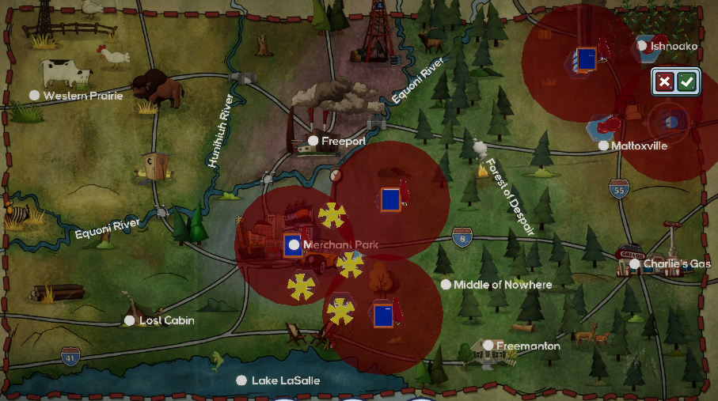
- End turn.

Turn 5:
- Hire one of each staff.
- Research Storm Drain Systems (Construction). This lets students build the storm drain structure.
- Open the Build menu to see the new structure that has been unlocked.
- End turn.

Turn 6:
- Hire one Engineering staff. This will allow students to research Flood Control.
- Research Flood Control (Construction).
- Hire one Medical staff. This will allow students to research Ambulance.
- Research Ambulance (Public Safety). This lets students build the hospital structure.
- Open the Build menu to see the new structure that has been unlocked.
- Hire one of each remaining staff.
- End turn.

Turn 7:
- Hire one Earth Science, Engineering, and Public Safety staff. This will allow students to research Above Ground Shelters.
- Research Above Ground Shelters (Construction). This lets students build the above ground storm shelter structure.
- Open the Build menu to see the new structure that has been unlocked.
- Hire one of each remaining staff. This will help unlock additional research.
- End turn.

Turn 8: PappyNado
- SoA:
  - Open the “Wind” map mode to view the Surface Wind map.
  - If prompted, review the instructional message.
  - Select “It does seem rather gusty” and “Tell them not to worry…” This increases Public Trust.
- Issue a Siren alert. This warns citizens of a tornado. Then, issue a Warning and a Radio alert. These reduce injuries from storms.
- Open the Build menu. Build a hospital and fire station beneath Merchant Park:
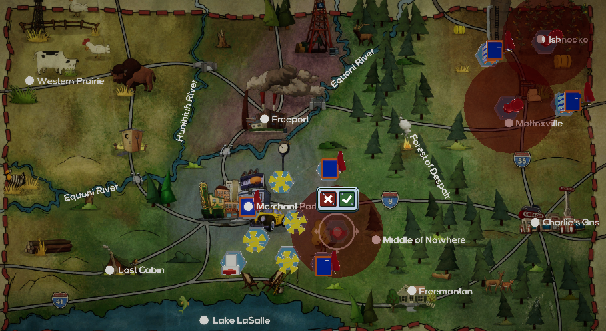
- End turn.

Turn 9:
- Hire one Earth Sciences staff. This will allow students to research the National Fire Danger Rating System.
- Hire one Data Sciences and one Engineering staff. This will help unlock Satellites.
- End turn.

Turn 10:
- Research the National Fire Danger Rating System (Earth Sciences). This unlocks the Burning Index map.
- Research Fujita Scale (Earth Sciences). This unlocks Broadcast alerts.
- End turn.

Era 2
Turn 1: HailMini
- SoA: Select “Yes, there appears to be a dryline.” This increases Public Trust.
- Issue a Broadcast alert and select “Hail.” Then, issue a Radio alert. These reduce damage and injuries from storms.
- Build one hospital, one fire station, and two above ground shelters to the right of Merchant Park and above the Middle of Nowhere:
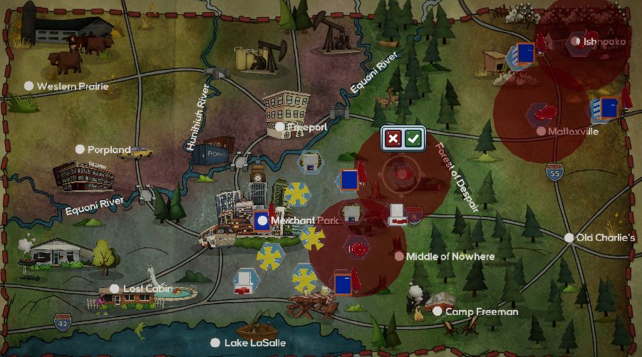

End turn.

Turn 2:
- Hire one Data Sciences and one Engineering staff. This will allow students to research Satellites.
- Research Satellites (Earth Sciences). This unlocks the Relative Greenness map.
- Hire one of each remaining staff. This will help unlock additional research.
- End turn.

Turn 3: FirstFire
- SoA: Read through the instructional messages. Then, select:
  - “Yes, there is low relative humidity.”
  - “See what our spotters have to say.” This increases Public Trust.
  - “No, I don’t think that will be helpful.”
- Issue Broadcast and Radio alerts.
- Build one hospital and one fire station above the Middle of Nowhere:
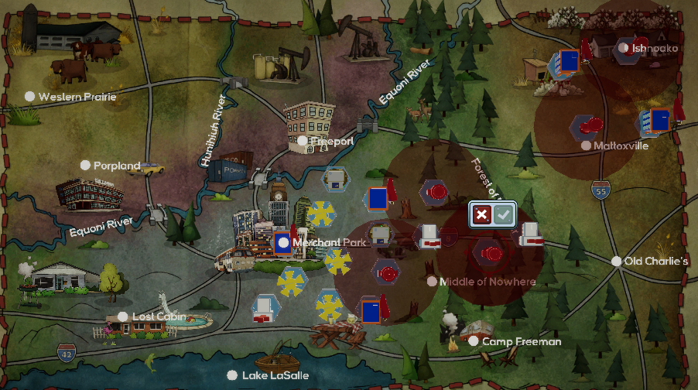

End turn.

Turn 4:
- Research Lookout Stations (Construction). This improves the effectiveness of fire stations.
- Research Siren Control Unit (Construction). This will allow students to issue a storm siren alert to target a specific area.
- Hire one Earth Sciences staff. This will help unlock additional research.
- End turn.

Turn 5: Downpour
- SoA: Select:
  - “Put up sandbags to prevent further flooding.”
  - “No, that might just cause more problems.”
- Click through the map modes. This helps determine the type and location of the upcoming storm.
- Issue Broadcast and Radio alerts.
- Build three storm drains below Freeport along the Hunihiuh River. Use the Flood overlay to determine where vulnerable areas are:
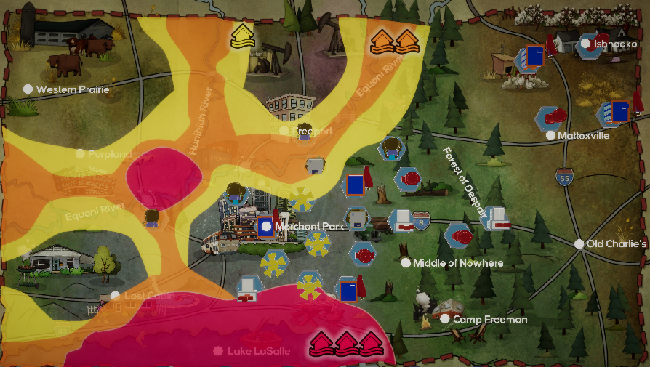
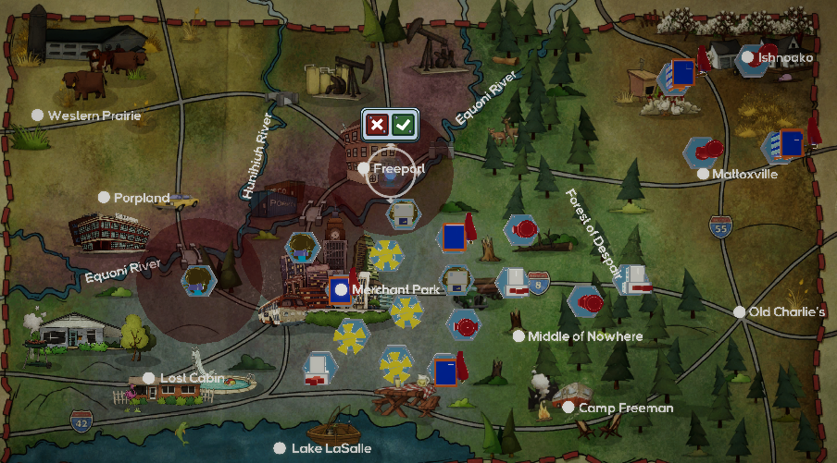
- Hire Data Sciences, Engineering, and Public Safety staff. This will help unlock additional research.
- End turn.

Turn 6:
- Hire one Earth Sciences, Medical, and Public Safety staff. This helps unlock additional research.
- End turn.

Turn 7:
- Research DOPPLER Radar (Earth Sciences). This improves the effectiveness of weather stations and unlocks additional weather tools in the SoA screen.
- Research Enhanced Fujita Scale (Earth Sciences).
- End turn.

Turn 8: MedNado
- SoA: Select “Sounds good to me!” If prompted, review instructional messages.
- Click through the map modes. This helps determine the type and location of the upcoming storm.
- Issue a Siren alert for Western Prairie. This warns citizens of a tornado.
- Issue a Broadcast alert and select “Tornado warning.” Then, issue a Radio alert.
- Build one hospital, one fire station, one weather station, four storm sirens, and two above ground shelters around Western Prairie:
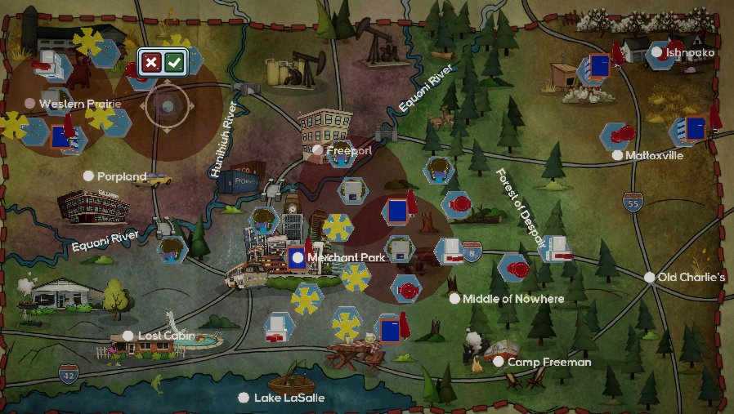
- End turn.

Turn 9:
- Research Personal Alert Safety System (Public Safety). This reduces damage and injuries from all fires.
- End turn.

Turn 10: Nader
- SoA:
  - Review instructional message(s) and map overlays when prompted.
  - Then, select “Issue a Take Shelter order.” This increases Public Trust.
- Click through the map modes. This helps determine the type and location of the upcoming storm.
- Issue a Siren alert. Select “The area west of Freeport.” This warns citizens of a tornado.
- Issue Broadcast and Radio alerts. These reduce damage and injuries from storms.
- Build one hospital, one fire station, one weather station, four storm sirens, and two above ground shelters below and to the right of Porpland:
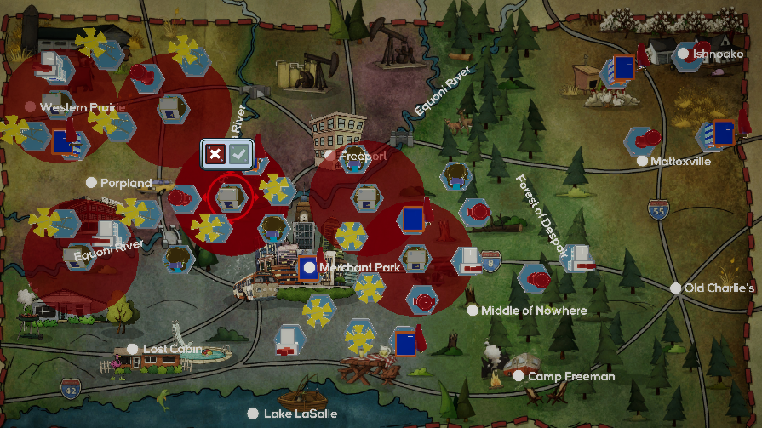
- Hire one of each staff. This will help unlock additional research.
- End turn.

Era 3
Turn 1:
- Research 911 (Public Safety). This lets students build the PSA Point structure.
- Research Mobile Rescue Apparatus (Public Safety). This reduces damage and injuries from fires.
- End turn.

Turn 2: TinyHail
- SoA:
  - Issue a Siren alert. Select “The area north of Middle of Nowhere.”
  - Issue a Broadcast alert. Select “Hail warning.”
  - Issue a Radio alert.
- Build one fire station, two weather stations, two above ground shelters, and two PSA Points at the Middle of Nowhere:
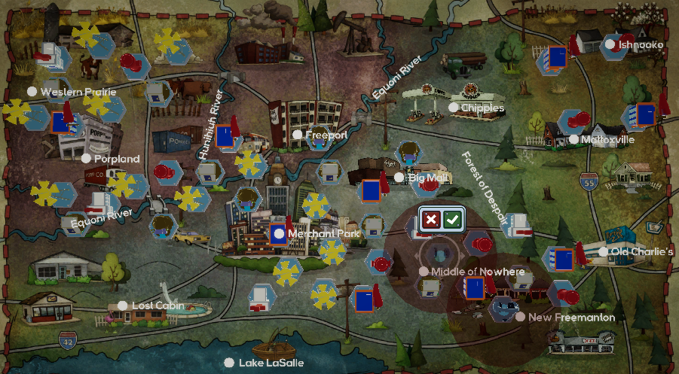
- End turn.

Turn 3:
- Hire one of each staff.
- Research Firefighter Breathing Equipment (Public Safety). This reduces injuries from fire.
- End turn.

Turn 4:
- Research Impact-Resistant Windows (Construction). This reduces damage and injuries from hail and tornadoes.
- Research Computer Aided Dispatch (Public Safety). This improves the effectiveness of PSA Points.
- End turn.

Turn 5: SecondFire
- SoA:
  - If prompted, review instructional messages.
  - Select “Yes, issue a Burn Ban.”
  - Select “Let’s do it!”
- Issue ETN, Broadcast, and Radio alerts.
- Build one fire station, one weather station, and one PSA Point at Western Prairie:
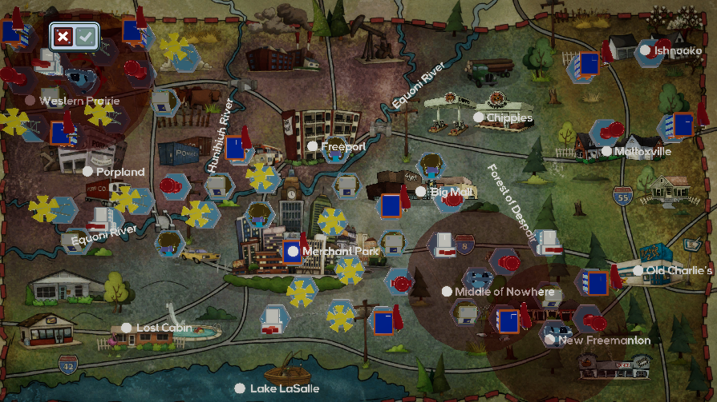
- End turn.

Turn 6:
- Hire one of each staff.
- Research Below Ground Storm Shelters (Construction). These improve the effectiveness of above ground storm shelters.
- End turn.

Turn 7: FalseNado
- SoA: Click through the dialog but do nothing.
- Hire one of each staff.
- Research Disaster Response Plans (Public Safety). This reduces damage and injuries from all storms.
- End turn.

Turn 8: BlubBlub
- SoA:
  - Select “Yes, let's close it."
  - Issue a Siren alert. Select “Freeport.”
  - Issue ETN, Broadcast, and Radio alerts.
- Build two storm drains along the river near Freeport. Build one hospital, three fire stations, and two PSA Points around Freeport:
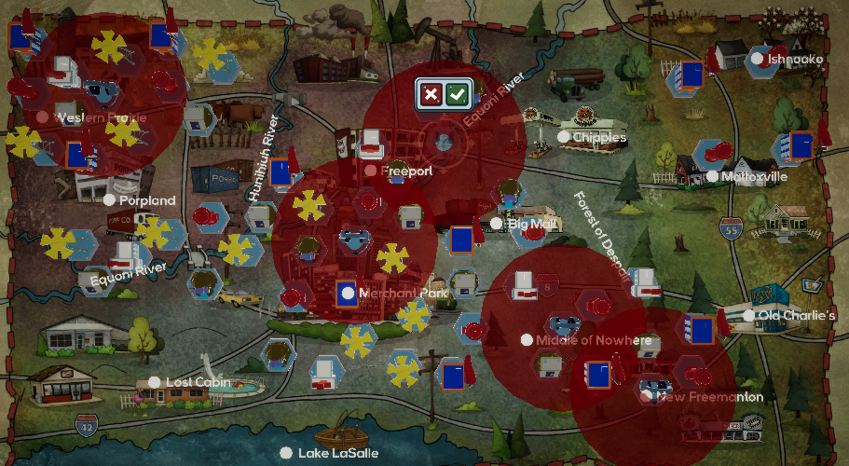
- End turn.

Turn 9:
- Research High Occupancy Safe Rooms (Construction). This reduces injuries from tornadoes.
- End turn.

Turn 10:
- Research Mesonet Stations (Earth Sciences). This unlocks the Skew-T map.
- Hire one Medical and one Public Safety staff.
- End turn.

Era 4
Turn 1: WildWildFire
- SoA:
  - Select “Yes, issue a Burn Ban.”
  - Select “Let’s do it!”
- Issue ETN, Broadcast, and Radio alerts.
- Build one fire station, one weather station, one hospital, two above ground shelters, and one PSA Point above Old Charlie’s:
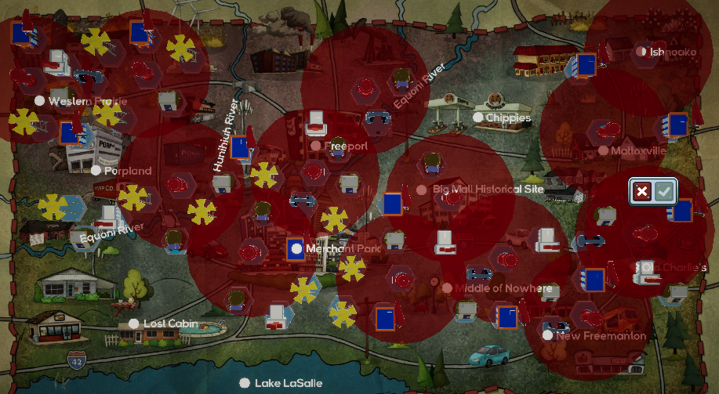
- End turn.

Turn 2: ToreNado
- SoA:
  - Review instructional messages when prompted.
  - Select “Sure” (in reference to above ground shelters)
- Issue a Siren alert. Select “Merchant Park.”
- Issue ETN, Broadcast, and Radio alerts.
- Build one fire station, one hospital, one weather station, two above ground shelters, three storm sirens, and one PSA Point from Lost Cabin to Merchant Park:
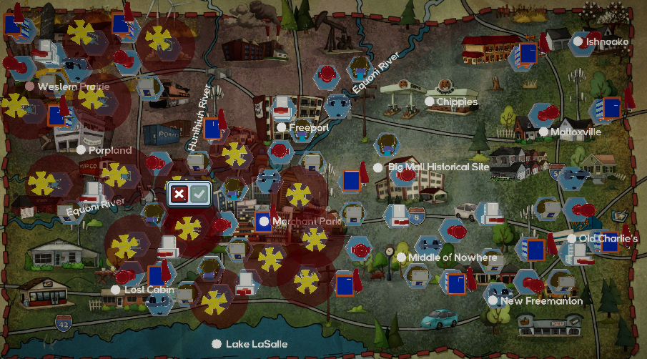
- Hire one Earth Sciences, Engineering, and Data Sciences staff.
- End turn.

Turn 3:
- Research Supercomputer (Construction). This improves the effectiveness of weather stations.
- End turn.

Turn 4: BustedNado
- SoA: Do nothing.
- Hire one of each staff.
- Research Self-Repairing Concrete (Construction). This reduces damage costs from storms.
- End turn.
Turn 5: WideFire
- SoA:
  - Select “Western Prairie.”
  - Issue ETN, Broadcast, and Radio alerts.
- Build one fire station, one hospital, one above ground shelter, and one PSA Point beneath Western Prairie:
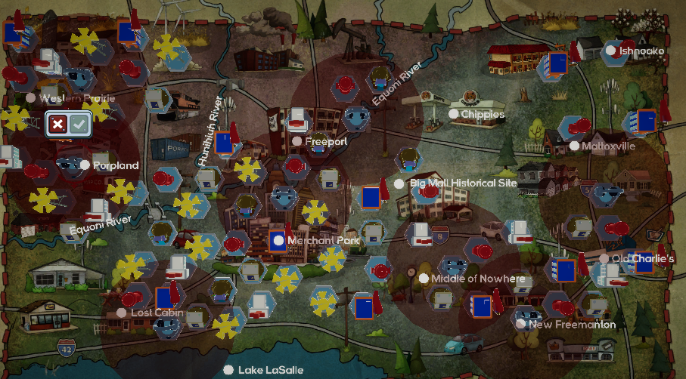
- End turn.

Turn 6:
- Research EAS (Public Safety). This unlocks the EAS alert type.
- Hire one Engineering and one Data Sciences staff.
- End turn.

Turn 7: FalseFlood
- SoA:
  - Select “Nah, I don’t think we need to worry this time.”
  - Select “No, that might just cause more problems.”
- Research ASOS (Earth Sciences). This reduces damage and injuries from all storms.
- End turn.

Turn 8:
- Research Incident Command System (Public Safety). This reduces damage and injuries from all storms.
- Research Wind-Resistant Garage Doors (Construction). This reduces damage and injuries from hail and tornadoes.
- Hire one Earth Sciences and one Engineering staff.
- End turn.

Turn 9: HailConcentrate
- SoA: Issue ETN and EAS alerts.
- Build one hospital, one above ground shelter, one weather station, and one PSA Point beneath Mattoxville:
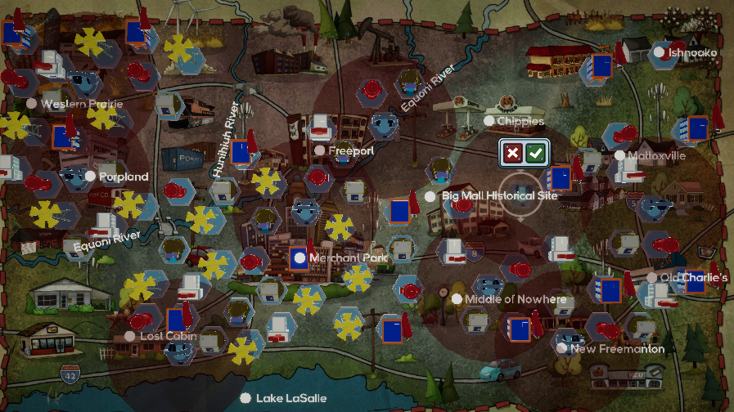
- Hire one Data Sciences staff.
- End turn.

Turn 10:
- Research NWSChat (Earth Sciences). This reduces damage and injuries from all storms.
- Hire one Medical, one Public Safety, and one Earth Sciences staff.
- End turn.

Era 5
Turn 1: BigWater
- SoA:
  - Select “Flood”
  - Select “Put up sandbags to prevent further flooding.”
  - Issue ETN and EAS alerts.
- Build one fire station, one hospital, one weather station, one PSA Point, and three storm drains from Lost Cabin to Merchant Park:
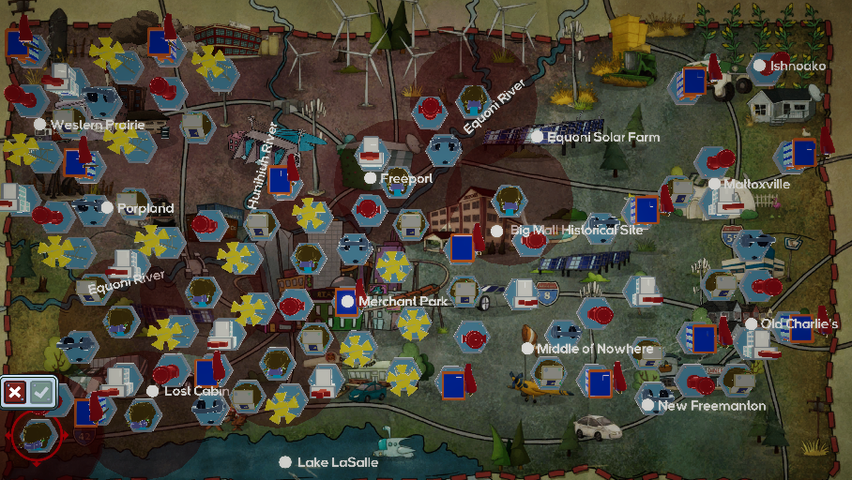
- End turn.

Turn 2: NoFire
- SoA: Select “Fire? There’s nothing to worry about!”
- Research Next Generation 911 (Public Safety). This improves the effectiveness of PSA Points and unlocks the CMAS alert type.
- Hire one Medical, Data Sciences, Engineering, and Earth Sciences staff.
- End turn.

Turn 3:
- Research FirstNet (Public Safety). This improves the effectiveness of hospitals.
- End turn.

Turn 4: AllHail
- SoA:
  - Review instructional messages when prompted.
  - Issue ETN, EAS, and CMAS alerts.
- Build one hospital, one above ground shelter, and one PSA Point around Merchant Park:
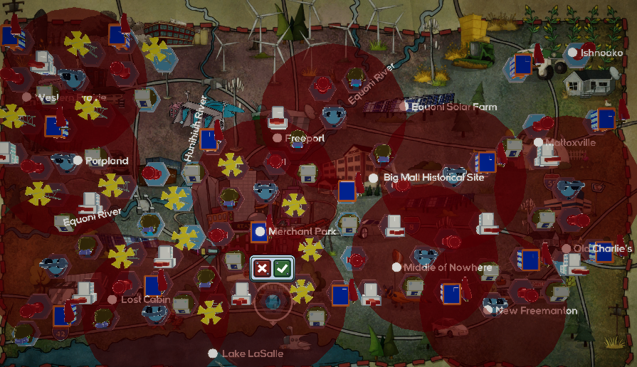
- Hire one Medical, Public Safety, Data Sciences, and Engineering staff.
- End turn.

Turn 5: DualNado
- SoA:
  - Review instructional messages when prompted.
  - Select “Yes!” (in reference to above ground shelters).
  - Issue a Siren alert. Select “Mattoxville.”
  - Issue ETN, EAS, and CMAS alerts.
- Build one fire station, one above ground shelter, and four storm sirens around Mattoxville:
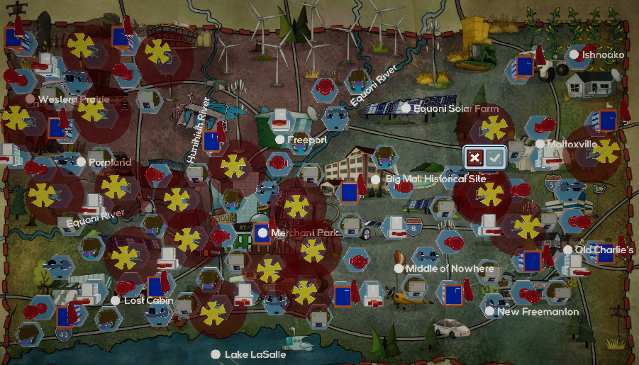
- End turn.

Turn 6:
- Hire one Data Sciences and Engineering staff.
- Research Phased Array Radar (Earth Sciences). This unlocks the Phased Array Radar instructional message.
- End turn.

Turn 7: BasicNado
- SoA:
  - Review instructional messages when prompted.
  - Issue a Siren alert. Select “Big Mall Historical Site.”
  - Issue ETN, EAS, and CMAS alerts.
- Build one hospital, one above ground shelter, and three storm sirens around Big Mall Historical Site:
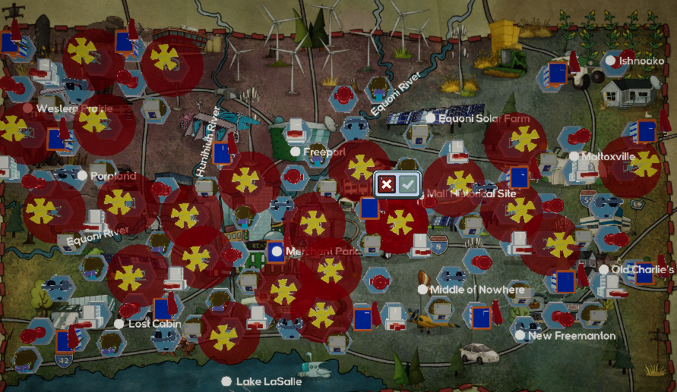
- Hire one Medical, Public Safety, Data Sciences, and Earth Sciences staff.
- End turn.

Turn 8: Noah
- SoA:
  - Select “I agree!”
  - Select “Put up sandbags to prevent further flooding.”
  - Review instructional messages when prompted.
  - Issue ETN, EAS, and CMAS alerts.
- Ensure that you have storm drains from Lake LaSalle to the Equoni River:
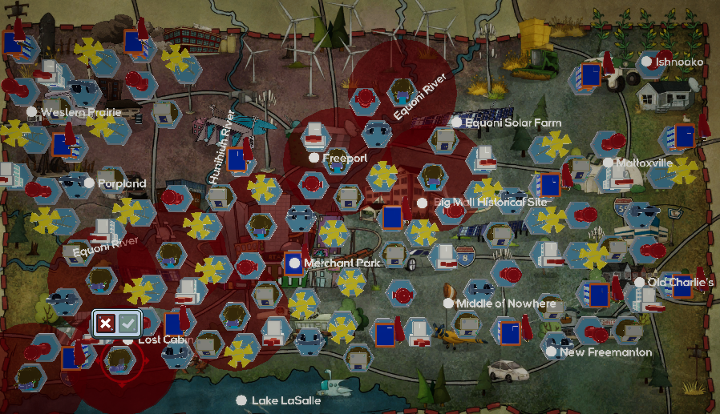
- Research Social Media Reporting (Earth Sciences). This unlocks the Internet alert type.
- Return to the SoA and issue an Internet alert.
- Hire one of each staff.
- End turn.

Turn 9:
- Research AI Construction (Construction). This reduces damage and injuries from all hazards.
- End turn.

Turn 10: MotherNado
- SoA:
  - Review instructional messages when prompted.
  - Select “Let’s do it!” (in reference to above ground shelters).
  - Issue a Siren alert. Select “Big Mall Historical Site.”
  - Issue Internet, ETN, EAS, and CMAS alerts.
- Ensure that you have structures built to the left and right of Merchant Park:
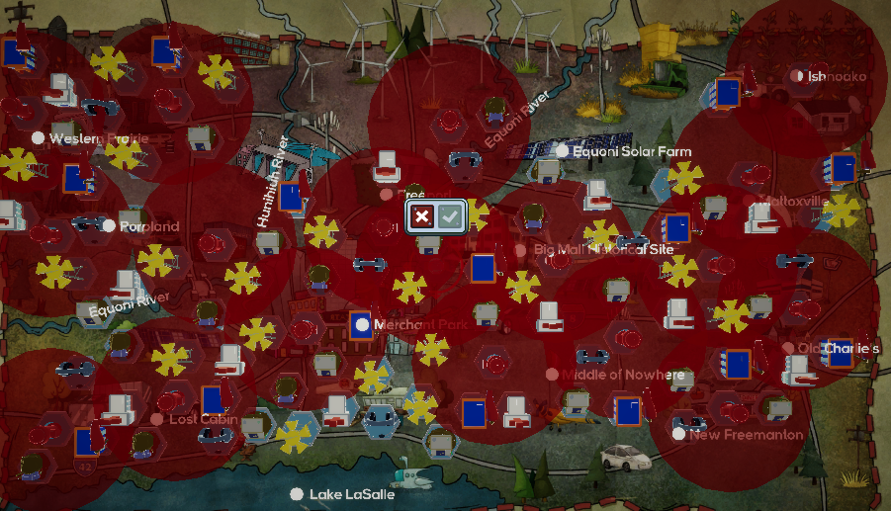
- Research Construction Drones (Construction). This reduces damage from all hazards.
- End turn.

