Honeycomb Harvest

**Ghost**

Casper

Salty

Spirit of the Dead

To end communication abruptly.



Taste

Mad

Vulgar language

**Cheese**

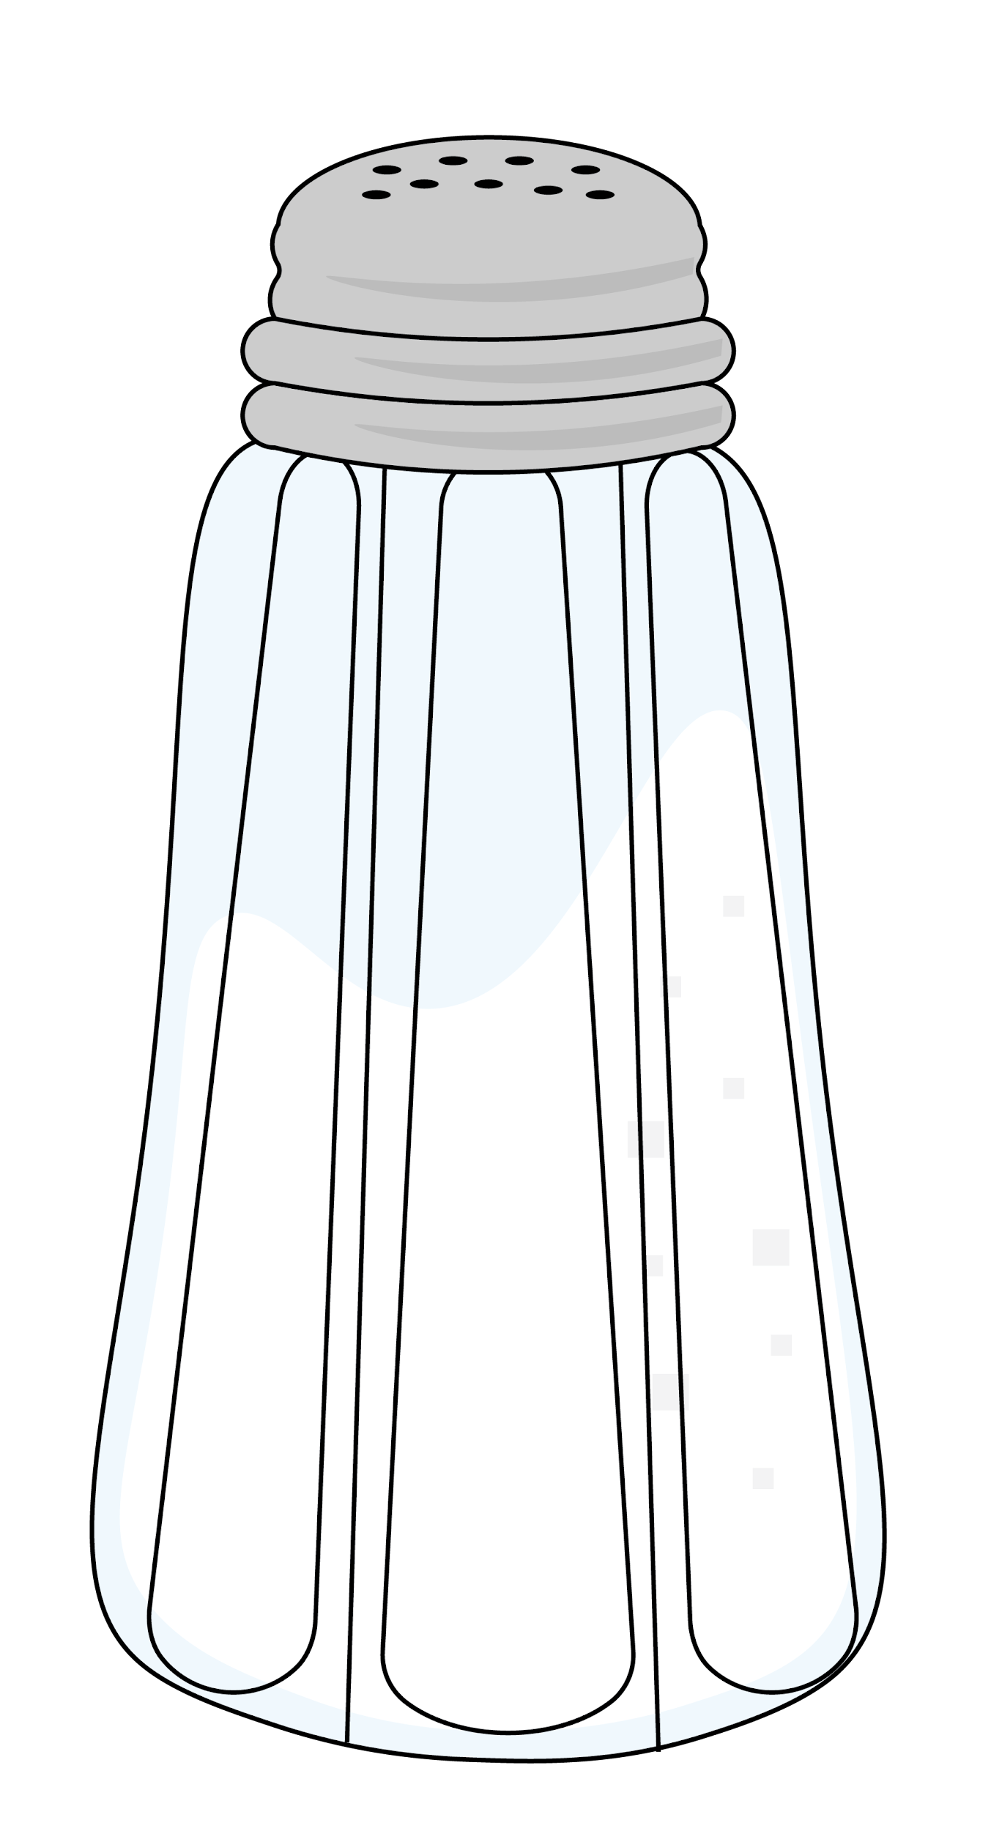

Honeycomb Harvest

Smile

Dairy Food

Angry

**Whip**

Tossing one’s hair.

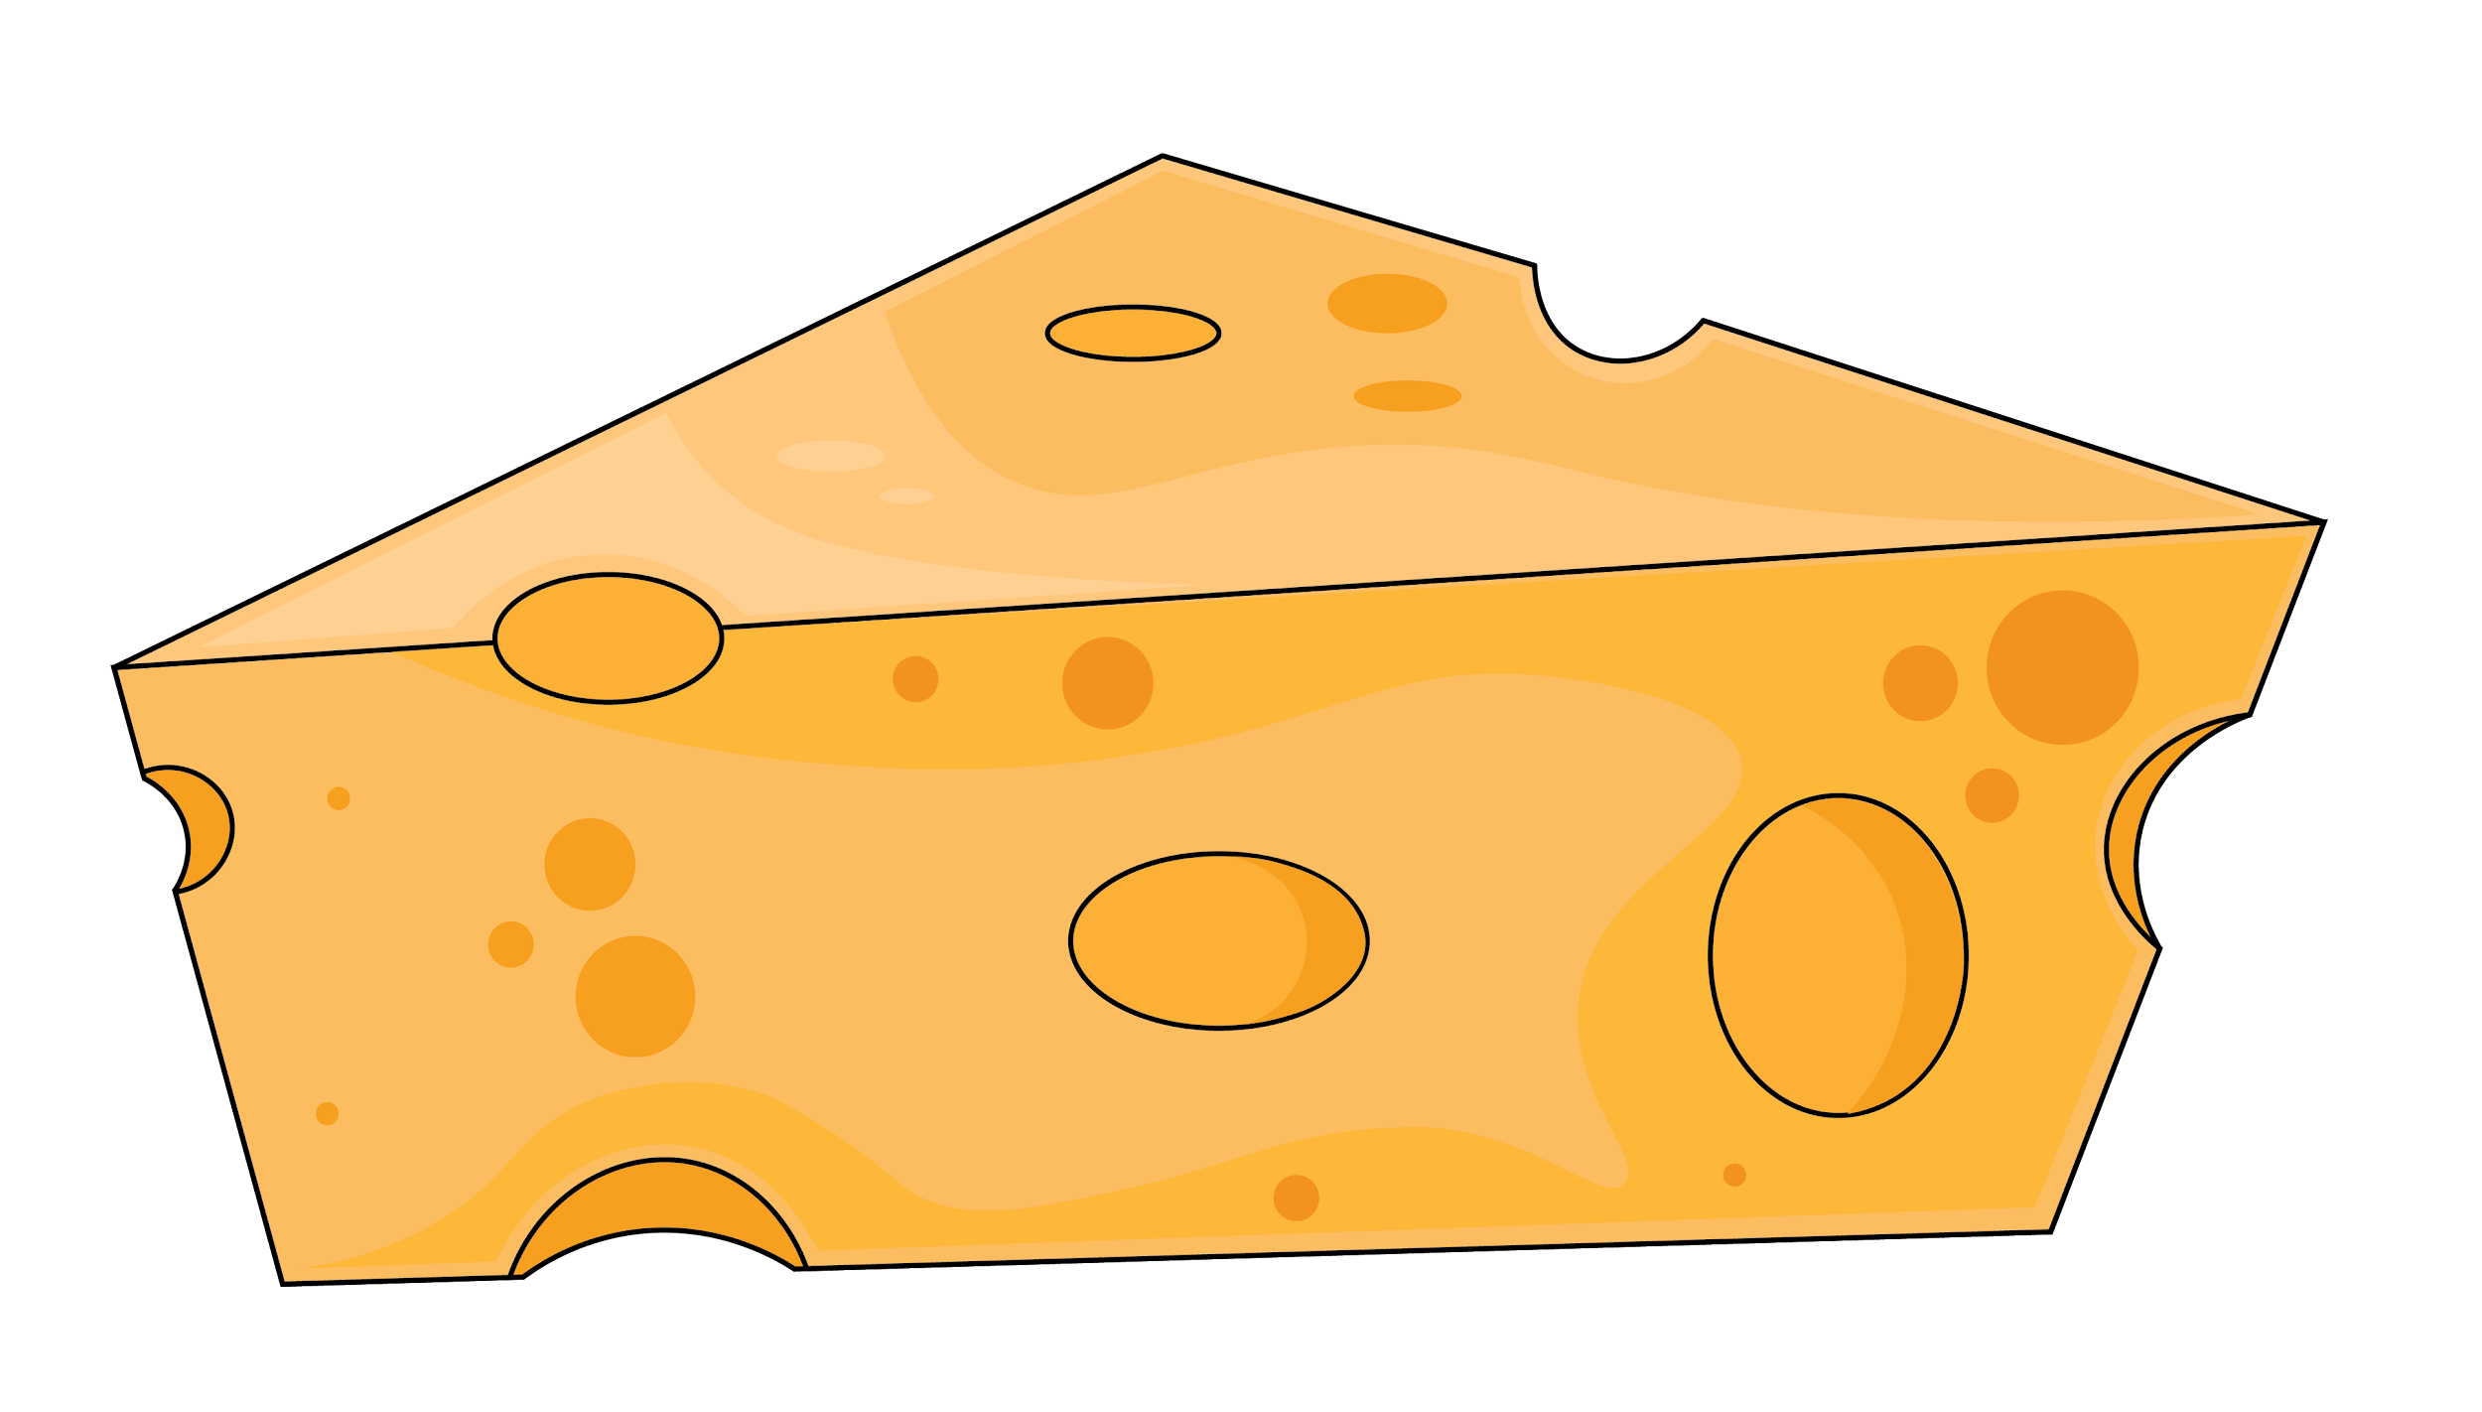

Car

Something Indiana Jones carries with him.

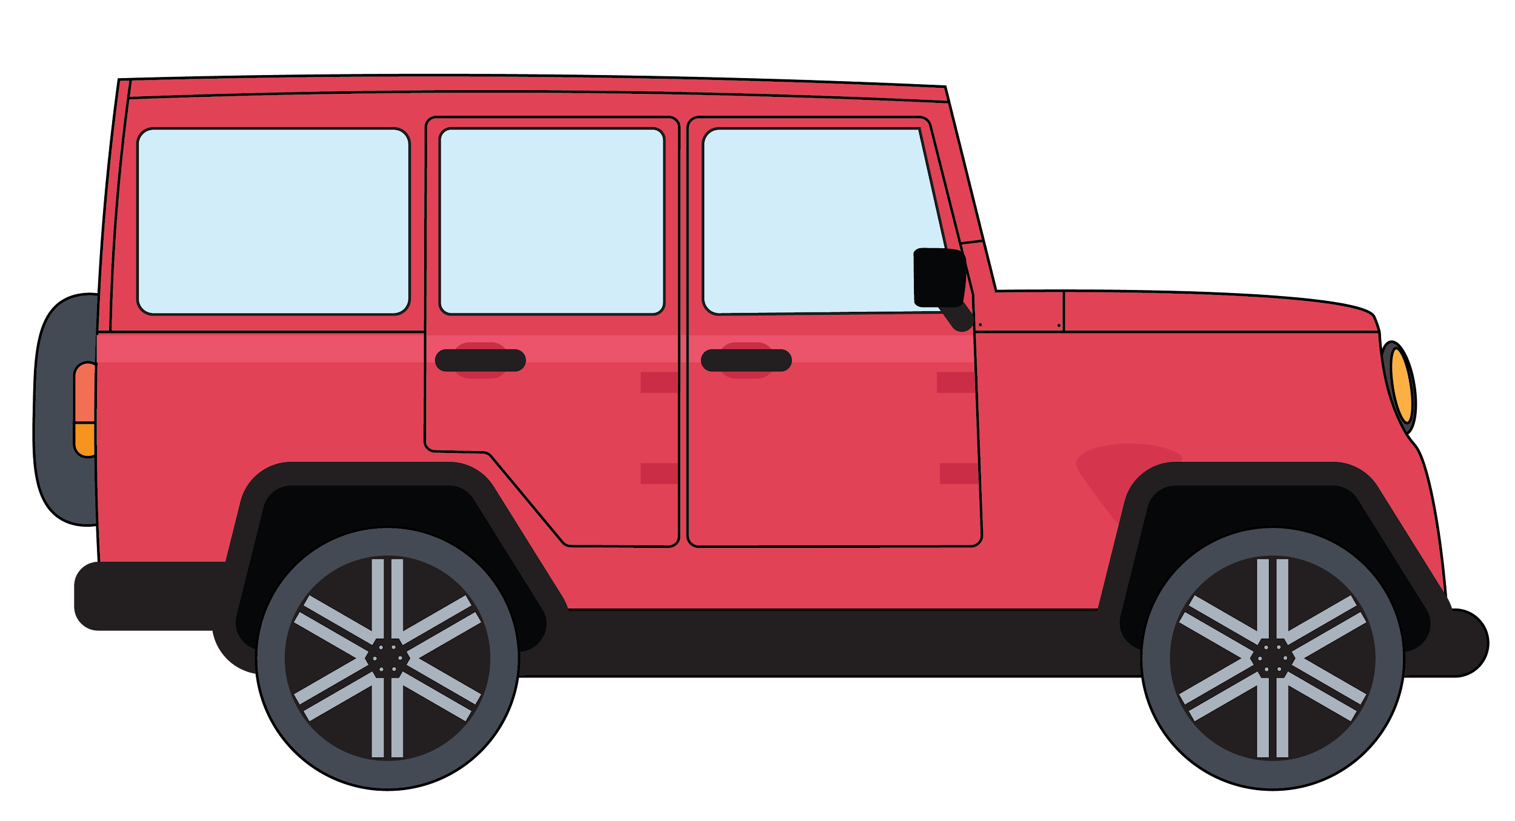

Flame

Fire

Honeycomb Harvest

Awesome

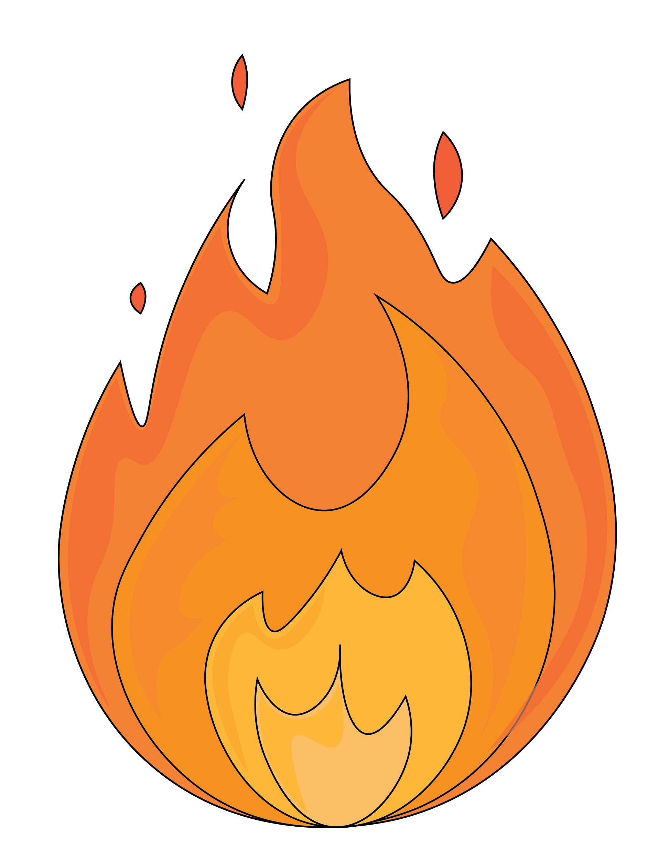

To terminate from a position of employment.