Inverse Trigonometry: Guided Notes

# Inverse Trig Functions

   *The angle is the* ***inverse sine*** *of k.*

   *The angle is the* ***inverse cosine*** *of k.*

   *The angle is the* ***inverse tangent*** *of k.*

*\*k is the ratio of the measurements from the right triangle, and θ is the acute angle measure.*

# Notation

 unlike , which is why  is often used instead.

not an exponent

exponent

## Examples

|  |  |
| --- | --- |
|  | **1)** Find *β* (*beta*) using two different inverse trigonometric functions. |

|  |  |
| --- | --- |
|  | The **angle of elevation** is the angle you would need to lift your head to see something above you. |

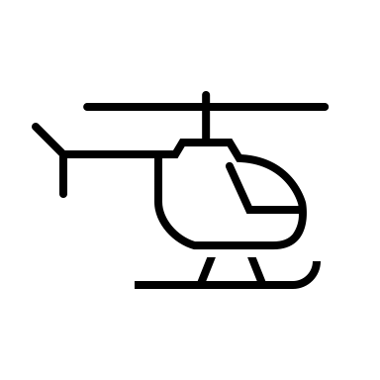

|  |  |
| --- | --- |
|  | **2)** Imagine you are watching a helicopter land. The helicopter is 70 feet directly above the landing pad, and the landing pad is 100 feet away from you. What is the angle of elevation? |