Card Matching
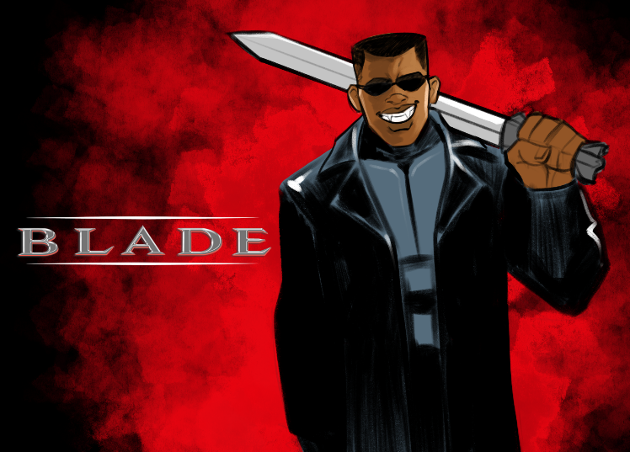 | 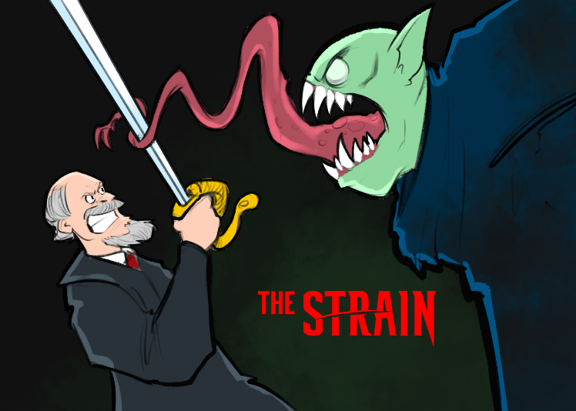
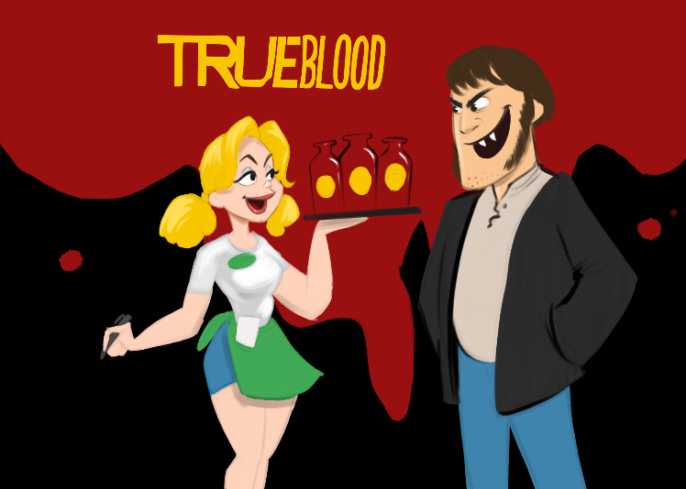 | 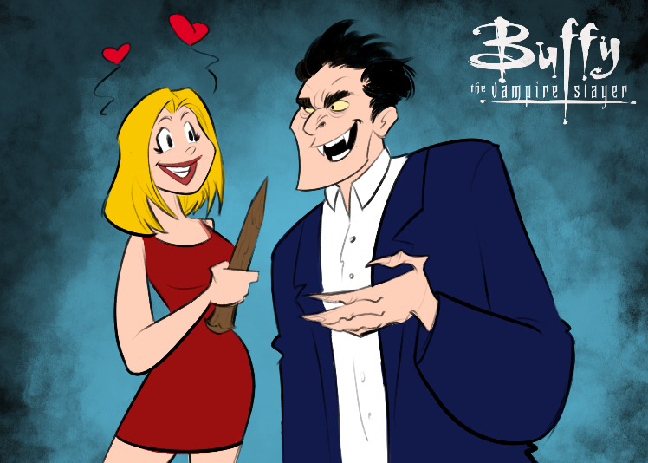
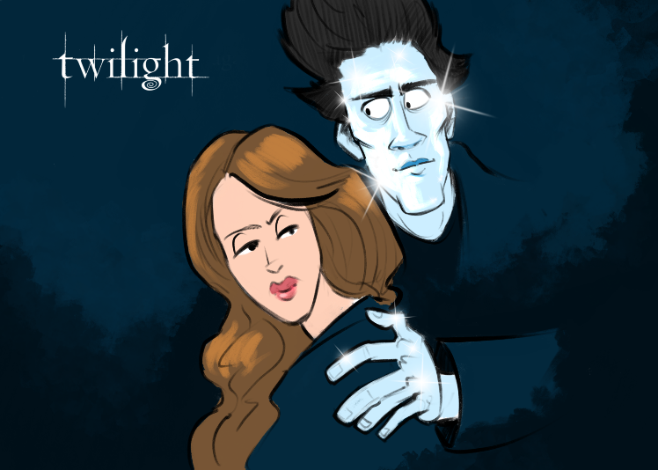 | 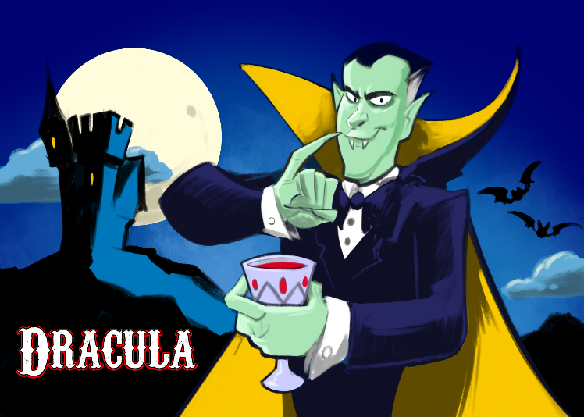

Vampires have pale skin. | Child vampire based off a child who recently passed away. | Vampires are alluring. | Vampires have pale skin.
Vampires are weak to sunlight. | Vampires can’t be recorded. | Based on America’s fascination with youth and staying young as long as possible. | Vampires are weak to sunlight.
Vampires can’t go outside during the day. | Vampires are restricted from entering homes without permission. | Religious influence: Catholicism | Vampires are weak to sunlight.
Vampires are weak to fire. | Vampires are restricted from entering homes without permission. | Religious influence: Mormonism | Vampires are beautiful.
Vampires are restricted from entering homes without permission. | Vampires are faster than normal. | Vampirism is a sickness. | Vampires are wealthy.
Vampires form councils. | Vampires hide in plain sight. | Vampires are wealthy. | Vampires are alluring.
Vampires are warped or inhuman. | Vampires are wealthy. | Vampires form councils. | Vampires are alluring.
Vampires are wealthy. | Vampires are associated with creatures of the night (bats and rats) but can’t shapeshift. | Vampires become detectives. | Historical influence: Vlad the Impaler
Historical influence: Elizabeth Báthory | Vampires are associated with sorcery or superpowers. | Vampires are restricted from entering homes without permission. | Vampires can’t be seen in mirrors.

