Appointment Clock
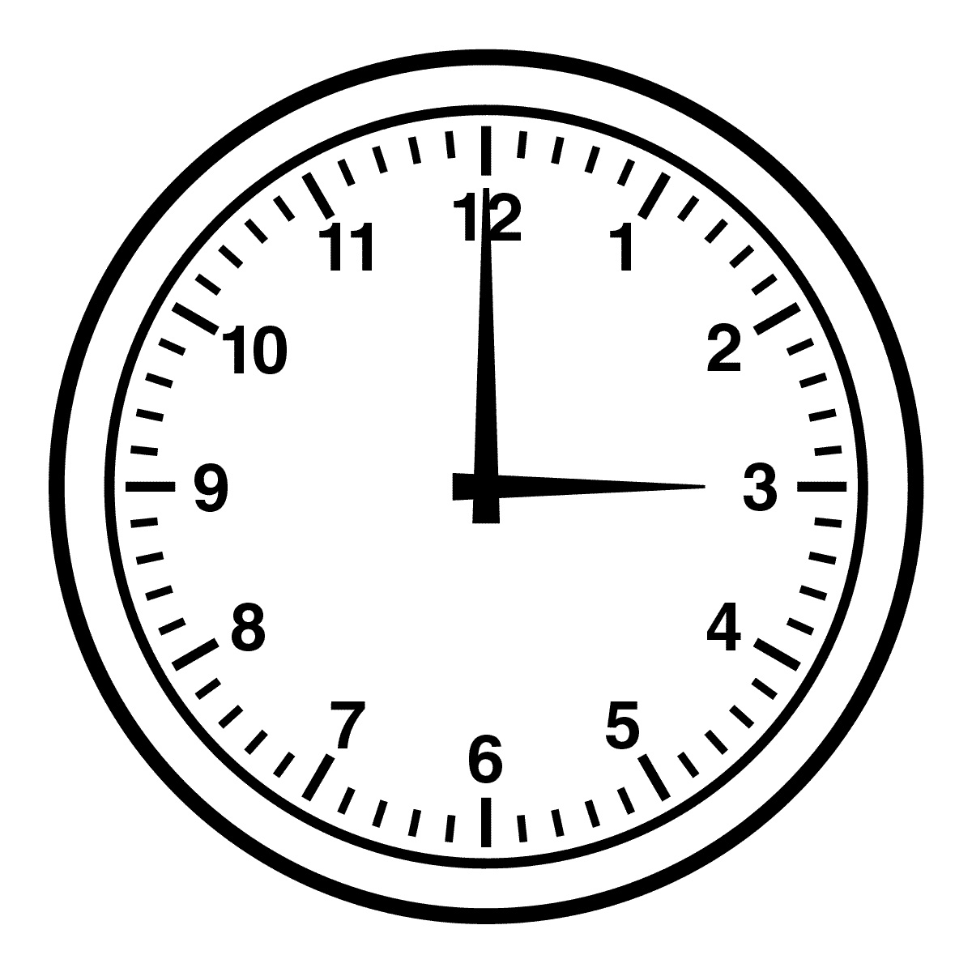

Appointment Clock Questions

- How did the gender roles of the 19th century drive the conflict in the story?

- How are the women today more free than in Kate Chopin’s time? While more freedoms exist for women, how are women still confined?

