image #1
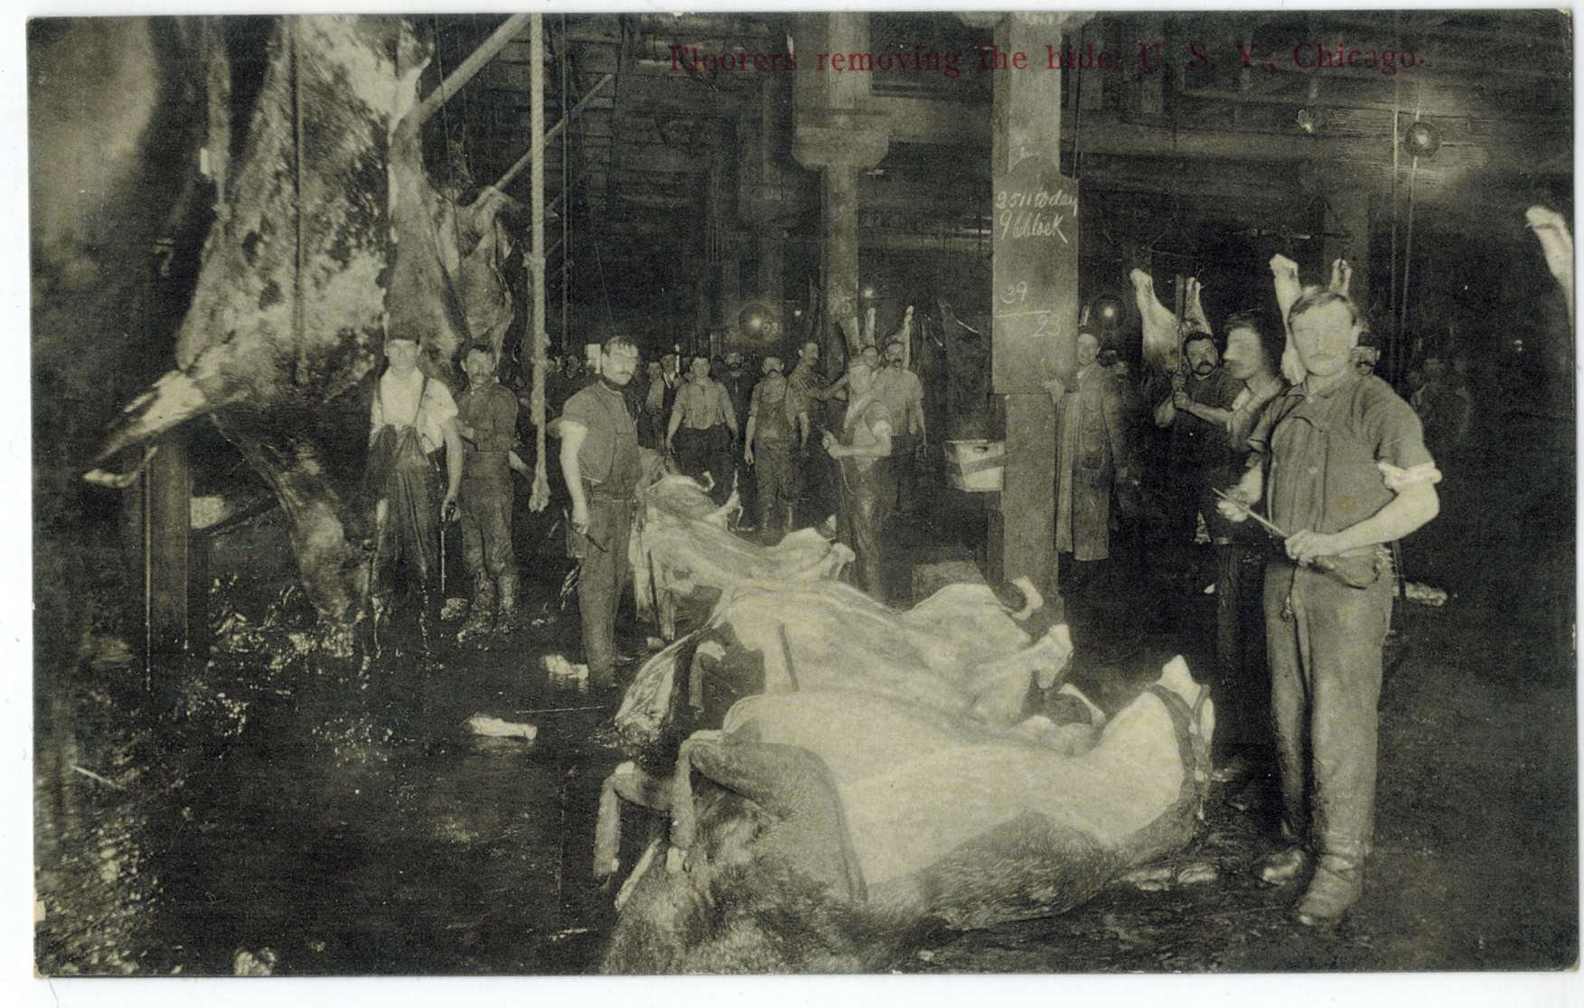
Suhling & Koehn Co. (1923). Floorers removing the hidse USY Chicago (front). Wikimedia Commons. https://en.wikipedia.org/wiki/The_Jungle#/media/File:Floorers_removing_the_hides_USY_Chicago_(front).tiff

image 2
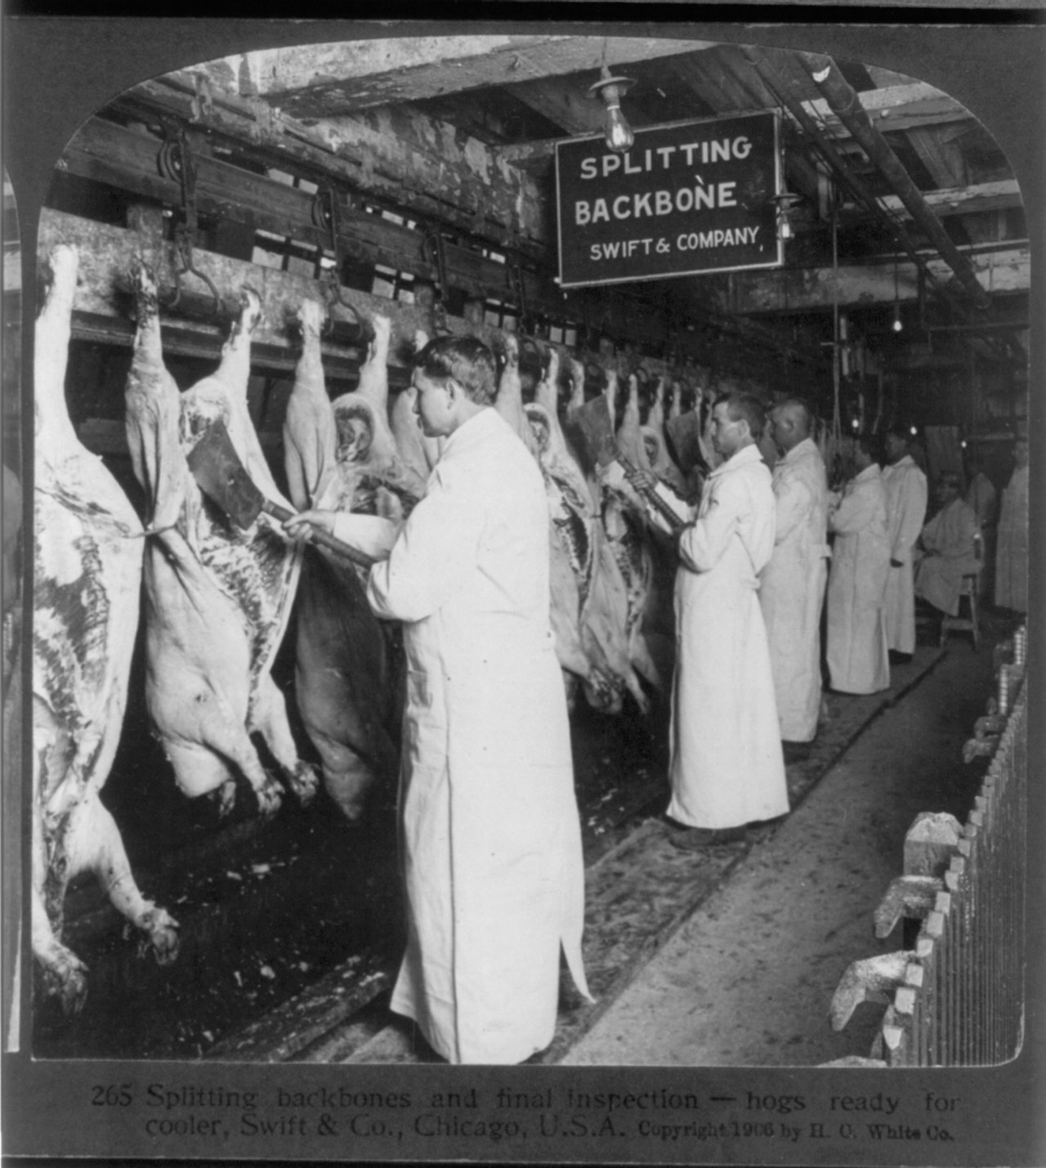
H. C. White Co. (1906). Chicago meat inspection swift co 1906. Wikimiedia Commons. https://en.wikipedia.org/wiki/The_Jungle#/media/File:Chicago_meat_inspection_swift_co_1906.jpg

image #3

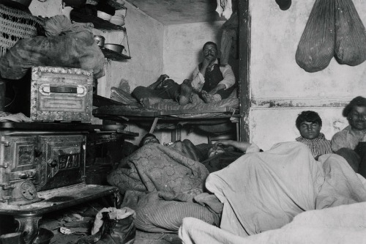
Riis, J. (1889). Jacob Riis, Lodgers in a Crowded Bayard Street Tenement. Wikimedia Commons. https://en.wikipedia.org/wiki/How_the_Other_Half_Lives#/media/File:Jacob_Riis,_Lodgers_in_a_Crowded_Bayard_Street_Tenement.jpg

image #4
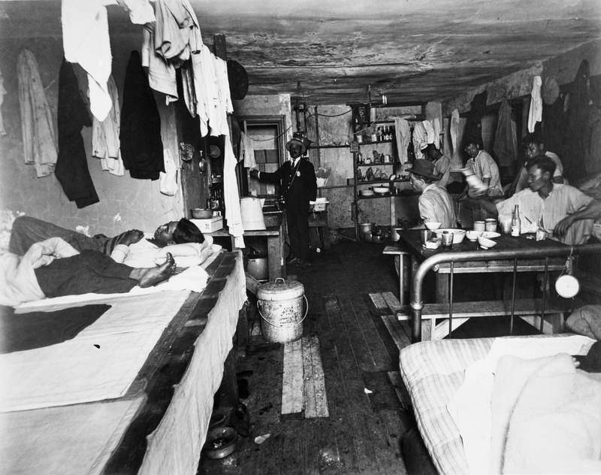
Riis, J. (1905). Sleeping quarters [Photograph]. History.com. https://www.history.com/topics/immigration/tenements#&gid=ci023648dc900027a7&pid=jacob-riis-tenements-515466514

