Name:_________________________________________________ Date:_____________ Hour: _________
FUNCTION JUNCTION
 | Food for Life Canned Food Drive
Homeroom | Number of Students | Number of Cans
101 | 25 | 133
102 | 22 | 216
103 | 24 | 148
104 | 22 | 195
105 | 20 | 74
106 | 21 | 150
DIRECTIONS: Even mathematicians don’t always agree on the definitions of some of our most commonly used terms. Below are some descriptions and definitions of three terms commonly used in algebra: function, domain, and range. Read each description and then write the definitions of function, domain, and range in your own words.
Description #1
  - Davidson, D. M. (2001). Pre-algebra: Tools for a changing world. Needham: Prentice Hall.
“The table shows the results of a canned food drive.
You can write the data in the table as a relation, a set of ordered pairs. The first coordinate of each ordered pair is the number of students in a homeroom. The second coordinate is the number of cans the students in the homeroom collected.
Here is the relationship represented by the table: {(25,133), (22,216), (24, 148), (22,195), (20,74), (21, 150)}
The braces, {}, indicate that these are all the ordered pairs in the relation. The first coordinates are the domain of the relation. The second coordinates are the range of the relation.
Some relations are functions. In a function, each member of the domain is paired with exactly one member of the range.”
  - (p. 384)
Description #2
  - Sullivan, M. (2002). College algebra (6th ed.). Upper Saddle River: Prentice Hall. Page 95.
“Let X and Y be two nonempty sets of real numbers. A function from X into Y is a relation that associates with each element of X a unique element of Y. The X is called the domain of the function. For each element x in X, the corresponding element y in Y is called the value of the function at x, or the image of x. The set of all images of the elements in the domain is called the range of the function.”
  - (p. 95)
Description #3
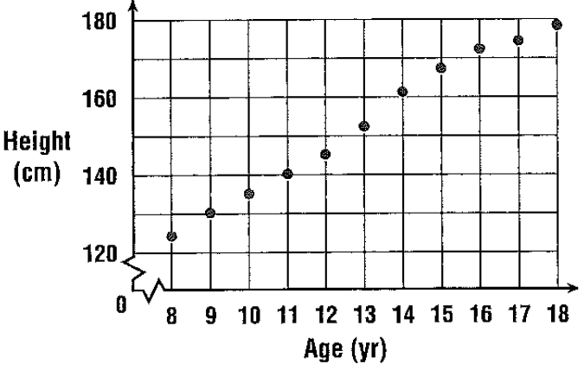
  - Collins, W. (2001). Mathematics Applications and Connections: Course 2. New York: Glencoe McGraw Hill.
“When Christian Laettner played basketball for Duke University, he was 83 inches, or 211 centimeters, tall. Certainly this is taller than the average 18-year-old.
It is clear from the graph that height increases with age. Height is a function of age, which means that height depends on age. A function describes a relationship between two quantities.”
  - (p. 249)
Description #4
  - Davidson, David M. (2001). Pre-Algebra: Tools for a Changing World. Needham: Prentice Hall.
“You can write a function using function notation, where you use f(x) instead of y. You read f(x) as “f of x.” You can think of a domain value as an input and the resulting range value as the output. A function rule is an equation that describes a function.”
function rule | Function rule
y = 3x + 7 | f(x) = 3x + 7
↓ ↓ | ↓ ↓
output input | output input
  - (p.404)
Description #5
  - Sullivan, M., & Sullivan, M., III. (2000). Precalculus: Enhanced with Graphing Utilities (2nd ed.). Upper Saddle River: Prentice Hall.
“Many everyday phenomena involve two quantities that are related to each other by some rule of correspondence. The mathematical tern for such a rule of correspondence is a relation. In mathematics, relations are often represented by mathematical equations and formulas. For instance, the simple interest I earned on $1000 for 1 year is related to the annual interest rate r by the formula I = 1000r.
The formula I=1000r represents a special kind of relation that matches each item from one set with exactly one item from a different set. Such a relation is called a function.
Definition of a Function
A function f from a set A to a set B is a relation that assigns to each element x in the set A exactly one element y in the set B. The set A is the domain (or set of inputs) of the function f, and the set B contains the range (or set of outputs). […]
Characteristics of a Function from Set A to Set B
- Each element in A must be matched with an element in B.
- Some elements in B may not be matched with any element in A.
- Two or more elements in A may be matched with the same element in B.
- An element in A (the domain) cannot be matched with two different elements in B.”
  - (p. 27)
My definitions:
Function: __________________________________________________________________________________________
__________________________________________________________________________________________
Domain: __________________________________________________________________________________________
__________________________________________________________________________________________
Range: __________________________________________________________________________________________
_______________________________________________________________________________________________

