Guided Notes (Model Notes)

# Vocabulary

* **input:** the independent variable, what “goes in” the function
* **output:** the dependent variable, what “comes out” of the function
* **function:** a relation where each input has only one output
* **domain:** the set of all possible input values
* **range:** the set of all possible output values

# Notation

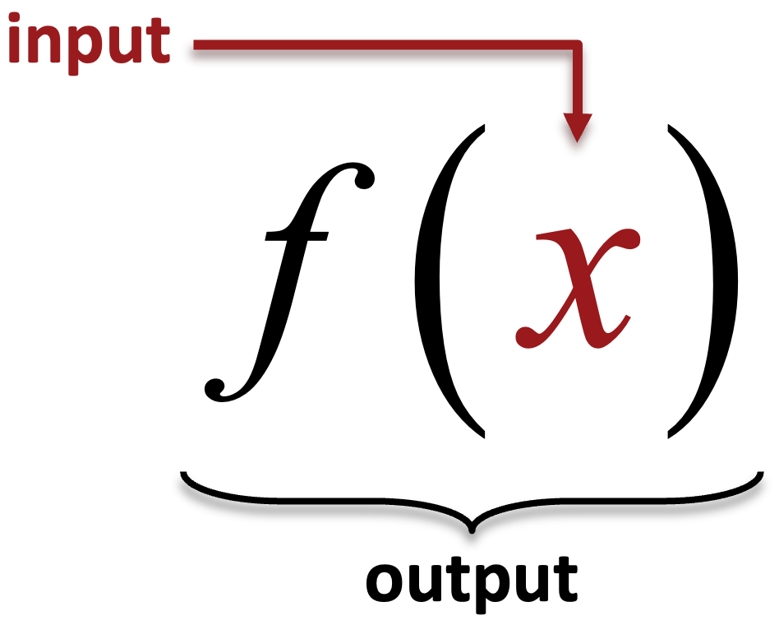

The letter inside of the parentheses is the independent variable. The letter outside of the parentheses is the name of the function. The entire *f* (*x*) is the dependent variable.

# Examples

Represent each of the following as a function using function notation.

## Toaster:

* Input: Bread = *b*
* Function: *T*( )
* Output: *T*(*b*)
* Domain: anything you could put in a toaster (bread slices, waffles, plastic forks)
* Range: what you would get out of a toaster (toast, toasted waffles, melted forks)

## Juicer:

Let ***J*** be the variable representing the juicer. Let ***f*** represent the fruit and ***d*** represent the juice you can drink.

**1)** What would *J*(*f* ) represent? *J*(*f* ) is the output of juice, which we also called *d*.

**2)** What would be the input? *f*, the fruit

**3)** What would be the output? *J*(*f* ) or *d*, the juice

**4)** Describe the domain of *J*(*f* ). Anything you could press with the juicer

**5)** Describe the range of *J*(*f* ). The liquid you would get out of the juicer

## Paper Shredder:

How could you use function notation to represent how the paper shredder functions?

We put paper into the shredder, so the input can be *p*. The shredder function can be *S*( ). So the shredder function could be represented by *S*(*p*).