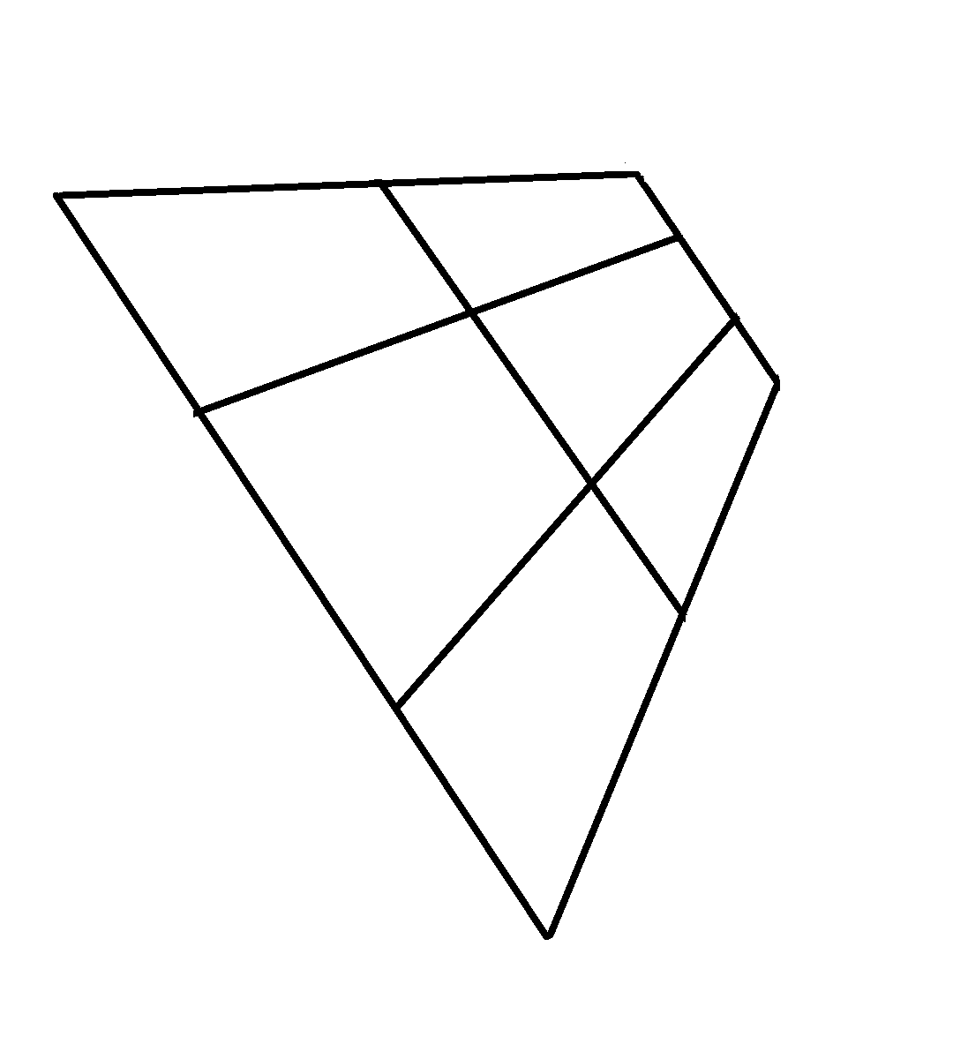
QUICK DRAW IMAGE FOR PARALLEL LINES

