Decision Tree Examples

# What kind of Grocery Item is it?

YES

YES

YES

YES

YES

NO

NO

NO

NO

NO

# What kind of Pet Should You get?

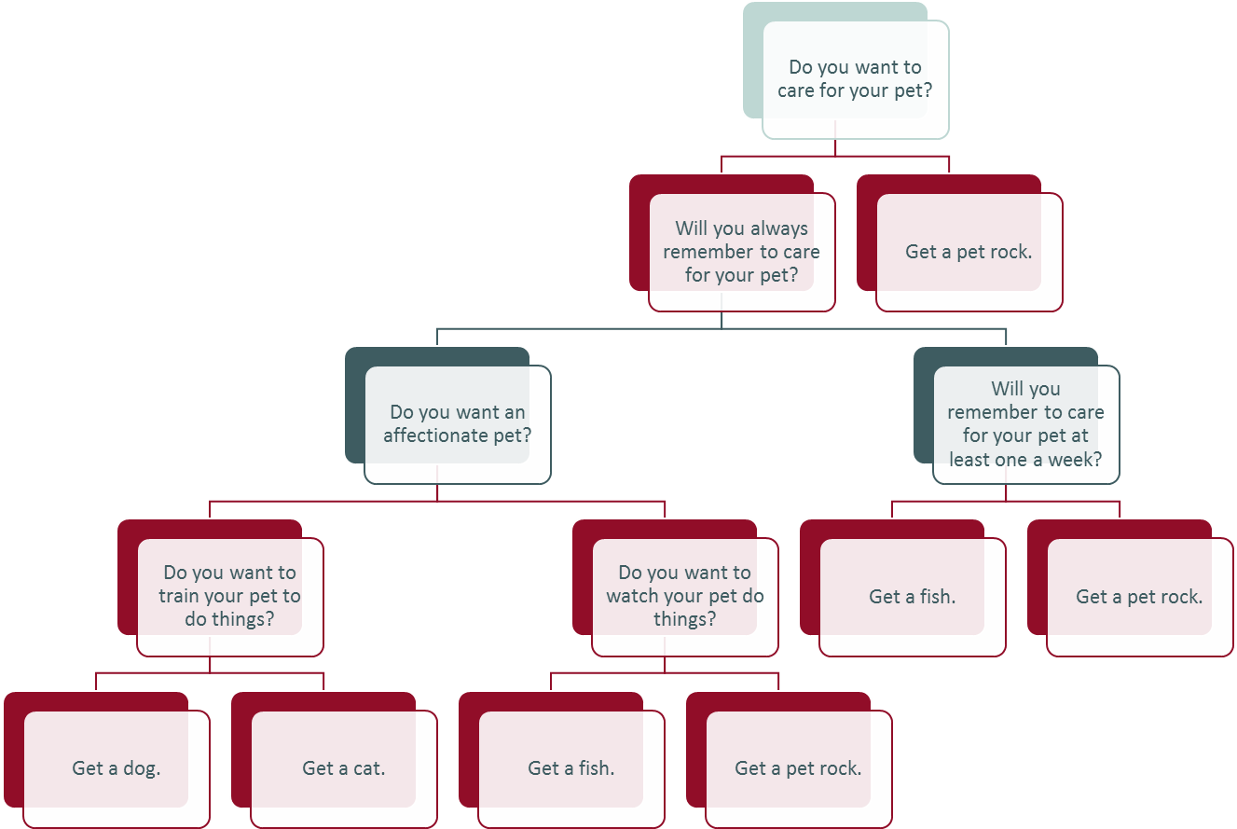

YES

YES

YES

YES

YES

YES

NO

NO

NO

NO

NO

NO