Choice Board
Complete enough questions below to earn 6 points.
1 Point | 2 Points | 3 Points
Fair Dice:  Let X = the value shown when rolling a fair die.  Determine and explain what represents. | 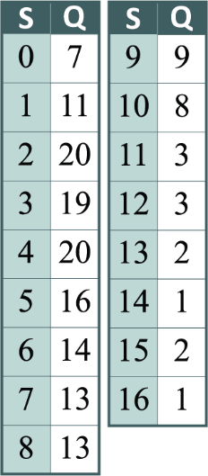  Baseball:  The Houston Astros earned 0-16 points in each game of the 2021 baseball season. The table shows the final scores (S) and the quantity of games where the scores were earned (Q).  What is the expected value of the number of points scored during a game? | Create Your Own:  Write a problem that contains a discrete random variable. Include a probability distribution table, the mean, and the standard deviation.
Eye Color:  Predict all possible outcomes of a child having brown eyes when the parents have brown (Bb) and blue (bb) eyes. Then create a table (e.g., Punnett square) or graph to display the results. Lastly, determine the probability of the child having brown eyes. | Spinner Game:  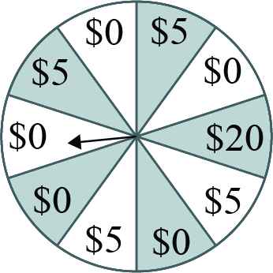  You attend a donation event and play the spinner game. For an entry of $5, you win what the pointer lands on. The pointer has an equal chance of landing on each value. Let X be the amount the fundraiser receives each game: X = $5, $0, –$15. Create a probability distribution table, then find the expective value. | Music:  In western music, there are 7 natural notes: C, D, E, F, G, A, and B. You are writing all possible chords using three of those notes (notes can be repeated in a chord, and BBE and BEB are not the same chords). What is the probability that your chord contains at least one C? Hint: There is 1 option with 3 Cs and 108 options with 1 C.
Reflection:  1) What do you consider the most confusing part of this lesson?  2) What is one thing you learned during this lesson? | Actuaries:  Research three different businesses that employ actuaries. For each job, write a paragraph and describe how they use random variables. | Let’s Make a Deal:  Write 1-2 paragraphs about Marilyn Vos Savant’s influence on the Monty Hall problem.
Baseball Reference. (n.d.). Team game-by-game schedule. 2021 Houston Astros. Retrieved October 26, 2022, from https://www.baseball-reference.com/teams/HOU/2021-schedule-scores.shtml#team_schedule

