Research Card Deck
Holocaust Research
Victim  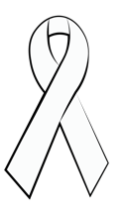 | Dr. Franz Goldberger

Holocaust Research
Victim | Isadore  Frenkiel

Holocaust Research
Victim | Ossi  Stojka

Holocaust Research
Victim | Moshe  Levin

Holocaust Research
Victim | Robert  Desnos

Holocaust Research
Victim | Carl Von Ossietzky

Holocaust Research
Victim | Yitskhok  Rudashevski

Holocaust Research
Victim | Rywka  Lipszyc

Holocaust Research
Survivor  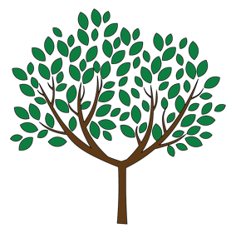 | Wladyslaw  Szpilman

Holocaust Research
Victim | Peter  Wilhelm  Pollmanns

Holocaust Research
Victim | Szeina Katzenelen-boigen

Holocaust Research
Survivor | Tom  Lantos

Holocaust Research
Survivor | Klaus  Langer

Holocaust Research
Survivor | Eva Unterman

Holocaust Research
Survivor | Nesse  Godin

Holocaust Research
Survivor | Marianne  Winter

Holocaust Research
Survivor | Stefan  Moise

Holocaust Research
Survivor | Max  Glauben

Holocaust Research
Survivor | Jozsef  Forgacs

Holocaust Research
Rescuer | 45th  Infantry  Division

Holocaust Research
Rescuer | Chiune  Sugihara

Holocaust Research
Survivor | Thomas  Doeppner

Holocaust Research
Rescuer | Hannah  Senesh

Holocaust Research
Rescuer | Sir  Nicholas  Winton

Holocaust Research
Rescuer | Raoul  Wallenberg

Holocaust Research
Rescuer | Father  Jacques  (Lucien  Bunel)

Holocaust Research
Rescuer | Mordechai  Anielewicz

Holocaust Research
Rescuer | Alexander  “Sasha”  Pechersky

Holocaust Research
Rescuer | Feng-Shan  Ho

Holocaust Research
Rescuer | Tosia  Altman

