Poster one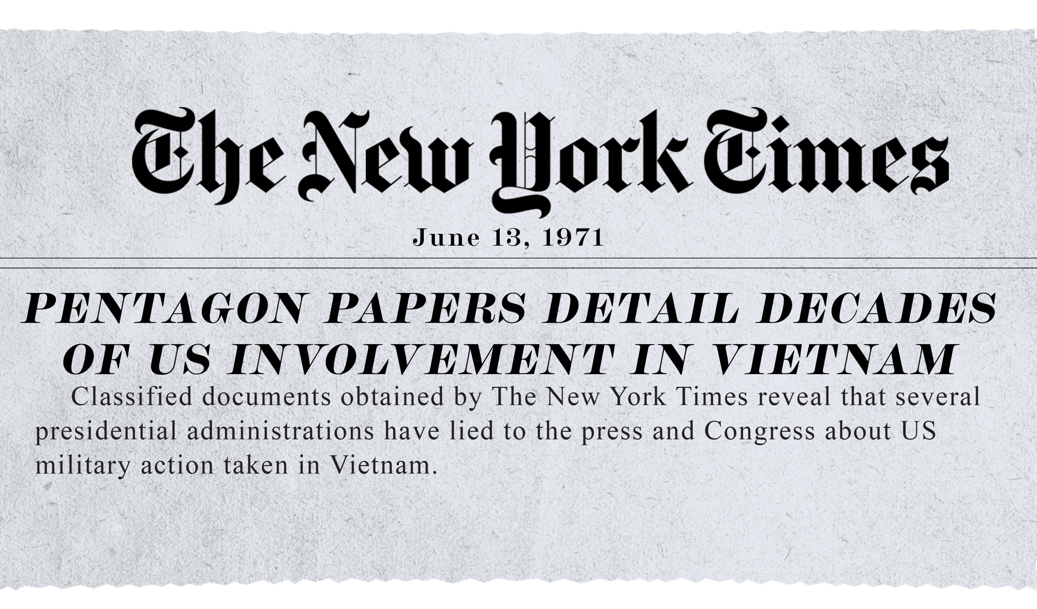

poster two
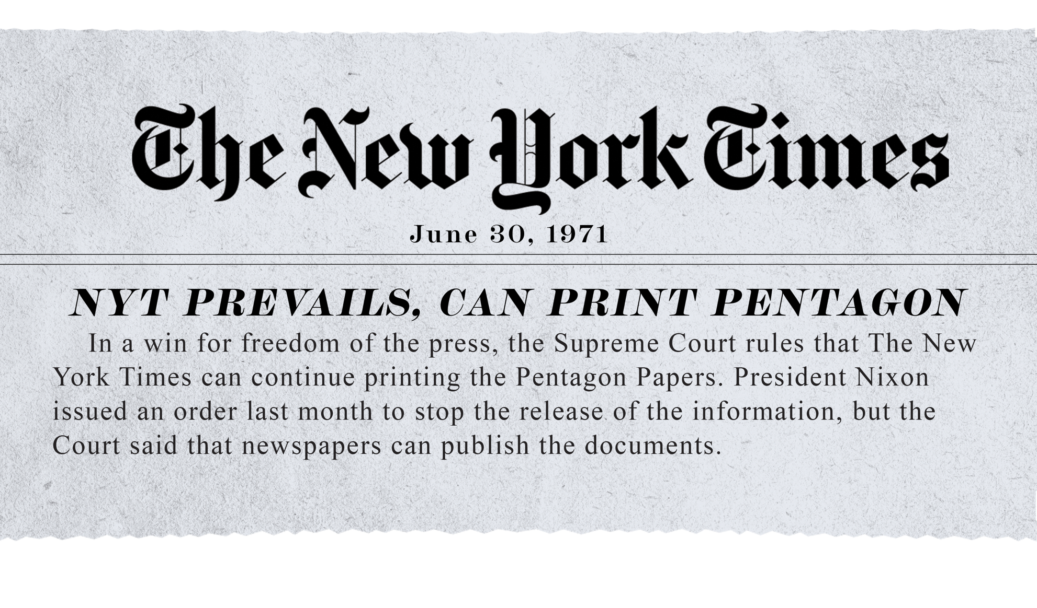

poster three
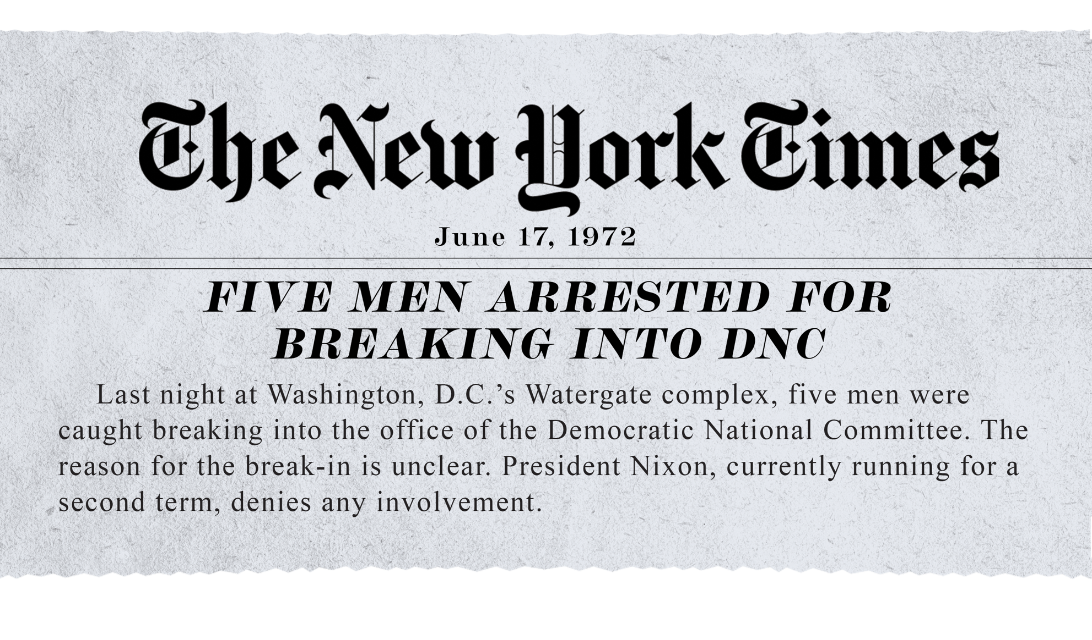

poster four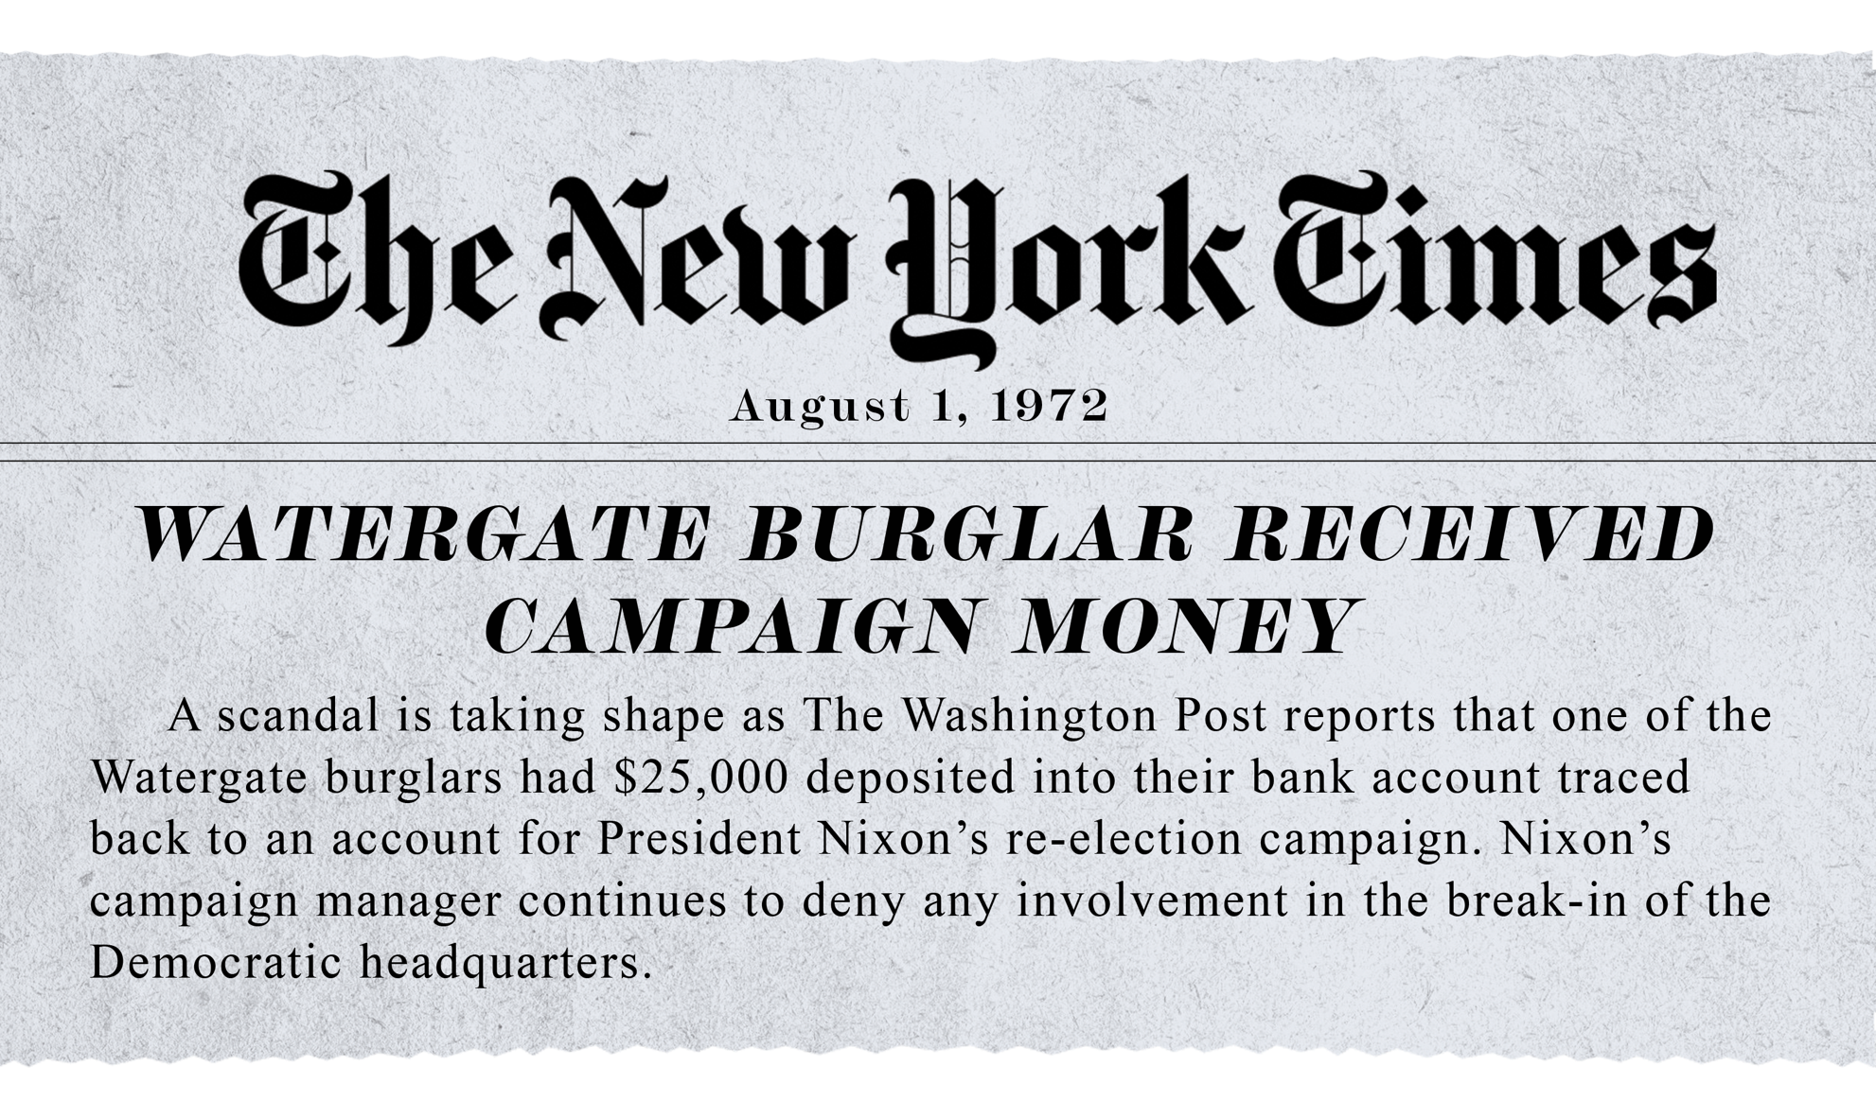

poster five
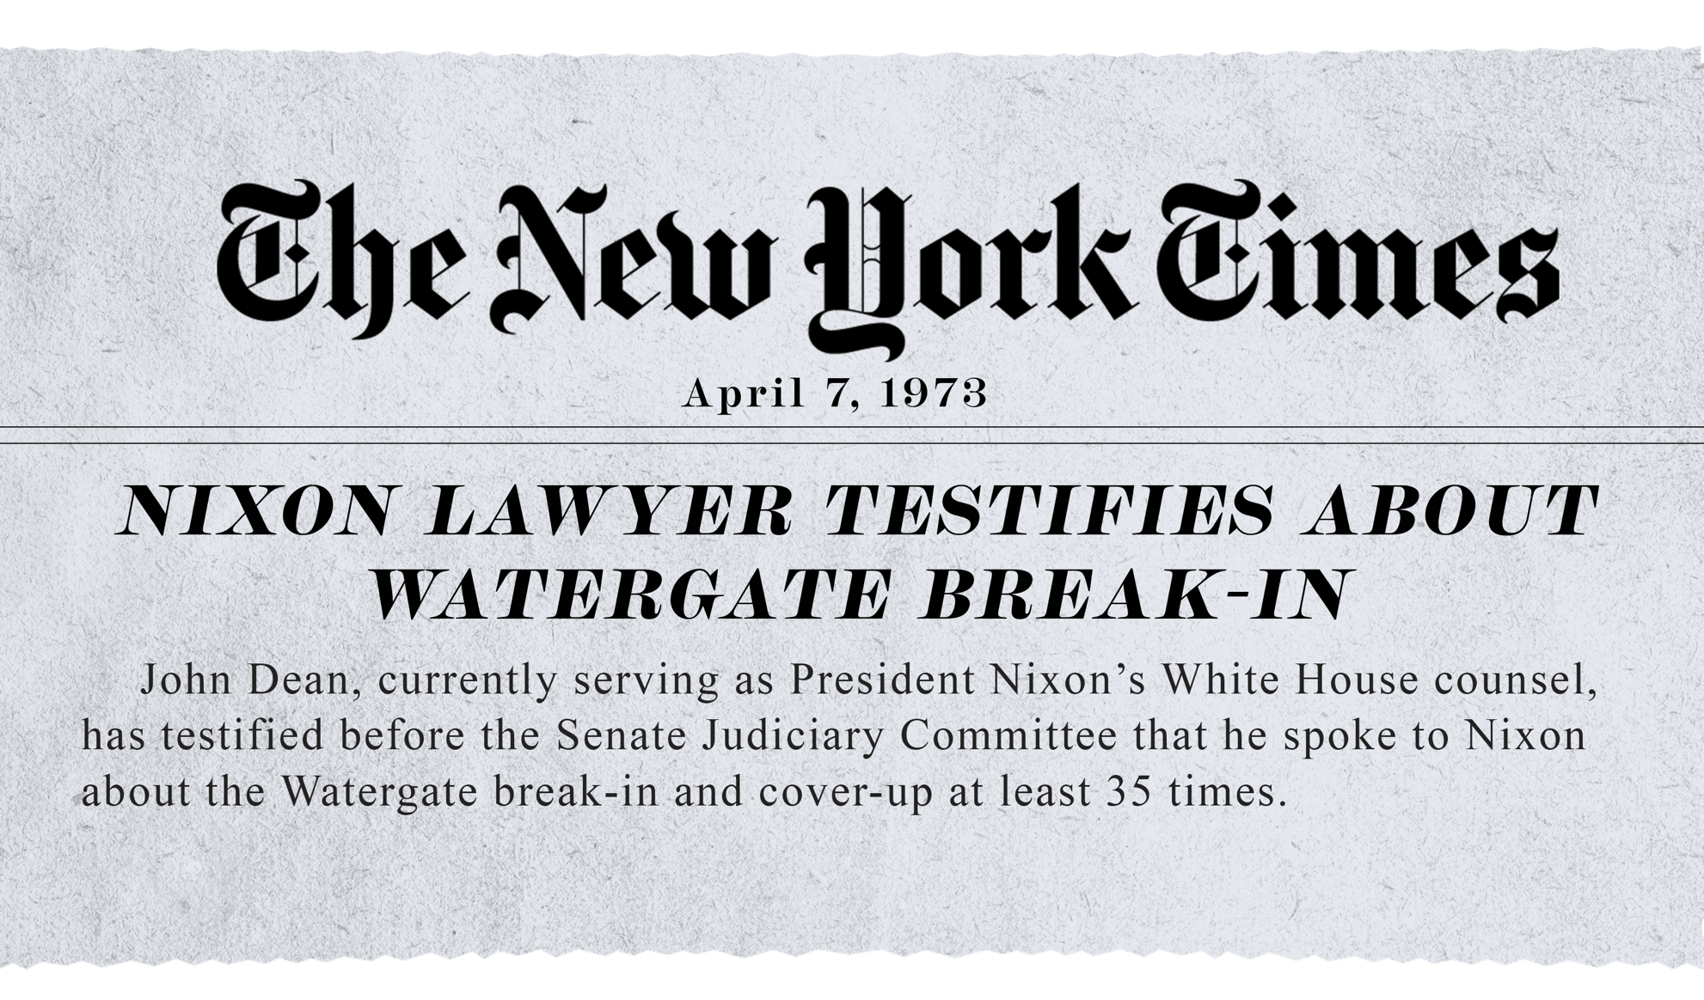

poster six

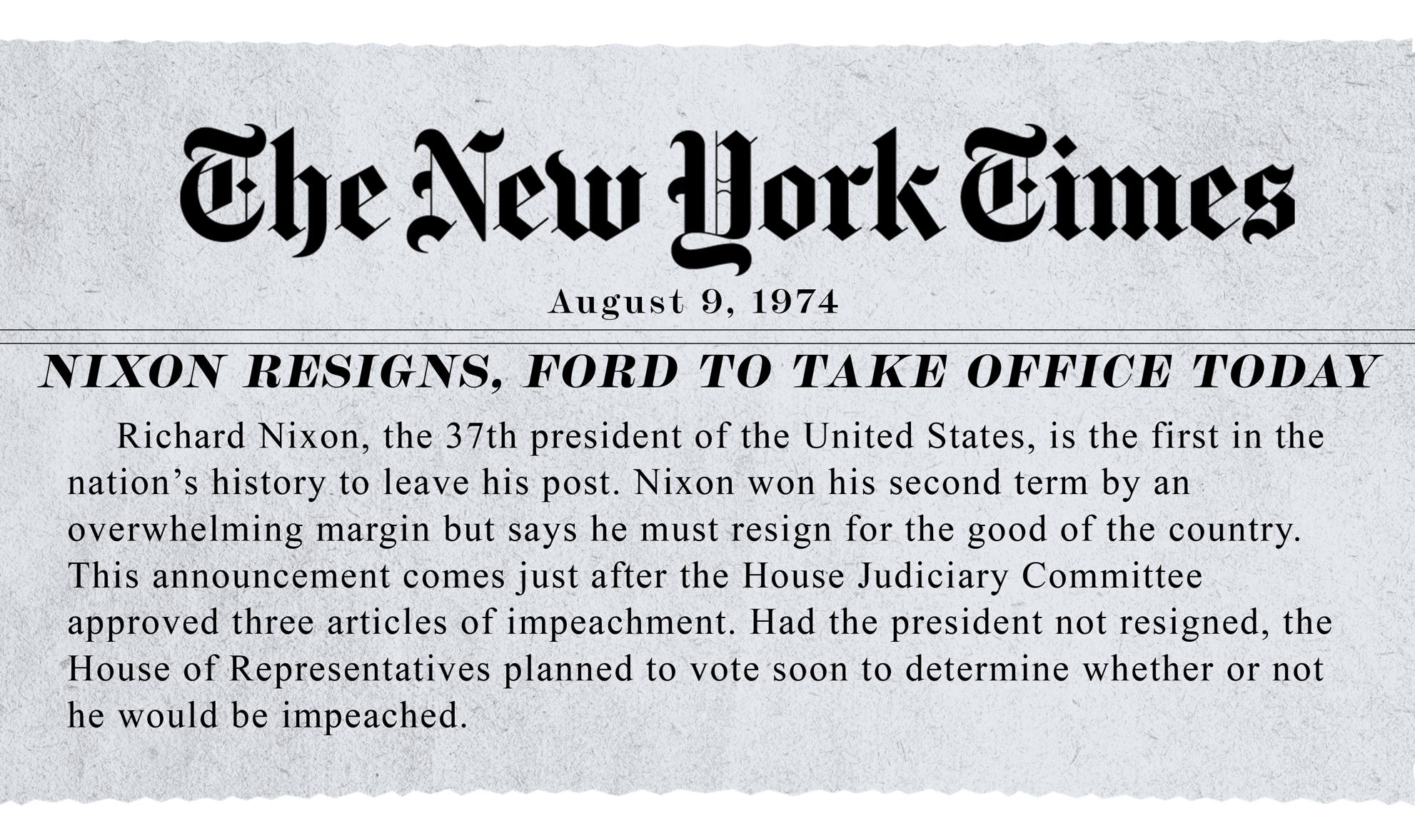

History. (2009, November 16). The New York Times publishes the "Pentagon Papers". History.com. https://www.history.com/this-day-in-history/the-new-york-times-publishes-the-pentagon-papers
History. (2018, October 9). The Watergate scandal: A Timeline. History. Retrieved November 29, 2022, from https://www.history.com/news/watergate-scandal-timeline-nixon
Public Broadcasting Service. (n.d.). President Nixon's Resignation Speech. PBS. Retrieved November 29, 2022, from https://www.pbs.org/newshour/spc/character/links/nixon_speech.html

