CHOCOLATE BAR PICTURES
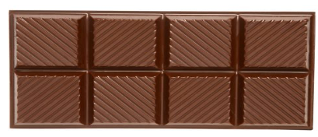
Chocolate Bar. (n.d.). https://www.beauregardvineyards.com/product/Dark-Chocolate-Bar

